**KIC Vision2 User Manual**

Hardware and Software

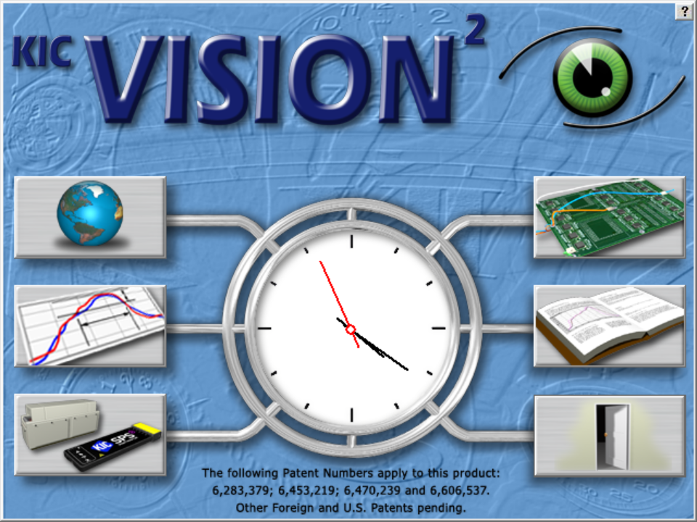

Version 2.0

Publication Number SFT-321000-100



**KIC Vision2 User Manual**

Copyright © 2017 KIC. All rights reserved. Patents pending.

16120 West Bernardo Drive

San Diego, CA 92127

Phone: +1 858 673 6050 Fax: +1 858 673 0085

A Division of Embedded Designs Inc.

This document contains information that is proprietary to KIC. Said information is copyrighted, as is all associated software and hardware. All rights are reserved. Patents are pending.

This document and the information contained in it may not be sold, duplicated, used, or disclosed, in whole or in part, except as specifically authorized in writing by KIC. The information contained in this document and associated software is subject to change without notice.

There are no warranties with respect to the information contained in this document, express or implied, except as provided by written contract between KIC and the customer.

All KIC product names and logos are trademarks of Embedded Designs, Inc. All other trademarks used herein are the property of their respective owners.

**Software Licensing Agreement and Product Warranty**

The KIC software is subject to the following license terms and conditions.

**KIC SOFTWARE LICENSE**

* 1. This is a software license granted by *KIC*, mailing address 16120 West Bernardo Drive San Diego, CA 92127.
  2. The KIC software is licensed to you as the end user, and is not sold.
  3. The KIC software is copyrighted material.
  4. The KIC software is licensed for use with one or more pieces of associated hardware that together constitute a thermal process management system. This license allows you to use the software with the purchased system. You must purchase additional copies of the software if used with additional system hardware.
  5. You may not change, modify, decompile, disassemble, or otherwise reverse engineer the licensed software or any associated hardware.

**LIMITED WARRANTY**

* 1. KIC warrants that the system hardware and software are free from defects in material and workmanship under normal use. KIC warrants that the system as a whole will perform substantially in accordance with the specifications set forth in the documentation provided with it.
  2. Warranty regarding rated temperature: Components of the system hardware are rated by KIC for proper performance up to a specified maximum temperature. Any component that KIC determines to have been exposed to temperatures higher than the rated temperature is not covered under this warranty.
  3. Start of the Warranty period. The warranty period begins the day the KIC product is delivered to you as the first customer.
  4. Obligations of KIC during The warranty period:
     1. Return for complete refund: If, within the first thirty (30) days after the start of the warranty, the customer returns, for any reason whatsoever, any of the purchased hardware or software in its original condition, KIC will refund the associated money paid and accept the return as payment for any money owed.
     2. Replacement: Within the first year of the start of the warranty, KIC will replace, on an exchange basis and without additional charge, any product proven defective in materials or workmanship.
     3. Correction of software: KIC will either replace or repair, without additional charge, any software that does not perform in substantial compliance with its documented specifications. In the foregoing circumstances, KIC will deliver either corrective code or a corrected copy of the software.
     4. Final Remedy: If KIC is unable to replace defective media or provide a corrected copy of the software within a reasonable amount of time, KIC will either replace the software with a functionally similar program or refund the license fees paid for use of the software.
  5. **Exclusion of Other Warranties**
     1. KIC does not warrant that the functions contained in the software will meet your requirements or that the operation of the software will be uninterrupted or error free. The Warranty does not cover any copy of the software that has been altered or changed in any way by you or others. KIC is not responsible for problems caused by changes in the operating characteristics of the computer hardware or operating system which are made after delivery of the software.
     2. **EXCEPT WHERE LIMITED BY LOCAL JURISDICTIONS, KIC SHALL NOT IN ANY CASE BE LIABLE FOR SPECIAL, INCIDENTAL, CONSEQUENTIAL, INDIRECT OR OTHER SIMILAR DAMAGES ARISING FROM ANY BREACH OF THESE WARRANTIES EVEN If KIC OR ITS AGENT HAS BEEN ADVISED OF THE POSSIBILITY OF SUCH DAMAGES.**
  6. **Other Conditions**
     1. **The warranties set forth above are in lieu of all other warranties, whether oral, written or implied, INCLUDING BUT NOT LIMITED TO ANY IMPLIED WARRANTIES OF MERCHANTABILITY OR FITNESS FOR ANY PARTICULAR USE. the remedies set forth above are the customer’s sole and exclusive remedies**. Only an authorized officer of KIC may make modifications to this warranty, or additional warranties binding on KIC. Accordingly, additional statements such as advertising, collateral or presentations, whether oral or written, do not constitute warranties by KIC and should not be relied upon as such. This warranty gives you specific legal rights, and you may have other rights, which vary by state and/or country.

**LIMITATION OF LIABILITY**

* 1. In no case shall KIC's liability exceed the license fees paid for the right to use the licensed software or One Hundred Dollars ($100.00), whichever is greater.

**Part 1 – The Basic System**

[The Hardware 3](#_Toc494303876)

[Hardware Diagram 5](#_Toc494303877)

[Dual Lane Systems 6](#_Toc494303878)

[Install the Software 7](#_Toc494303879)

[The Main Screen 10](#_Toc494303880)

[Global Preferences 11](#_Toc494303881)

[Global Tab 11](#_Toc494303882)

[KIC Vision2 Tab 13](#_Toc494303883)

[Data Backup Tab 16](#_Toc494303884)

[Define/Edit Process Window 17](#_Toc494303885)

[Solder Paste Menu 18](#_Toc494303886)

[Edit Specs 19](#_Toc494303887)

[Save Process Window 22](#_Toc494303888)

[Import Legacy Process Windows 23](#_Toc494303889)

[Hardware Status Screen 24](#_Toc494303890)

[Run a Profile 25](#_Toc494303891)

[Specify Oven Characteristics 26](#_Toc494303892)

[Attach Thermocouples 28](#_Toc494303893)

[Attach Thermocouples To Semiconductor Wafers 29](#_Toc494303894)

[Select Thermocouples to Start a Profile 30](#_Toc494303895)

[Start The Profile 31](#_Toc494303896)

[Live Profile Graph 33](#_Toc494303897)

[View the Profile and Statistics 36](#_Toc494303898)

[Manual Profile Prediction 44](#_Toc494303899)

[Set Different Top and Bottom Set Point Temperatures 45](#_Toc494303900)

[Profile Explorer 49](#_Toc494303901)

[Browse for Historical Data 50](#_Toc494303902)

[View Historical Data Over a Network (History Mode) 50](#_Toc494303903)

[Profile Explorer – Virtual Profiling 52](#_Toc494303904)

[Access History Data Backup Files 54](#_Toc494303905)

[Insert Data Files from an Outside Source 55](#_Toc494303906)

[Rename Profiles 55](#_Toc494303907)

[Virtual Profiling 56](#_Toc494303908)

[Get a Valid Baseline Profile 56](#_Toc494303909)

[Create/Load a Virtual Profile 57](#_Toc494303910)

[Live Mode - General Tab 58](#_Toc494303911)

[Live Mode - Description Tab 61](#_Toc494303912)

[Verify the Virtual Profile 61](#_Toc494303913)

[Historical Mode 64](#_Toc494303914)

[Historical Mode - General Tab 64](#_Toc494303915)

[Historical Mode - Description Tab 67](#_Toc494303916)

[Password Protection 68](#_Toc494303917)

[Printing 69](#_Toc494303918)

[Portrait Mode 69](#_Toc494303919)

[Landscape Mode 70](#_Toc494303920)

[Write Data to and View Data Over a Network 71](#_Toc494303921)

[Write Data to a Network Drive 71](#_Toc494303922)

[Viewing Historical Data 74](#_Toc494303923)

[Messages During Profiling and Baseline Profiling 75](#_Toc494303924)

[System Messages and Alarms 75](#_Toc494303925)

[Alarms and Messages During Virtual Profiling 76](#_Toc494303926)

[eTPU Communication 77](#_Toc494303927)

[Communicate with Oven Controllers 78](#_Toc494303928)

[Confirm Oven Communications 79](#_Toc494303929)

[Configure Software for Oven Communication 79](#_Toc494303930)

[Use a Base Oven Recipe With Oven Communication 80](#_Toc494303931)

[Run a Profile Using Oven Communication 81](#_Toc494303932)

[Start a Virtual Profile With Oven Communication 83](#_Toc494303933)

[Base Oven Recipe Automatic Verification 84](#_Toc494303934)

[Dual Lane Systems And Functionality 85](#_Toc494303935)

[Dual Lane Dual Systems 85](#_Toc494303936)

[Configure Dual Lane Systems 86](#_Toc494303937)

[Configuration Program 88](#_Toc494303938)

[User Settings Tab 88](#_Toc494303939)

[Shifting Tab 89](#_Toc494303940)

[Decimal Tab 89](#_Toc494303941)

[Hardware Tab 89](#_Toc494303942)

[Message Config Tab 89](#_Toc494303943)

[Troubleshoot COM Ports 90](#_Toc494303944)

**Part 2 – Software and Hardware Options**

[Software Options 93](#_Toc494304109)

[Navigator 93](#_Toc494304110)

[Auto-Focus 93](#_Toc494304111)

[Navigator/Auto‑Focus Power 93](#_Toc494304112)

[Sweet Spot 93](#_Toc494304113)

[Statistical Process Control Charts 93](#_Toc494304114)

[Live Data Output 93](#_Toc494304115)

[Use Navigator to Optimize Profiles 94](#_Toc494304116)

[Search Mode For Optimization 94](#_Toc494304117)

[Conveyor Speed Constraints 94](#_Toc494304118)

[Use Auto-Focus 95](#_Toc494304119)

[Auto-Focus Tab 95](#_Toc494304120)

[Profile Optimization Settings—Search Mode 95](#_Toc494304121)

[Conveyor Speed Constraints 95](#_Toc494304122)

[Save Energy With Navigator and Auto-Focus 96](#_Toc494304123)

[Enable the Power Feature in Auto-Focus 96](#_Toc494304124)

[Enable the Power Feature in Navigator 96](#_Toc494304125)

[Use Sweet Spot Target 97](#_Toc494304126)

[Use Statistical Process Control Charts 98](#_Toc494304127)

[Live Mode - Charts Tab 98](#_Toc494304128)

[View Chart Data 99](#_Toc494304129)

[Historical Mode - Chart Tab 100](#_Toc494304130)

[View Control Charts 100](#_Toc494304131)

[Viewing Chart Data 101](#_Toc494304132)

[History Mode Chart Options Menu 101](#_Toc494304133)

[Using Live Data Output 102](#_Toc494304134)

[LDO Formats 103](#_Toc494304135)

[Details Of Output Files 103](#_Toc494304136)

[LDO Standard TSV And CSV For WordPad 103](#_Toc494304137)

[LDO Standard TSV And CSV For Excel 103](#_Toc494304138)

[LDO 1 Board 1 File (Txt Output) 103](#_Toc494304139)

[LDO XML (1 Board 1 File) 103](#_Toc494304140)

[Configure LDO 104](#_Toc494304141)

[Delete Accumulated LDO Files 105](#_Toc494304142)

[Alarm Relay 106](#_Toc494304143)

[Light Tower 106](#_Toc494304144)

**Appendices**

[Appendix A: The Process Window Index A Method for Quantify Thermal Profile Performance 107](#_Toc469045156)

[The Problem 107](#_Toc469045157)

[Defining the Process Window Index 107](#_Toc469045158)

[Calculating the PWI 108](#_Toc469045159)

[Benefits of Ranking Thermal Profile Performance 109](#_Toc469045160)

[Conclusion 109](#_Toc469045161)

[Appendix B: Recalculating Zone Delta Limits From Navigator/Auto-Focus Predictions 110](#_Toc469045162)

[For Stand-Alone Software Installations 110](#_Toc469045163)

[For Oven Controller Software Installations 112](#_Toc469045164)Error! Hyperlink reference not valid.**Error! Hyperlink reference not valid.Error! Hyperlink reference not valid.Error! Hyperlink reference not valid.Error! Hyperlink reference not valid.Error! Hyperlink reference not valid.Error! Hyperlink reference not valid.Error! Hyperlink reference not valid.**

[Contact KIC 114](#_Toc469045173)

[On the Web 114](#_Toc469045174)

[KIC Technical Support 114](#_Toc469045175)

[KIC Product Training 114](#_Toc469045176)

[KIC Sales 114](#_Toc469045177)

[Find the KIC Representative in Your Area 114](#_Toc469045178)

**Introducing the Automatic System**

The automatic system is a comprehensive suite of thermal process management tools designed to give you the ultimate in PCB soldering quality control. It can monitor the entire thermal process, giving advanced warning before a product drifts out of specification.

The product combines software and hardware components into an integrated system. The software supplements its thermal profile analysis core with special tools for performance optimization, changed variable prediction, and data file management. The hardware includes the probes that measure oven temperature, sensors to track product movement and conveyor speed, a profiler to move through the process accumulating thermal data, an Ethernet communication hub, and alarm system.

**Note**: For more information about the hardware components of the system, see the *Automatic System Hardware Installation Manual* (TFS-330210-000).

**About this Manual**

This user manual is divided into two parts.

***Part 1: The Basic System*** describes all of the included functionality of the basic system. It details the core software capabilities together with an overview of the hardware components.

***Part 2: Available Software & Hardware Options*** describes the enhancements that can be added to the basic system, which will extend the capabilities of your core software and hardware.

**Part 1: The Basic System**

[The Hardware 3](#_Toc494304160)

[Dual Lane Systems 6](#_Toc494304161)

[Install the Software 7](#_Toc494304162)

[The Main Screen 10](#_Toc494304163)

[Global Preferences 11](#_Toc494304164)

[Define/Edit Process Window 17](#_Toc494304165)

[Hardware Status Screen 24](#_Toc494304166)

[Run a Profile 25](#_Toc494304167)

[Profile Explorer 49](#_Toc494304168)

[Virtual Profiling 56](#_Toc494304169)

[Password Protection 68](#_Toc494304170)

[Printing 69](#_Toc494304171)

[Write Data to and View Data Over a Network 71](#_Toc494304172)

[Messages During Profiling and Baseline Profiling 75](#_Toc494304173)

[Communicate with Oven Controllers 78](#_Toc494304174)

[Dual Lane Systems And Functionality 85](#_Toc494304175)

[Configuration Program 88](#_Toc494304176)

[Troubleshoot COM Ports 90](#_Toc494304177)

# **The Hardware**

There are five major hardware components to the basic system:

* Ethernet Thermocouple Processing Unit (eTPU)
* Probes
* Board sensor
* Conveyor speed encoder
* Profiler

### eTPU

The eTPU interfaces with the computer using an Ethernet cross-over cable that connects from the UpLink port on the eTPU directly to a USB to Ethernet adapter (or to an installed Network Interface Card (NIC)). Please follow manufacturers’ instructions to install the USB adapter or NIC.

The computer used with the system can be a machine that is dedicated to only supporting the software or it can also serve as the oven controller PC. The software can interface directly with the oven controller on selected models from oven manufacturers. If you have an oven that is capable of communication with the software, you will want to connect the software to the oven controller computer.

The eTPU must be plugged into an AC power source. The eTPU utilizes a universal A/C transformer power supply. The eTPU ships from the factory with multiple AC connectors to accommodate any connector/voltage requirement.

### Probes

The probes are mounted in the oven process chamber. They are usually suspended from the conveyor rails by oven manufacturer approved brackets. The probes are connected to the eTPU - Odd/Even ports. Each probe connector is stamped with an **E** or **O** in order to designate **Odd** or **Even**. See the [Hardware Diagram](#_Hardware_Diagram).

### Board Sensor

The Board Sensor is mounted near the entrance of the oven. It can be mounted further into the oven if necessary. The Board Sensor is usually mounted to the fixed conveyor rail. The Board sensor is connected to any of the eTPU Sensor ports. Dual lane systems use a board sensor for each lane.

### Con**veyor Speed Encoder**

The Conveyor Speed Encoder is mounted to read pulses from a gear that turns while the oven is operating. The Conveyor Speed Encoder connects to any of the eTPU Sensor ports.

### Profiler

The profiler is the data acquisition component of the system. It provides the on-board, through-the-process temperature data. The software analyzes this data together with oven zone temperature and conveyor speed factors to display the thermal profile graphically.

You can usesoftware with several profiler models such as:

1. SPS Smart Profiler
2. SlimKIC 2000
3. KIC Explorer
4. X5
5. K2

The software works the same with any of the profilers. Once you have the software running, you indicate your specific profiler model. The program then displays the text and graphics that reflect the model you chose. (The artwork that appears throughout this manual reflects a variety of profiler models.)

Profilers can operate in either of two modes—datalog and wireless*.* In standard datalog mode, the profiler records temperature data as it moves through the thermal process. A cable then transfers the data to your software application computer. In wireless mode, the profiler transmits data directly to the computer by radio signals or Wi-Fi instead of an attached cable. The application software can then display the accumulating data in real-time.

For specific information regarding your profiler, consult one of the following publications:

* SPS Smart Profiler Hardware Guide (Publication Number PTG-330310-000)
* SlimKIC 2000 Profiler Hardware Guide, (Publication Number SLK-332310-000)
* KIC Explorer Profiler Hardware Guide, (Publication Number EXP-330310-000)
* X5 Profiler Hardware Guide, (Publication Number EXP-337310-000)
* K2 Profiler Hardware Guide, (Publication Number EXP-331310-000)

## Hardware Diagram

The hardware diagram below illustrates the interconnection of the hardware components (including some optional hardware):

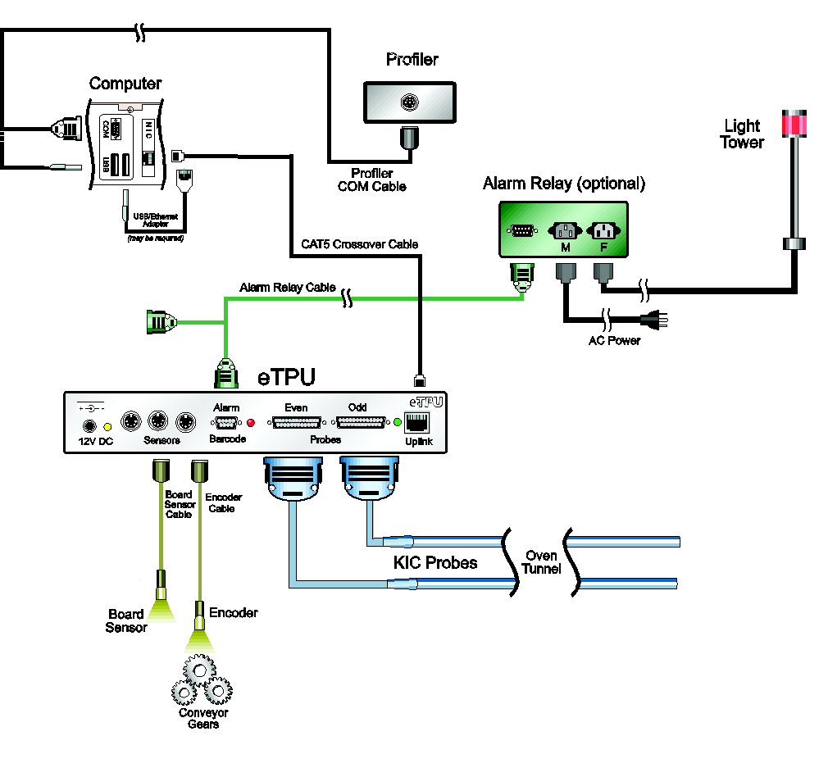

Figure 1: Hardware Configuration Diagram

It is critical that all system hardware be installed and configured properly. Any malfunctioning or incorrectly setup component may prevent the system from providing accurate data or from running Virtual Profiling.

# Dual Lane Systems

The automatic system can monitor production through dual lane reflow ovens.

A *Dual Lane-Dual System* configuration uses two instances of the software application to track different recipes through the oven.

See [Dual Lane Systems and Functionality](#_Dual_Lane_Systems) for details on installation and configuration.

# Install the Software

### Minimum PC System Requirements

* Dual Core / 1GHz processor PC with 2GB RAM
* 2GB available storage
* Video 1024 x 768 / 16-bit color
* 1 available USB port (for software key)
* 1 available USB port for data download (used with serial-to-USB adapter for SlimKIC 2000 profiler)
* 1 available Ethernet port or 1 available USB port with Ethernet-to-USB adapter
* For product compatibility with Windows® operating systems, visit our website at <http://kicthermal.com/support-download/os-compatibility-chart>

**Note**: Additional powered USB ports may be needed for additional accessories.

### Note Before Installation

* Shut down all other applications as a precaution against software conflicts.
* SlimKIC 2000 profiler users should disable or uninstall all applications that interface with the PC through a serial COM port, other than your oven controller software. For example: PDA communication software.
* If you are installing the software on an oven that is capable of communication with the software, **DO NOT place the software icon in the Windows Startup folder**. If the software loads before the oven controller software, it can cause the oven controller software to malfunction.

### Languages

The software supports the following languages:

|  |  |
| --- | --- |
| * English | * Japanese |
| * German | * Korean |
| * Spanish | * Simplified Chinese |
|  | * Traditional Chinese |

The use of specific languages depends on the operating system:

* English, German, and Spanish can be run on any of the supported Windows operating systems.
* Japanese, Korean, Simplified Chinese, and Traditional Chinese cannot be used with English versions of Windows operating systems.
* To run the software in Japanese, the operating system must be Windows-Japanese version.
* To run the software in Simplified or Traditional Chinese, the operating system must be Windows-Chinese version.

### Install

1. Insert the software CD into your CD-ROM drive.

The software installation starts automatically.

1. If the software does not auto-start, navigate to **Windows *Start Menu*** and click **Run**.
2. Type **D:\setup** (or your CD-ROM drive letter) and press the **Enter** key on the keyboard.
3. Follow the instructions for the installation program as the screens appear.

\*When installing the software over an existing system directory, the installation will automatically create a backup folder of the existing directory. A warning message will be displayed when selecting an existing directory, and a checkbox can be de-selected if you do not wish to create a backup.

The name of the backup directory created will be C:\software root directory\_Old\_MM-DD\_YYYY

**Note**: If you have questions regarding your hardware or software configuration contact Tech Support.

### Start the Software

The installation automatically adds a named software folder to the main Windows Start Menu. Click the Windows Start button and scroll up to the software folder. Then click the software icon.

1. Click the Windows Start button to locate the automatic software icon and click the icon.

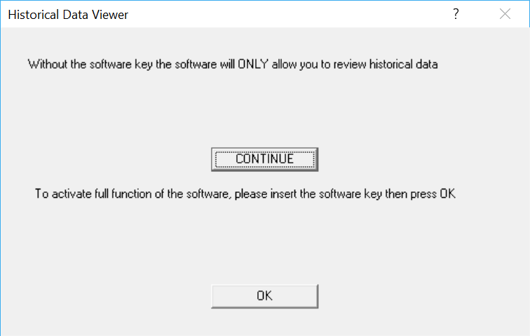

Figure 2: Missing USB Dongle notification

1. A specifically programmed USB dongle key is required to run the automatic system software. When starting, if you see the above message, insert the key and click **OK**.

The first screen in the software will prompt you to either enter the current belt speed for the oven, or choose to work in History mode. See Figure 3.

**Note**: This screen will not appear if the software is installed on an oven that has compatible oven controller software unless the communication between the two applications in not enabled.

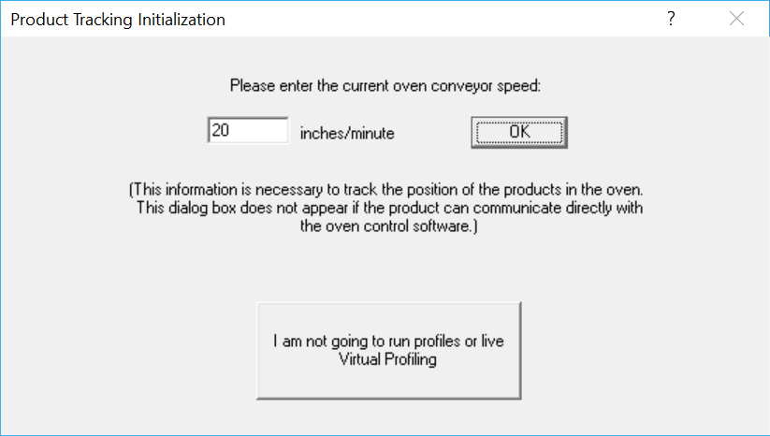

**View History Mode-**

Choose this button to view Virtual Profile history, browse to a different hard drive or computer on the network.

**Production Mode -**Choose this button to run profiles and Virtual Profiles.

Figure 3: Product Tracking Initialization

**Production Mode -** If you wish to run profiles or Virtual Profile, enter the current belt speed for your oven and choose the **OK** button, this will activate Production mode. You can view historical data while in Production mode, but not while a Virtual Profile is running.

To view historical Virtual Profile data from the same PC while Virtual Profiling live, launch a separate Host.exe file located in: C:\software root directory\APPforViewer\KICHost.exe. This will open a separate Profile Explorer that will allow you to browse through the history of any product including the one currently running VP. Historical data will be available for any virtual profiles that have already been calculated.

**View History Mode** - If you wish to work offline and do not plan to profile or Virtual Profile, choose *I am not going to run profiles or live Virtual Profiling* button, this will activate History mode. While History mode is active, you cannot run profiles or Virtual Profile, as the software will not communicate with the system hardware. The software will not even check for the hardware unless Production mode is active. If working in History mode you can browse to any working directory in Profile Explorer, even over a network.

# The Main Screen

There are six buttons on the main software screen. The buttons on the left are for setup and status; the buttons on the right are for running and viewing profiles and exiting the software. Placing the mouse pointer over each button will display a description for each button. See Figure 4.

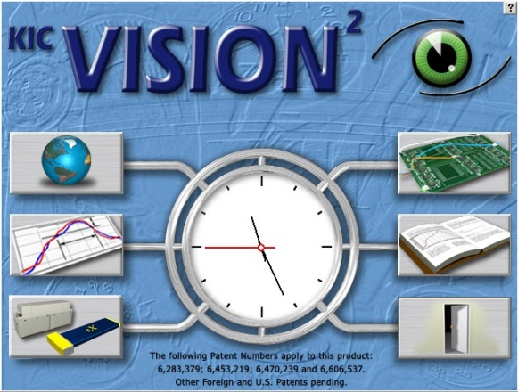

**Setup**

**Status**

**Run**

**Exit**

**View**

Figure 4: Main screen

|  |  |  |
| --- | --- | --- |
| bt-NAV_Prefs **Global Preferences**  Set units of measure, Maximum product start temperature, Oven name, Password, Board sensor, Cpk and Optional equipment setup.  bt-NAV_Process-menu **Define/Edit Process Window**  Create or edit Process Window files for solder paste and profile specifications.  bt-NAV_HW-status-X5-9ch **Hardware** **Status**  Shows the status of the oven controller (if applicable), *e*TPU inputs, the profiler status, and operating software components. |  | bt-NAV_Run-profile **Run a Profile**  Begins the step-by-step procedure for running a product profile.  bt-NAV_Log-book **Profile Explorer**  Filing system used to manage and view all profiles and Virtual Profiles run using the software.  bt-NAV_Exit **Exit**  Exits the software. |

# bt-NAV_PrefsGlobal Preferences

## Global Tab

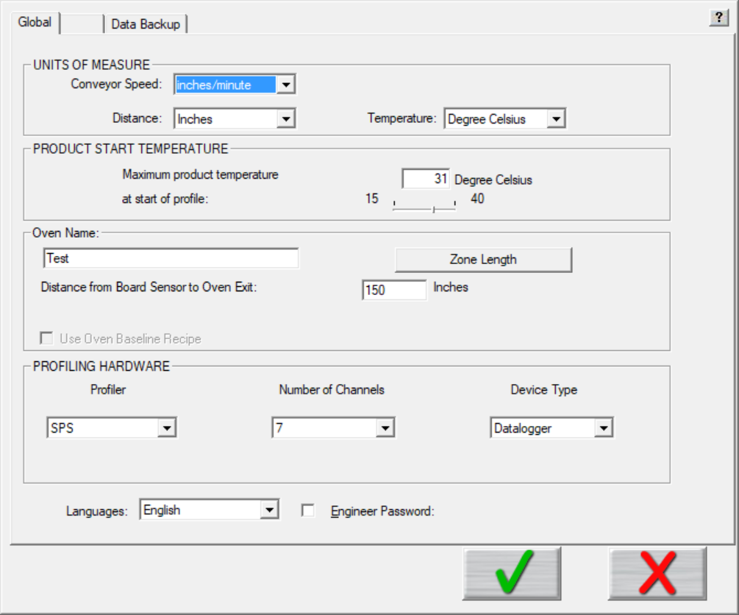

Figure 5: Preferences – Global Tab

**Units of Measure** – There are four drop down menus to choose units for *Conveyor Speed, Distance, and Temperature.*  Auto Focus users enter the units for weight.

**Product Start Temperature** – The software cannot accurately analyze a profile while a board is too hot. Before it can begin, the temperature of all thermocouples connected between the product and the profiler must be below the value you specify here with the slider bar. Profiling automatically starts when the Air TC temperature drops to less than 2° C above the product start temperature.

**Oven Name –** Enter a name for your oven, and click the oven Zone Length button to enter the minimum and maximum zone temperatures, and as needed, the length of the zones.

**Profiling Hardware** – Specify the model of your profiler, the number of channels (7, 9, or 12), and, if using the SPS Smart Profiler, SlimKIC 2000, X5, or the KIC Explorer, specify the data transmission mode (Datalogger or Transmitter).

**Languages –** Select the language (English, Spanish, German, Traditional Chinese, Simplified Chinese, or Japanese) you prefer to see displayed in the software. A restart of software is required after change of language.

**Engineer Password** – By checking this and entering a password you can control access to certain menus in the software. See [Password Protection](#_Password_protection)section of this manual for details.

### Define Your Oven

|  |  |
| --- | --- |
| 1. On the **Global Preferences** screen **Global** tab, type a new, unique name in the **Oven Name** field. | Figure 6: Enter Oven Name - Global Tab |
| 1. Click the **Zone Length** button. |
| The Verify the Length of Each Zone and the Minimum and Maximum Setpoint Temperatures screen. See Figure 7. | Figure 7: Verify Zone Length | |
| 1. In the **Number of Zones** field, type in the quantity for the oven.   **Note**: For best results only define and enter heated zones. |
| The screen populates with numbered zones and default length and temperature values.  Description: C:\Users\dklueck\Desktop\Autopopulate zonesTemps.png | | |
| 1. Change the default values as needed. 2. Click the green check button Description: \\RND\RND_Service\For DaveK\RPI\RPI Graphics\RPI Art File\bt-NAVint_Check.bmp to save the settings and return to the **Global Preferences** screen. | | |

## KIC Vision2 Tab

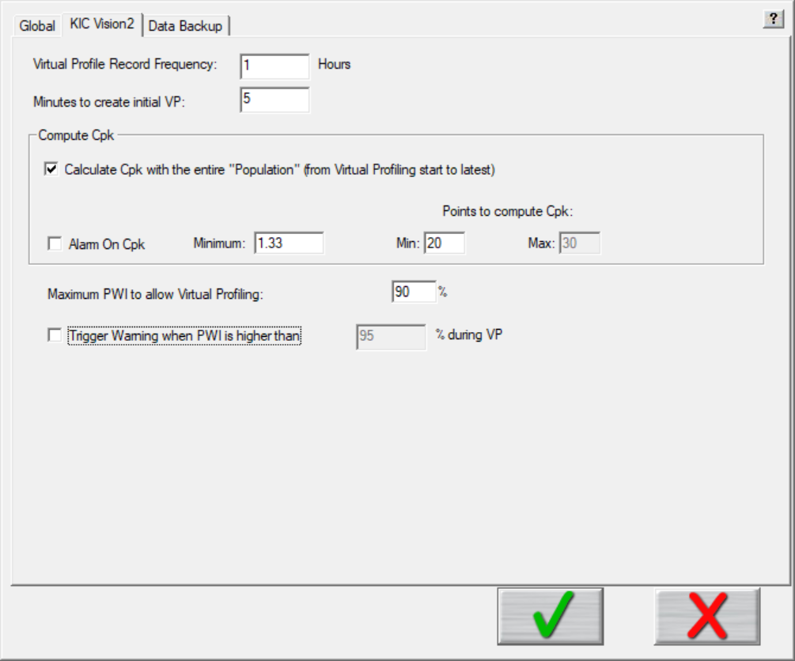

Figure 8: Global Preferences – KIC Vision2 Tab

Settings on the *KIC Vision2* tab let you:

* Specify time intervals for the software to generate Virtual Profiles.
* Enter parameters for computing the Process Capability Index (Cpk).
* Set operating limits related to the Process Window Index (PWI).

### Specifying VP generation

* **Virtual Profile Record Frequency** – Enter the time between each automatic profile. Limits: 1-24 hours.
* **Minutes to Create Initial VP** - Enter the amount of time after the Virtual Profile is started in which the first automatic profile is collected. Limits: 2-60 mins.

**Process Capability Index** (Cpk) gives a continuous indication of how current production is keeping within specifications and will indicate if the process is drifting towards a condition where defective product may be produced. It is a measure of where the process spread falls within the Process Window. By monitoring this and alarming when it becomes too low, you can proactively address issues in the process before a single defect occurs.

### Specifying Cpk Computation Values

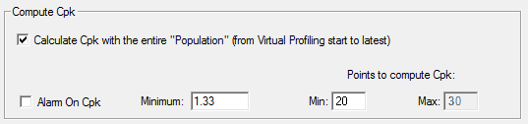

**Calculate Cpk with the entire “Population” (from Virtual Profiling start to latest) –** When selected, the software will calculate Cpk across an entire production batch once the specified minimum points to compute Cpk has been exceeded.

**Alarm on Cpk –** Enable or disable the Cpk alarm that can accompany the *Optional* SPC charts that the software can display when running Virtual Profiling. If the Cpk drops below the defined value, the software can activate an onscreen, or *Optional* hardware alarm. (Default = 1.33.)

**Minimum –** When Alarm on Cpk is enabled, this value determines the lower threshold for the Cpk alarm. If the Cpk value drops below this minimum, the software activates a software and/or hardware alarm. (Default = 1.33.)

**Points to Compute Cpk**

* **Minimum –** Specify the minimum number of data points needed for the software to begin calculating Cpk.
* **Maximum –** Enter the maximum number of data points to calculate Cpk. The Cpk value will be calculated over a rolling window of data, only using up to the maximum data points at any given time.

**Maximum PWI to enable Virtual Profiling –** This percentage value determines the maximum PWI allowable in order for any given profile to qualify as a Virtual Profile baseline. If the PWI for a profile is lower than this value, it can be used as a Virtual Profile baseline. By default this value is 90%. Profiles that exceed this value cannot be used as a Virtual Profile baseline.

**Trigger Warning when PWI is higher than** – Enabling this feature allows you to display a Warning dialog box on the screen when the PWI exceeds the user defined PWI percentage.

### How the Software Calculates Cpk

Cpk = ⏐ – nearest spec limit⏐ ÷ 3

❍ = Mean of the data points

⬧ = Standard deviation of the data points calculated for a whole population

 

= √(X2 - (X)2) ÷ N2

  Number of items in a population, process, or lot.

X = Set or group of data, observations, or measurements

Figure 9: How the software calculates Cpk

Values used for the spec limits and the data are translated in terms of the Process Window Index.

Here is a simple example. Let us set the Points to Compute Cpk to five, and the five PWI values are as follows: 68%, 88%, 70%, 64%, and 50%.

Mean = (68 + 88 + 70 + 64 + 50) ÷ 5

= 68

StdDev = √ ((5 • (682 + 882 + 702 + 642 + 502)) – (68 + 88 + 70 + 64 + 50)2) ÷ 52

= √ (117670 – 115600) ÷ 25

= √ 82.8

= 9.10

By definition, the overall PWI is always positive and the limit is always 100%.

Cpk = ⏐68 – 100⏐ ÷ (3 • 9.10)

= 32 ÷ 27.31

= 1.17

Therefore, while the worst PWI is 83%, the Cpk is 1.17, which is below the typical target minimum of 1.33. This tells us that the chance that the process drift out of spec is too high and this process should be improved.

Here is five more sample PWIs: 91%, 91%, 92%, 89%, and 90%.

Mean = 90.6.

StdDev = √ (205235 – 205209) ÷ 52

= 1.02

Cpk = ⏐90.6 – 100⏐÷ (3 • 1.02)

= 3.07

Even though every PWI in the second list is considerably higher/worse than the worst PWI in the first list, the Cpk is a very good 3.07. Such a high Cpk indicates that there is very little chance this process will drift out of spec. The reason the second process is better than the first is because the second process has very little variation in it.



## Data Backup Tab

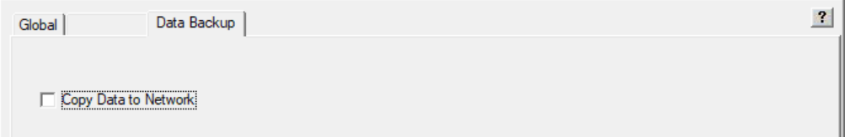

### Copy Data to the Network

The *Copy to Network* tool lets you store all software files and data to a network location for backup or archival purposes. When you click the check box, the tool software launches, and an icon appears in the system tray area. Right click, and then choose *Settings* to configure the *CopyToNetwork* settings.

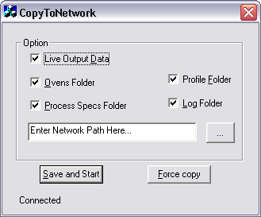

Figure 11: CopyToNetwork software tool screen

Select the folders and/or data to be copied and then enter or browse to the network location. You must enter a valid network path. Click the Save and Start button to begin copying the selected files and folders to selected network location.

The software will prompt you to either, copy all the data now or save the settings without copying the data.

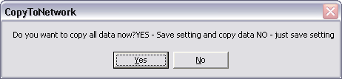

Figure 12: CopyToNetwork message

**Yes** – The selected data is copied to the selected network location and the settings are saved.

**No**- The settings are saved, but no data is copied.

**Notes**:

* If the network location is not available, is an invalid path, or the network is disconnected the software will temporarily write the selected data to the C:\software root directory\\_Data\_Backup\_ folder until the network path or connection has been reestablished.
* The CopyToNetwork tool launches automatically as long as the Copy Data to Network option is checked in the Global Preferences tab.
* Whenever any selected folder is updated with new/modified information, the new information is automatically backed up to the network location without any further user interaction.

# bt-NAV_Process-menuDefine/Edit Process Window

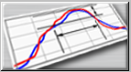

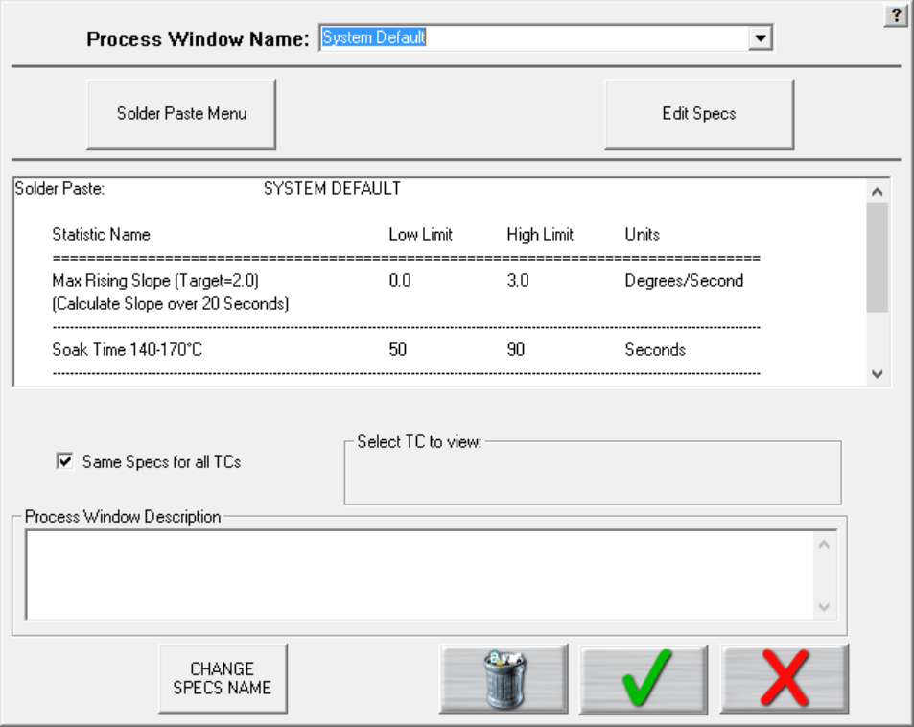

Deselect this check box to assign separate specs for each thermocouple used. See details below.

Figure 13: Process Window Setup

To create a Process Window, follow these steps:

* Choose a solder paste from the Solder Paste Menu.
* Edit the specs if necessary.
* Enter a name the Process Window
* Save the Process Window

**Process window name** – Name of the Process Window file that includes the statistics chosen and limits for those statistics, along with whatever text appears in the Description field.

**Solder Paste Menu** – A read only library list of numerous solder pastes along with the statistics and limits suggested by the paste mfg., also included is a user-defined option in the list which allows you to create a spec. of your own. See below for additional details.

**Edit Specs** – Screen allowing you to edit or choose statistics and limits for a chosen solder paste or define your own specs.

**Read only text box** – Shows the paste name, statistics name, and limits for a Process Window chosen, edited, or saved by you. To edit select the *Edit Specs* button.

**Same specs for all TCs** – By deselecting this checkbox, you can assign separate specifications for each individual thermocouple you are using. This option would be used if you had component specific specifications that differ from the general solder paste specs. Another use for this would be if you wanted to monitor the actual board temperature as well as component temps. You would then only select the statistics for that TC that are relevant. If you wish to use the same specifications for all thermocouples, put a check mark in the box.

**Select TC to view** – This dialog box will appear only if the *Same Specs for all TCs* checkbox is deselected. By clicking on the dropdown menu, you can view the specifications that have been defined for that number thermocouple. If a description was included, it will be displayed next to Label.

**Process Window Description** – Field allowing for freehand notes for a particular Process Window.

**Change Specs Name** – Opens an external application allowing you to customize the name of any individual statistic. (See [Change Specs Name](#_Change_Specs_Name) for additional details).

## Solder Paste Menu



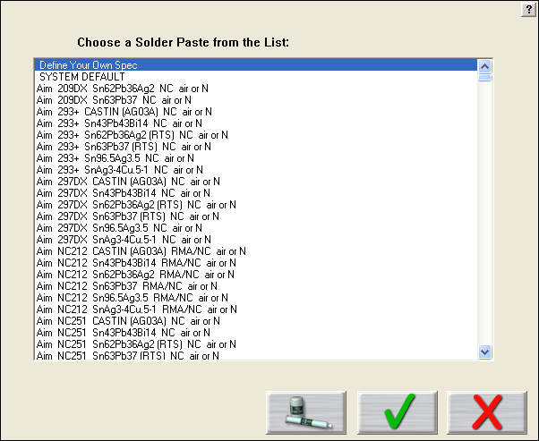

Figure 14: Solder Paste Menu

**Solder Paste Menu** - Once you have clicked on *the Solder Paste Menu* you will have a list of pastes to choose from. Use the scroll bar on the right to find your paste, and then click on the paste in the list. See Figure 14.

* Clicking the **green check** will accept that paste and load its specs. The software first presents disclaimer information. When you click the green check, a new screen presents an opportunity to fine tune the solder paste specifications. When you click the green check on this screen, you return to the Process Window Setup screen. Clicking the green check on this screen saves the named process and associated solder paste specs.
* Clicking the picture of the **paste jar and tube** will give you technical support information for the solder paste manufacturer that you chose.
* Clicking the red **X** will cancel your selection and return you to the Process Window screen without making any changes.

**Note**: Updates to the solder paste list occur on a regular basis. Check for new additions at www.kicthermal.com.

## Edit Specs



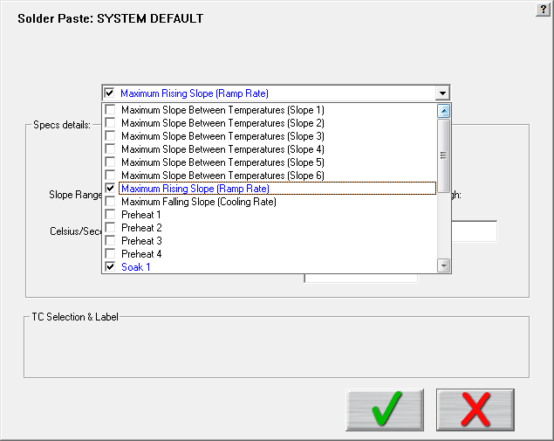

Figure 15: Process Window Edit Specs

The Process Window name appears at the top of the screen. See Figure 15.

There is a single drop down list at the top that contains all of the available specifications that can be applied to your Process Window. These specifications are specific limits or a group of limits that define the overall Process Window for your product. These specifications include Slope, Preheat, Soak, Peak temperatures, and Time above temperatures.

**Specs details** – The Spec details coincide with the selected specification. For each specification selected, enter the temperature, and time limits. These limits are usually dictated by the solder paste used. The software uses the limits to measure the profile PWI.

**Caution**: Changes made within this screen will have a direct effect on the profile PWI value.

Once you have completed all spec modifications you can click on the **green check “DONE”** button and your changes will be applied. Clicking on the **red X “CANCEL”** button will cancel your changes and exit.

### Specify Different Specs for Individual TCs

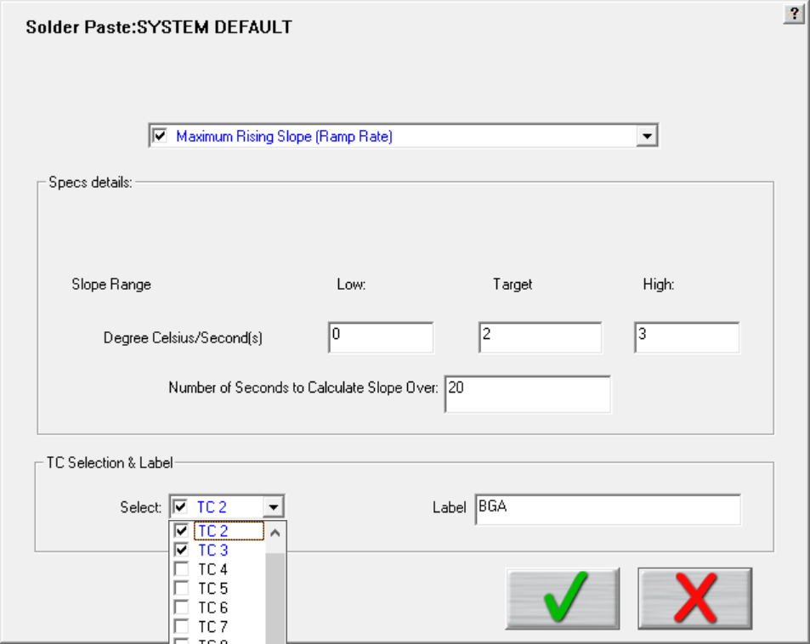

This panel is available when *Separate Specs* for each TC is enabled.

Figure 16: Edit Specs screen with TC Selection & Label panel displayed

### TC Selection & Label

If you deselected the **Same Specs for all TCs** option on the [Process Window Setup](#_Define/Edit_Process_Window) screen, the Edit Specs screen will display an additional TC Selection & Label. See Figure 16.

**Select** - Use the Select drop-down menu to select the TC whose specifications you wish to view/edit. The Spec Details for the selected TC appear.

**TC label –** This area will allow you to type in a description or label to identify that particular TC. If left blank, the TCs will simply be identified as TC2, TC3, etc.

Note: **When using separate specs, the Edit Specs screen is the only place where you can select or deselect which TCs will be used for a profile.**

Once you have completed all edits of the specs, click the green check button and your changes will be applied. Clicking the red X(Cancel) button will cancel your changes and exit.

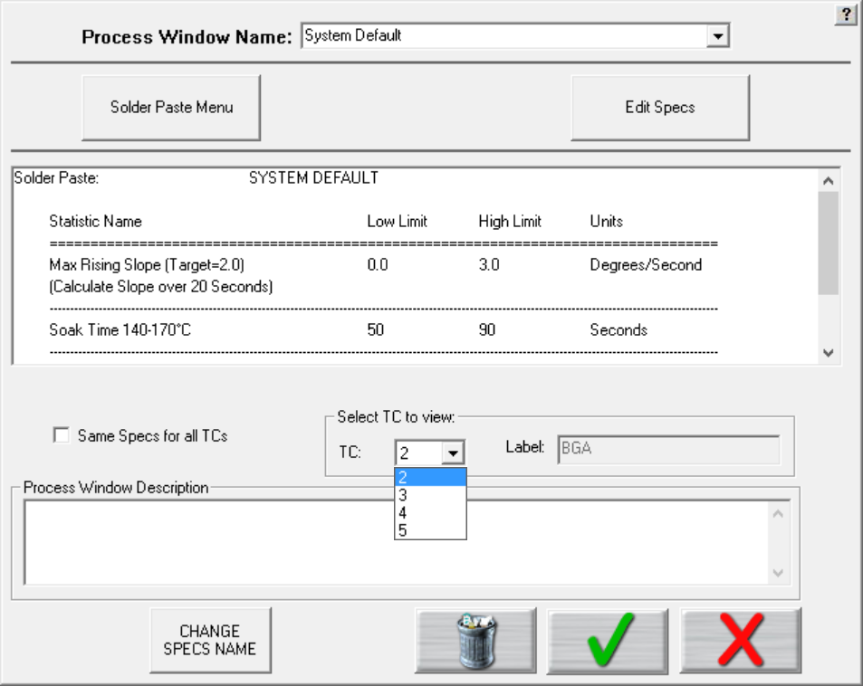

Figure 17: Process Window Select TC to View

**Select TC to view** – Drop-down menu containing the TCs that have already been defined. (Previous step). See Figure 17.

### Change Specs Name

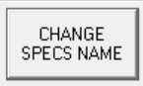

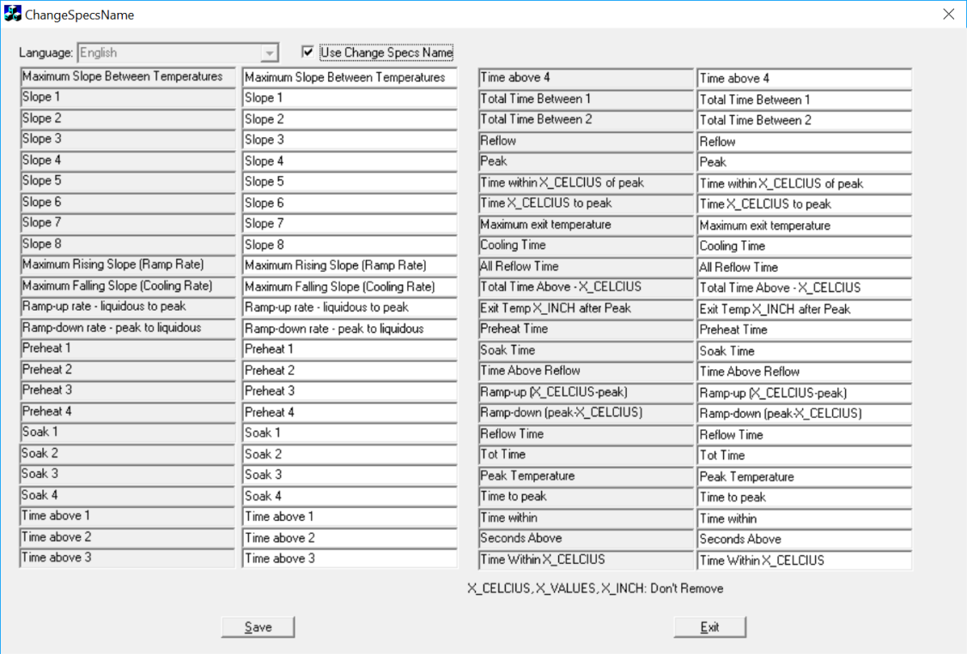

If you wish to rename the label for a particular statistic, start by clicking the *Change Specs Name* button, which opens a separate window. Put a check mark in the checkbox at the top of the screen to enable the change function. Next, locate the desired specification in the greyed out columns, and type in the new name in the corresponding editable column. Click the Save, then Exit to close the window and return to the Process Window screen.

## Save Process Window

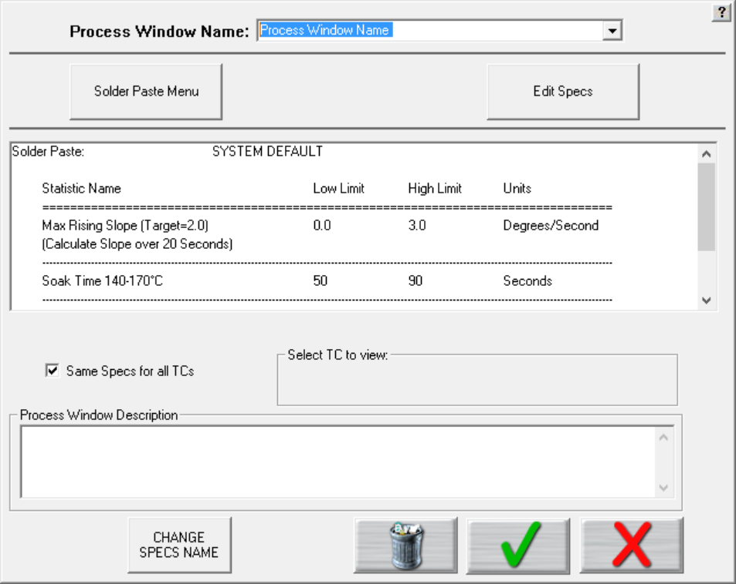

Figure 18: Save Process Window

**To save** - Click the green check button. A dialog box will appear asking if you want to add this Process Window to your current list of Process Windows. See Figure 18 and Figure 19.

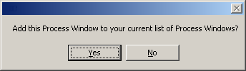

Figure 19: Add Process Window Prompt

Clicking **Yes** will save it and exit to the main screen. You can click **No** and then click the red X “Cancel button” to exit without accepting or saving any changes.

## Import Legacy Process Windows

You can import process windows that you’ve created in KIC 2000 software into the automatic system software and use them in your current production.

|  |  |
| --- | --- |
| 1. Open the KIC 2000 main product folder. | C:\Users\dklueck\Desktop\KIC 2000 folder.jpg |
| 1. Open the KIC 2000 **Process Specs** folder: | C:\Users\dklueck\Desktop\process specs folder.jpg |
| 1. Copy the files that you want to run in the automatic system. | C:\Users\dklueck\Desktop\KIC 2000 files selected.jpg |
| 1. Open the C:\software root folder\ProcessSpecs folder and paste in the copied files. 2. Run the automatic system software. Access the Process Window screen and the newly copied files will be displayed. | C:\Users\dklueck\Desktop\Process Window pull downShortened.jpg |

# Description: C:\Users\dklueck\Desktop\bt-NAV_HW-status-X5-9ch.bmpHardware Status Screen

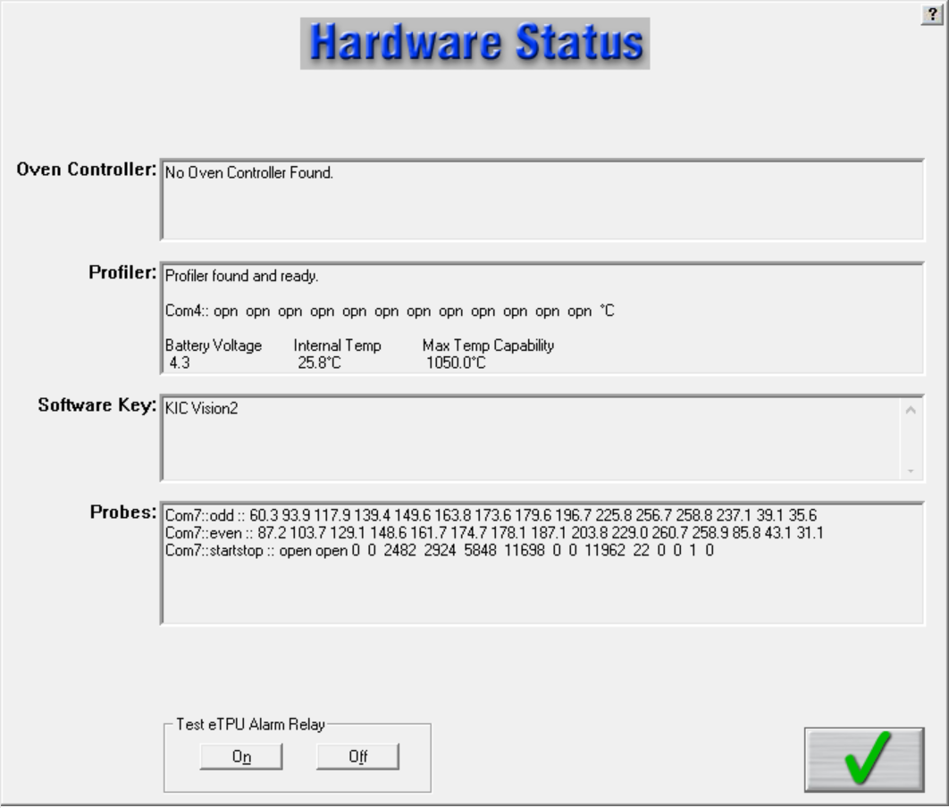

Figure 20: Hardware Status Screen

**Oven Controller –** When connected to an oven that is capable of communicating with the software, the software will display oven status and display the oven controller software name.

**Profiler –** Shows the status of the profiler unit, including the following information:

* Profiler communication status.
* COM port – when connected.
* Temperature display – for all connected thermocouples.
* Battery Voltage.
* Internal Temperature (of the profiler).
* Maximum Temperature Capability – This value determines the maximum temperature that the profiler can read.

**Software Key –**. Displays all of the features currently programmed on the USB Dongle key.

**Probes –**The current live temperatures for the probes are displayed. A third line displays hardware information in regards to the Board Sensor, and Conveyor Speed Encoder.

**Note**: If you do not see any data displayed in this field, then the software is not communicating properly with the eTPU hardware.

**Test eTPU Alarm Relay** – Use this button to test the *optional Alarm Relay* function of the software. The Alarm Relay hardware must be properly connected. Use this button to manually disable the alarm, should it stay active after Virtual Profiling is not running. The button appears as long as the software is detecting the eTPU device.

**Tip**: The Alarm Relay is not energized until the Virtual Profile is running and the VP goes out of spec. To learn more about this see the Alarm Relay chapter.

# bt-NAV_Run-profileRun a Profile

The *Run a Profile* button will guide you through a series of screens. Use the **Back** and **Next** arrow buttons at the bottom to move through the screens in the process, which will end with a completed and graphed profile. The **Cancel** button returns you to the main menu.

**Note:** If you have already profiled your product using the software, you can save time and go directly to the Profile Explorer, start a Virtual Profile, or load the most recent profile for your product, then use the prediction capabilities to improve the profile PWI and generate new oven settings.

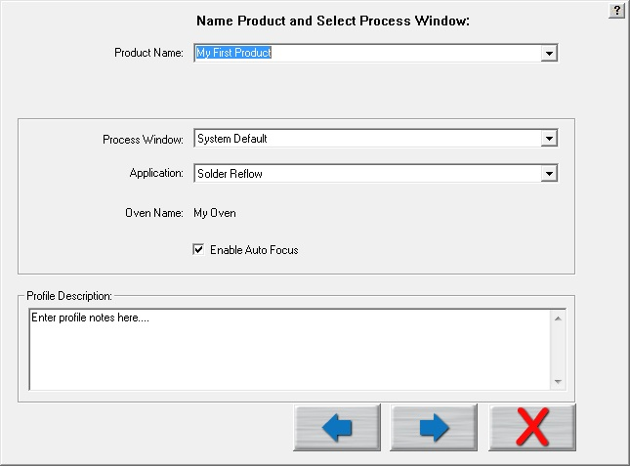

**Back**

**Next**

**Cancel**

Figure 21: Run a Profile Screen #1

**Product Name** – Enter in a unique product name (long file names are acceptable) or choose an existing product name from the drop down list.

**Process Window** – Choose a *Process Window* from the drop down list. These Process Windows are created in the Define/Edit Process Window screen that is accessed from the main screen.

**Application** – Select your Application type from the list. The software will function depending on the selected Application type. Some variables that might change depending on the selected Application type are: *data-sample rate, profile temperature trigger values, and specific artwork*.

**Oven Name:**

* The oven will have information about the number of zones saved with it as well as other zone information.
* If you are running the software on an oven controller computer that is communicating with the automatic system software, the Entering Oven Recipe screen shown on the next few pages is skipped because the software already has the recipe information from the oven controller.

**Profile description** – Allows for freehand typing of any notes you may want to include with this profile. These notes can be changed later from the Profile Explorer.

## Specify Oven Characteristics

To ensure accurate profile data, you may need to enter specific information into the software about the oven(s) you intend to use--information that changes the default values used by the software’spredictive algorithms. These default values are stored in an oven *initialization* file that the software creates when you first enter the name of a new oven. The software adds the extension .kiccfg to the name you entered and stores the file in this location:

C:\Software Root Directory\Ovens

Unless you specify otherwise, the software works with the following initialization file default assumptions:

* The zones are uniform and consecutive with no large gaps between them.
* The minimum temperature for all zones is 70° C.
* The maximum temperature for all zones is 350° C
* Default setpoint values start at 100° C and increases at 5° intervals at each zone.

In the Global Preferences screen, the software lets you change the default values of a configuration file to accurately reflect your equipment. You will likely need to set some values, such as the length of oven heating zones, and min/max temperature limits only once -when you first set up the oven. Others, such as temperature setpoints and conveyor speed values that make up an oven recipe, you may change frequently to match to new products.

### Specify An Oven Recipe

|  |  |  |
| --- | --- | --- |
| 1. In the *Enter Oven Setpoints and Conveyor Speed* screen (Figure 22), type in the current temperature values for the each of the oven zones.   **Note**: This screen does not appear when the softwareis communicating with an oven controller. | Description: C:\Users\dklueck\Desktop\Enter Oven Setpoints and Conveyor Speed1.png  Figure 22: Run a Profile screen #2 | |
| 1. If the bottom of the zones are to have different setpoint values than the top, deselect the **Top and Bottom Setpoint are the same** checkbox.   The bottom row of fields becomes editable (white). | Description: Description: C:\Users\dklueck\Desktop\New oven setup art\Top and bottom zones.png | |
| 1. Enter new temperature values in the bottom row fields. 2. Type in a value in the **Conveyor Speed** field.   Description: Description: C:\Users\dklueck\Desktop\New oven setup art\conveyor speed field.png | | |
| 1. Click the next button to advance to the thermocouple attachment phase of running a profile. | | |
| **Note**: If you want to check the current settings, use the **Zone Length** button to display the *Verify the Length of Each Zone* and the Minimum and Maximum Setpoint Temperatures screen. | | Description: Description: C:\Users\dklueck\Desktop\New oven setup art\zone length button.png |

## Attach Thermocouples

Thermocouples (TCs), attached to solder joints or other important sites on the board, directly measure the temperature at the point that the TC bead is in contact with the PCB. The TC measurements are collected by the profiler and the software to create thermal profiles.

Two methods are typically used to attach TCs—*aluminum tape* and *high temperature solder*. Both methods are discussed below.

The system works with two kinds of TCs—*standard* TCs and the *Air TC*. Standard TCs record the temperature data for various sites on the board. The air TC gets specific positioning because its temperature *triggers the start of the profile* data processing, aids with TC shifting, and improves the prediction capabilities of the software.

### Attach the Air TC

There are two important considerations regarding the Air TC:

|  |  |
| --- | --- |
| * It must be attached at the leading edge of the board, extending one inch (25mm) in front of the leading edge of the board. * It MUST be plugged into **channel 1** on the profiler.  1. **Click the Next button.** |  |

### Attach Standard TCs

|  |  |
| --- | --- |
| Attach the standard TCs at selected sites on the board, and plug them into the remaining connectors on the profiler. Order is not important, unless you plan on labeling where each TC is attached.  When selecting a position for the standard TCs, you want to measure points on the product that represent the mass-range of the product. Select at least one position that is a high mass (large component) area of the board and at least one position that is a low mass (small component) area of the board. If you can develop an acceptable profile for the low and high mass areas of the board, you can process the other areas of the board within the same parameters.   1. **Click the Next button.** |  |

## Attach Thermocouples To Semiconductor Wafers

|  |  |
| --- | --- |
| Attach the Air TC:  1. It must be attached at the leading edge of the wafer, extending one inch (25mm) in front of the leading edge of the wafer. 2. It MUST be plugged into **channel 1** on the profiler. |  |
| Attach Standard TCs: Attach the standard TCs at selected sites on the wafer, and plug them into the remaining connectors on the profiler. Order is not important, unless you plan on labeling where each TC is attached. |  |

## Select Thermocouples to Start a Profile

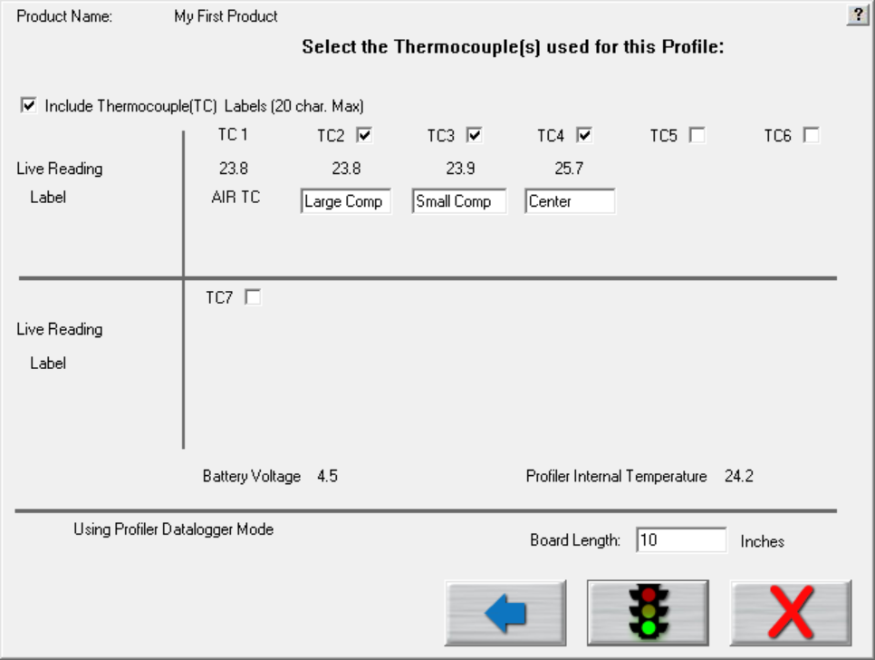

Figure 23: Run a Profile Screen – Select TCs

**Include thermocouple (TC) labels (20 char. max)** – Checking this will display a field below each TC that is selected. Up to 20 characters can be used to describe the placement or description of the TC.

**TC Checkboxes** – Place a check next to each TC channel that is going to be used for this profile. TC number 1 is always used for the AIR TC. You must use at least one other TC as well.

* Turn on theprofiler*.*
* Click the green traffic light button to start the profile

**Live readings** – When the profiler is on and plugged directly to either the download cable for datalogging or the receiver/Base Station, you will see live temperature updates for the TCs plugged into the profiler. The TC checkbox must be selected for each TC you are using in order to view the temperature readings.

**Battery voltage** –Displays the live readings of the profiler battery voltage. The software will recognize if your battery voltage is too low and will not allow you to start a profile until you have batteries with enough voltage to complete the profile.

**Internal temperature** – Displays the internal temperature of the profiler. If the temperature is too high to complete the profile and stay under the maximum rating for the unit, it will not allow you to start the profile. You must wait until the profiler is cool enough. The software will let you know what temperature you will have to cool below.

**Board Length** – Enter the length of the board to be profiled. When using the *Auto-Focus* option, this value will automatically be filled in based on previous Board Length entry.

## Start The Profile

**Note:** Make sure your profiler is powered on and ready to operate.

Depending on the settings in the profiler and in the software, you may have to initialize the profiler. (The software lets you know when this is necessary.) To initialize your profiler, attach the cable from the receiver to the back of the SlimKIC 2000 or connect the communication cable directly to the X5, K2, or KIC Explorer. Click **OK** when the software displays the message that the initialization was successful.



Select this button to start a profile.

Once the oven has stabilized and you are ready to load the profiler and profile board into the oven select the green traffic light button.

|  |  |
| --- | --- |
| The software will ask if all the oven control thermocouples are within 2 degrees of the setpoint temperature values. See Figure 24.  **Note:** This dialog box will not appear if the software is communicating with the oven controller. The oven controller will send the zone temperature data directly to the automatic software. | Figure 24 |
| If the control thermocouples are NOT within 2 degrees of the setpoints, click No, then reference Appendix B. | |

|  |  |
| --- | --- |
| **If you answer yes**, the software will display a prompt telling you that the next board to pass under the board sensor must be the board being profiled. If no board sensor is used, this screen is skipped. You acknowledge the prompt, by selecting **OK**. See Figure 25. | Figure 25 |
| Next, the software will prompt you to put the profiler and profile board into the oven. Then choose the forward button. See Figure 26.  In order for the board sensor to properly calculate the length of the profile board, make sure the profiler is at least 8” behind the profile board. For profiling and Virtual Profile Verification profiling, the software will ignore any boards including the profiler that fall within 24” of the trailing edge of the profile board. | Figure 26: Run a Profile screen #7 – Insert Profiler/Product |

**IMPORTANT NOTE**: All profilers have a maximum operating temperature that, to avoid damage, should never be exceeded. See the product datasheet for temperature tolerance information:

|  |  |
| --- | --- |
| Profiler model | Maximum operating temperature |
| SlimKIC 2000 | 105°C/220°F |
| KIC Explorer | 85°C/185°F |
| X5 | 85°C/185°F |
| K2 | 85°C/185°F |
| SPS Smart Profiler | 85°C/185°F |

### Trailing Wire Profiling

You can also use the SPS, X5, K2, KIC Explorer, or SlimKIC 2000 profiler with elongated thermocouples or a thermocouple extension long enough to pass through the process. This is especially useful for low clearance processes or higher temperature processes that would normally cause the profiler to overheat during use.

If you have a datalogger model and plan to keep the profiler connected during the profile, ignore the message to unplug the download cable from the profiler. At the end of the profile, be sure and leave the product TCs connected long enough to achieve the profile-stop trigger value, 110°C, otherwise the profile will not complete. Leave the product TCs connected until the download has completed and the software asks you to turn off the profiler.

Using long thermocouples or thermocouple extensions will have an effect on the profiler temperature accuracy. In order to compensate for the length of thermocouple or thermocouple extension wire, recalibrate the profiler using the same length and gauge TC wires that are to be trailed through the oven or process.

If the profiler remains connected to the communication cable while profiling, the live profile will be plotted on the graph.

## Live Profile Graph

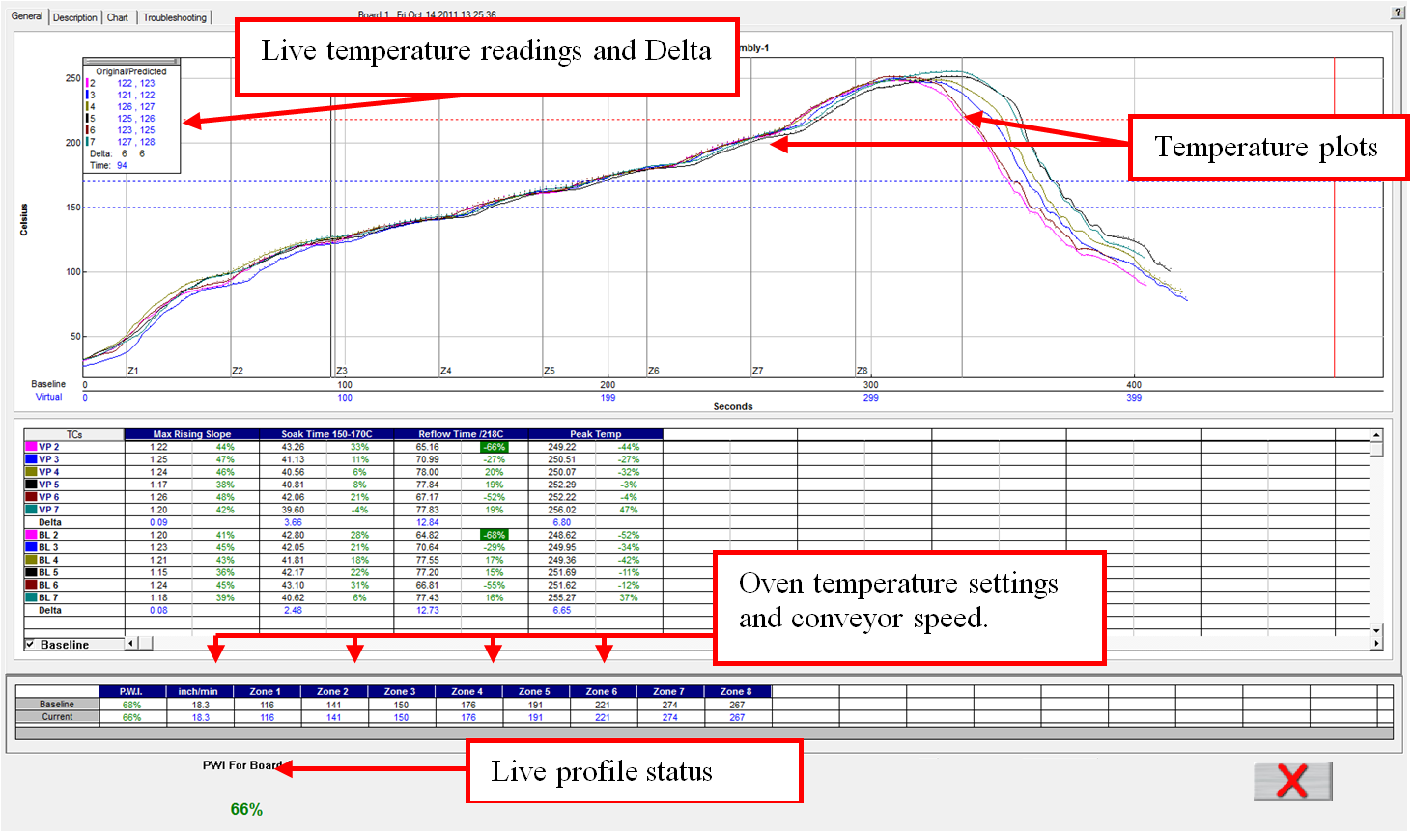

Figure 27: Live Profile Graph Display

The Live graph screen shows the real-time plot of the product as it travels through the oven. See Figure 27. This will only appear for the wireless models. During the live profile, all of the tabs on the screen are deactivated and are inaccessible to you. The only action that you can take at this point (besides waiting for the profile to complete) is to cancel the profile by clicking on the red X button. This will bring you back to the main menu.

The bottom left area of the screen will show you the status of the profile.

1. Waiting for the Air TC to exceed the start trigger temperature
2. Profile started- Waiting for the Air TC to exceed the midpoint trigger temperature
3. Profile will stop when all thermocouples drop below 110 Celsius
4. Profiler currently retransmitting.
5. Profiler retransmission successful.

**During the live profile** (Wireless models only)**:**

* The live profile is plotted on the graph.
* The current temperatures for each thermocouple and the Delta between them are displayed in a small window in the upper-left hand corner of the profile graph. The elapsed time is also displayed..
* The current oven temperature setpoints and conveyor speed for this profile appear beneath the Statistics table.

### Profiler Temperature Triggers

The software uses temperature triggers for the profilers to determine when the profile is started, and when it ends. The use of temperature triggers makes it so that you do not have to worry about starting the profile at a specific point or time. Instead, the profile is started at the same temperature and ends at the same point each time you profile, making the profile data collection process consistent.

|  |  |  |  |  |  |  |  |
| --- | --- | --- | --- | --- | --- | --- | --- |
| **Solder Reflow** | |  | **Cure** | |  | **Semiconductor** | |
| Profile start | 33ºC/92ºF |  | Profile start | 33ºC/92ºF |  | Profile start | 33ºC/92ºF |
| Mid trigger | 130ºC/266ºF |  | Mid trigger | 100ºC/212ºF |  | Mid trigger | 130ºC/266ºF |
| Profile end | 110ºC/230ºF |  | Profile end | 80ºC/176ºF |  | Profile end | 110ºC/230ºF |

Table 1: Default temperature trigger values for various Application types

The default trigger values should be fine for most processes. The Profile start-trigger is determined by the Maximum Product Temperature at Start of Profile setting in the Global Preferences screen. The start trigger value is always 2ºC above this setting.

### Change the Profiler Temperature Trigger Settings

To change the profiler temperature trigger settings close the software and then launch the configuration software tool.

**Configuration software tool location:**

C:\SoftwareRootDirectory\ConfigurationProgram.exe

In the User Settings tab enter the new temperature trigger settings for each application type; Reflow, Cure, Semiconductor then select the *Apply*, or *OK* button to implement the changes.

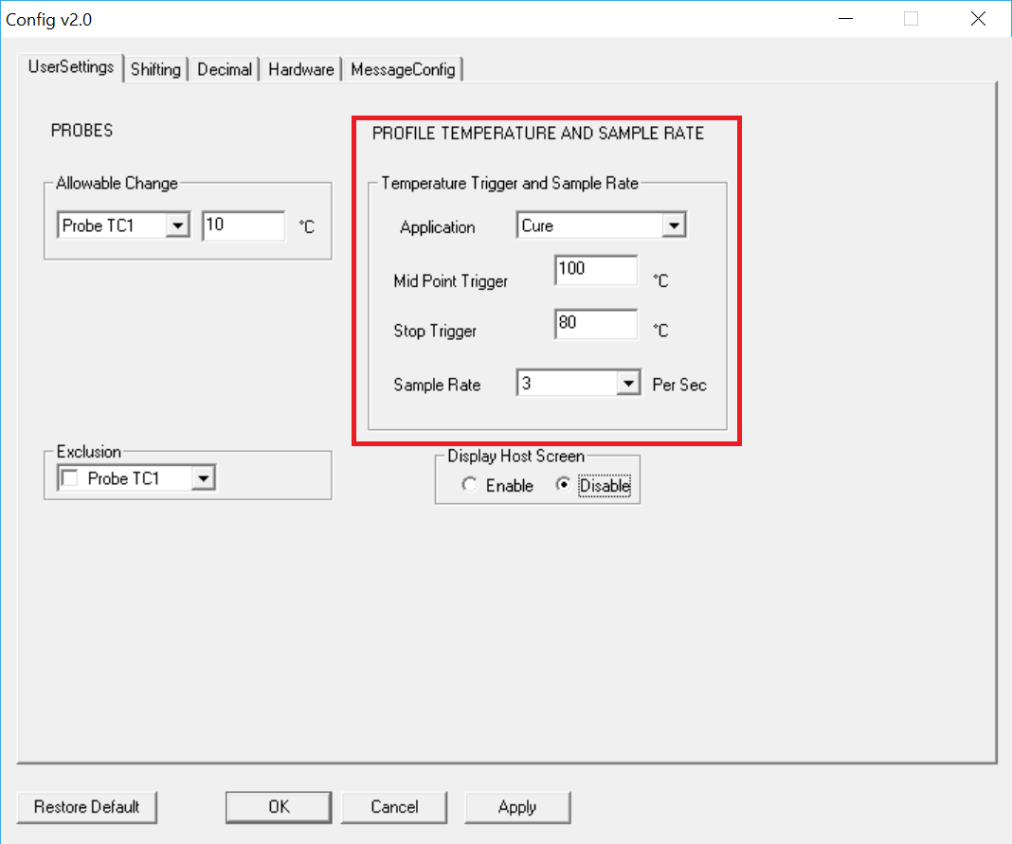

Figure 28: Configuration software tool, changing temperature triggers

### Profile Retransmission

**Note**: Profile retransmission applies to users of profilers with wireless capability.

While the profiler transmits the live profile data to the computer running the software, it simultaneously stores the profile data in its onboard memory.

Once the profiler detects that all of the thermocouples have cooled below the profile-end trigger value, it will begin retransmitting the profile data. When retransmission begins, the profiler will send the profile in data packets. The retransmission status appear at the bottom of the screen. See Figure 29.

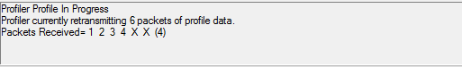

Figure 29: Wireless models profile retransmission

If you have a datalogger version, you must remove the profiler from the oven and thermal shield and then connect the download cable to the profiler. The profile data will automatically begin downloading to the software.

Caution: **The profiler and your product may be hot when exiting the oven. Use gloves if necessary.**

When all of the data packets have been received, the software will display a message asking you to turn the Profiler off, choose OK. *Failing to turn the profiler OFF will drain the battery.*

After the profiler has completed its retransmission, click “OK” and you will be brought to the graph screen, with the profile and statistics displayed for the current profile run.

* If the Air thermocouple was more than 10º C cooler than any other TC, you will get an error message. At this point you must check to see that the Air thermocouple is plugged into the first channel on the profiler and that all the other thermocouples are firmly attached to the product. Then you will have to rerun the profile.
* If the message “Waiting for the board to exit” appears, wait until the “Turn the Profiler off” message appears and then follow any subsequent messages that may appear.

Next, the software will automatically analyze the profile data and presents the profile and statistics.

## View the Profile and Statistics

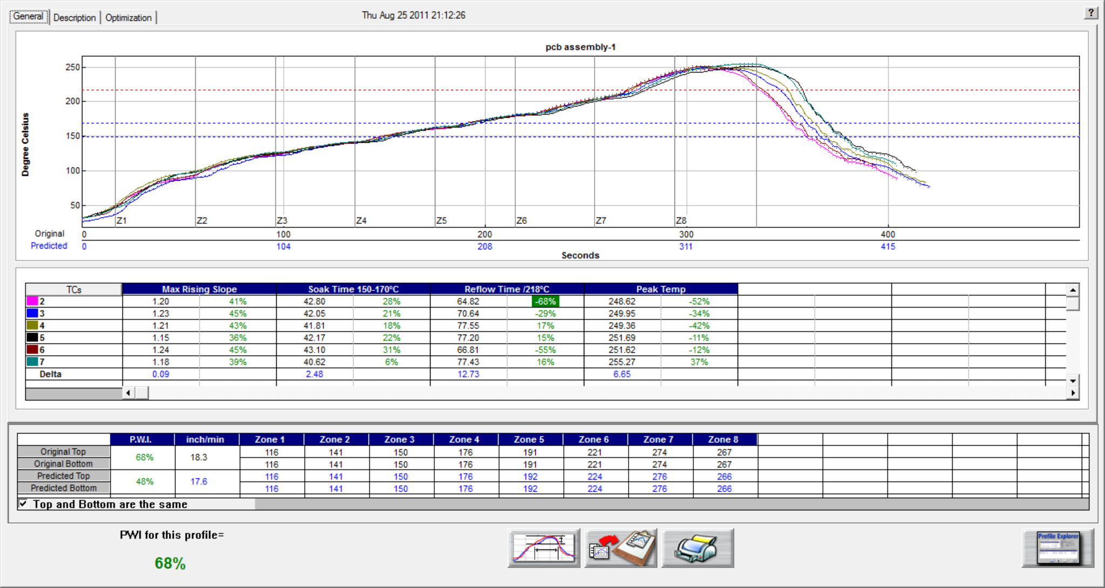

Figure 30: Profile General Tab – Shows graph, statistics, and recipe

### General Tab

The General tab shows the profile graph, profile statistics, current, and predicted recipes. To enlarge the graph portion of the General Tab, simply double click on the graph. To enlarge the statistics portion of this screen, double click on the statistics. See Figure 30.

**Tip**: If you have run a profile that meets the Virtual Profile criteria, then the “Start Virtual Profiling” button will appear once the profile has completed. Click the Start Virtual Profiling button to start Virtual Profiling for this product.

### The Graph Controller

|  |  |
| --- | --- |
| The *Graph Controller* allows you to modify the view of the profile graph. See Figure 31. To open the Graph Controller, left-click on the TC column header in the Statistics table or double left-click, anywhere just outside the profile graph.  **Auto scale –** The Auto Scale feature will automatically adjust the X and Y-axis scales to fit all of the data in the profile graph. When the Auto Scale feature is disabled, you must manually input the minimum and maximum scale settings for the X and Y-axis scale of the profile graph.  **TCs**  The TCs section is a list of the thermocouples used for the profile. In the event that you wish to view the profile without a particular or multiple thermocouples, you can deselect individual thermocouples, or deselect the “All” check box, and choose only the thermocouples you wish to view. The software recalculates the PWI, and updates the profile statistics based on the remaining thermocouples selected. You must select at least one product thermocouple. | Figure 31: Graph Controller |

**Grid –** Enables/disables the view of the X and Y-Axis scales.

**Reference lines –** Enables the view of Reference Lines displayed on the profile graph. These lines represent any temperatures referenced in the selected Process Window.

**Zone lines –** Enables the view for the oven zone lines on the profile graph.

**Predicted TCs only** - Removes the Original profile plot from view, displaying only the prediction profile plot on the graph.

**Zero decimal** – When viewing the Pointer tool, this setting enables or disables the decimal display. When unchecked, the software will display one decimal point.

**Internal temp** – Enables the view of the profiler’s internal temperature profile plot on the graph.

**TCs Line Thickness** – The pull down menu lets you select five different thicknesses for the TC lines drawn on the graph.

**Display Detailed PWI** – With this unchecked, you will only see the “overall” PWI for the profile. It will not display the individual TC PWI values.

**Extra Cooling Slope** – Enabling this feature displays multiple Cooling Slope measurements which are customizable by the user.

### Graph Option Menu

|  |  |
| --- | --- |
| To view the graph option menu, right-click anywhere within the profile graph area. See Figure 32. | Figure 32 |

#### Examine Line

|  |  |
| --- | --- |
| The Examine Line feature displays the temperature for the location of the pointer on the profile graph. See . | b  Figure 33: Examine Line |

Wherever the pointer is moved across the profile, the following data will be displayed:

* The first column is the actual temperature for each TC.
* The second column is the temperature of the predicted profile data – based on set point or belt speed changes.
* The Delta T for both actual and predicted TC data.
* The time during the profile at which the pointer is placed.

#### Automatic Calculation Of Delta T + Delta (Or Range) For All Stats

The software will automatically calculate, and display in the statistical chart, the Delta for both the original and predicted profile data for all TCs for all Statistics. See Figure 33.

This is the range of the highest to the lowest value for any given specification. This information is strictly being displayed and is not factored in to the PWI value and is not used in the *optional* Navigator or Auto-Focus calculations.

#### Move TC Line

|  |  |
| --- | --- |
| The Move TC line feature allows the user to manually move the thermocouple plot on the profile graph. This is used to fine tune the profile or make corrections in the event the software did not properly display the plot. See Figure 34. | Figure 34 |

Select the thermocouple you wish to move and then click and drag the highlighted plot and move it to the desired location on the profile graph. See Figure 35.

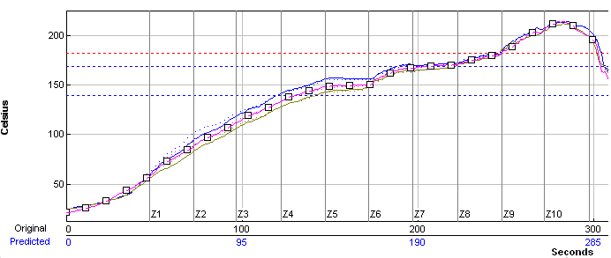

Figure 35: Move TC Line

#### Move Zone Line

|  |  |
| --- | --- |
| The *Move Zone Line* feature allows the user to manually move the zone separation lines on the profile graph. This is used to fine tune the profile or make corrections in the event the software did not properly display the zones. Zone Resize Select to move the first line (zone beginning) or the last line (zone ending) (See Figure 36) and then click and drag it to the desired location on the profile graph. See Figure 37. | Figure 36: Zone Resize |

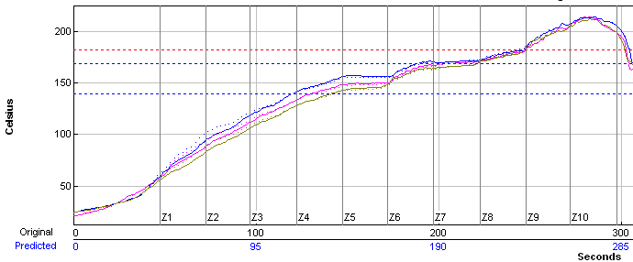

Figure 37: Move Zone Line

#### Reset

|  |  |
| --- | --- |
| The Reset feature will reset the profile and undo any changes you have made to the graph using the Graph Option Menu. Select the TC Line, or Zone Line option. See Figure 38. | Figure 38: Reset |

### Profile Screen Buttons

There are four buttons at the bottom of the profile screen.

|  |  |
| --- | --- |
| bt-NAVint_Proc-menu | **View/Edit Process Window –** Choose this button to either view or edit the process specification(s) for the product used in this profile. |
| bt-NAVint_Copy2Clipbd | **Copy to Clipboard –** Choose this button to copy the profile data to the windows clipboard. You can then paste the data to a different application. |
| bt-NAVint_Print | **Print –** Choose this button to print a copy of the profile that is currently on your screen. |
| bt-NAVint_Check | **Green check button –** When finished viewing or analyzing the profile select this button to either run another profile with this product or return to the software main menu. You return to the Profile Explorer if the profile was opened from there. |

|  |  |
| --- | --- |
| Exit The Graph Screen Upon exiting the graph screen, a message asks you, Do you want to run another profile with this product?  If you select **No**, you return to the main screen or the Profile Explorer if the profile was originally opened from there. | Figure 39 |
| If you select **Yes**, you will need to choose from the Original, or Predicted recipe settings.  **Original –** The same recipe settings used when this profile was originally run.  **Predicted -** The recipe settings as predicted by the Optional *Navigator*, or a standard prediction that you manually input. | Figure 40 |

For both the original and predicted recipe settings, the software will automatically send the selected recipe information to the oven controller. If there is no communication between the software and the Oven controller, the software will display a dialog box showing the recipe information. You must manually enter this recipe information in the oven controller software.

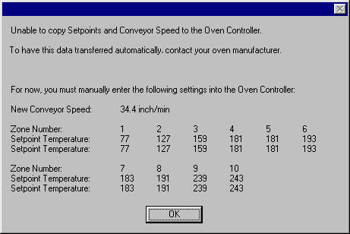

Figure 41

The software will automatically apply the changes to the Run a Profile –Enter Setpoints screen. You will exit to theRun a Profile –Enter Setpoints screen. If you are running on the oven controller PC, and the oven is compatible with the software the oven recipe will automatically be updated.

|  |  |
| --- | --- |
| Saving Changes To The Profile: Any changes to the Description Notes or the Process Window can be saved with the profile. This will permanently update this profile with the changes. Changes to the Process Window saved here only save the changes with the profile. To save the changes to Process Window file see next dialog box. See Figure 42. | Figure 42 |
| Saving Changes To The Process Window: If you have made changes to the Process Window from the Graph screen you can save these changes when you exit the graph screen. The Process Window will permanently have these changes whenever it is used to profile from this point forward. | Figure 43 |

The software will take you to the Edit Process Window screen in order to save the changes that you have made.

The first dialog – “Do you want to run a profile with this product?” will appear each time you exit the graph screen. Click on **No** if you do not wish to profile.

You will be sent back to the Main menu if you had just completed running a profile. If you opened the profile from the Profile Explorer you will be returned to the Profile Explorer. The other two dialogs will only appear if changes are made to the Description notes or Process Window.

#### General Tab Buttons

**Start Virtual Profile –** If your profile meets Virtual Profile criteria, this button will appear. Choose this button to start Virtual Profiling using the displayed profile as a Baseline.

**View/Edit Process Window –** This will allow you to view the Process Window specifications and limits.

Changes made to the Profile and Process Window can be saved when exiting the Graph screen.

**Copy to clipboard –** This button will copy the profile data to the clipboard for use with third-party software such as a spreadsheet application, or SPC software.

**Print –** This button will print the current profile. For more information about printing, see the Printing section of this manual.

**Tip**: If you wish to print a tab besides the General tab, pressing F9 on your keyboard will print the contents of any screen in the software.

**Green Check Button –** Select this button to run another profile or to exit.

### Description Tab

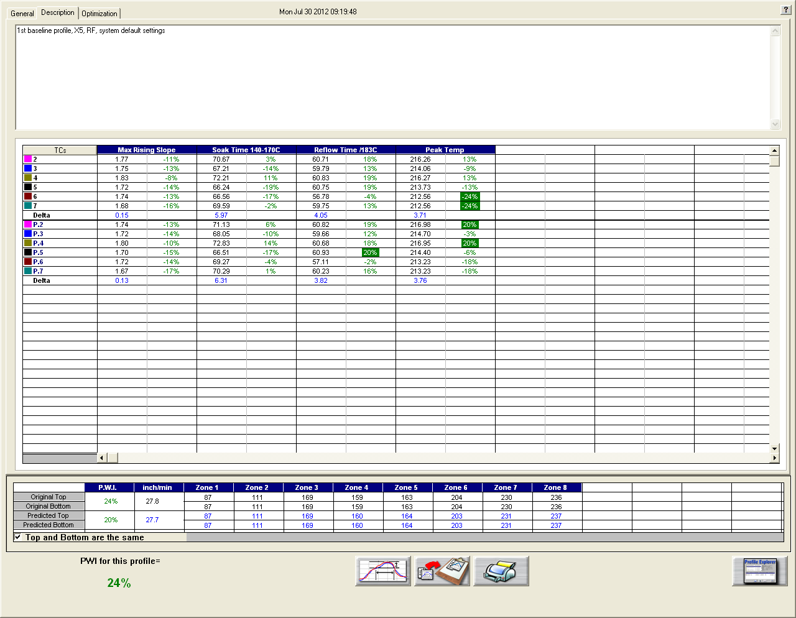

Figure 44: Profile Description Tab – Shows Description notes, statistics, and recipe

The Description tab shows the profile description notes, profile statistics, current and predicted recipes.

#### Description Tab Buttons

**View/Edit Process Window –** This will allow you to view the process window specifications.

**Copy to clipboard –** This button will copy the profile data to the clipboard for use with third-party software such as a spreadsheet application, or SPC software.

**Print –** This button will print the current profile.

**Tip**: If you wish to print a tab besides the General tab, pressing F9 on your keyboard will print the contents of any screen in the software.

**Green Check Button –** Select this button to run another profile or to exit.

## Manual Profile Prediction

The software has manual prediction capabilities. Manual prediction gives you the flexibility to easily predict changes to the oven settings (temperature settings, conveyor speed), and view the results without having to spend the time actually running unnecessary profiles. This feature is very helpful to you, minimizing the time spent fine tuning or developing a thermal profile.

### Predict Changes

To predict changes to the oven settings,

1. Click the zone you wish to change.

In the example below, zone 1 has been selected. See Figure 45.

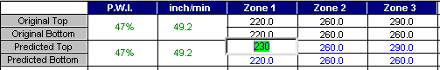

Figure 45: Prediction settings

1. Type the new temperature setting, and then press Enter.

* The manual prediction tool will predict the results of that change, and then automatically update the PWI, predicted Statistics, and the profile graph.
* The new predicted results will be displayed on the graph in a dotted-line format. This format enables you to easily determine the difference between the original and predicted profiles.

## Set Different Top and Bottom Set Point Temperatures

|  |  |
| --- | --- |
| The software will allow you to enter different top and bottom setpoint temperatures prior to running a profile. See Figure 46.  Notice the top of zone 8 is set to 267 and the bottom is set to 257. | Figure 46 Different Top and Bottom Setpoints |

### Profile Graph Display

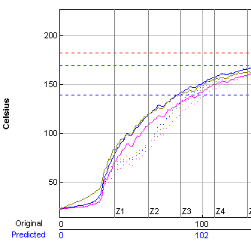

***Predicted*** profile plot (dotted lines)

***Original*** profile plot (solid lines)

Figure 47: Profile Graph Display

The PWI for the profile appears in the bottom left corner of this screen. See Figure 48. If the measured PWI is below 100%, the value will be displayed in a green font. If the measured PWI is 100% or higher, the value will be displayed with a red font. This enables you to easily identify whether the profile is in or out of spec.

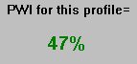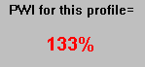

A PWI under 100% is acceptable

A PWI above 100% is unacceptable

Figure 48: Profile PWI

### Exit the Graph Screen

|  |  |
| --- | --- |
| The following message appears whenever a profile is closed: “Do you want to run another profile with this product?” See .  If you select **No**, you will be returned to the main screen or the Profile Explorer if the profile was originally opened from there. | PL 68  Figure 49 |
| If you select **Yes**, you will need to choose from the Original, or Predicted recipe settings. See .  **Original –** The same recipe settings used when this profile was originally run.  **Predicted -** The recipe settings as predicted by standard prediction that you input manually. | PL 69  Figure 50 |

For both the original and predicted recipe settings, the software will automatically send the selected recipe information to the oven controller. If there is no communication between the software and the oven controller, the software will display a dialog box showing the recipe information. You must manually enter this recipe information in the oven controller software. See Figure 51.

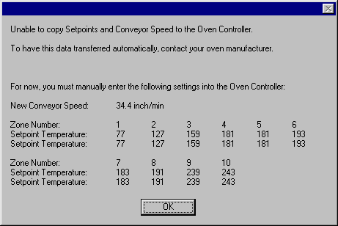

Figure 51: Oven controller communication error

The software will automatically apply the changes to the Run a Profile – Enter Setpoints screen. You will exit to theRun a Profile screen. If you are running on the oven controller PC, and the oven is compatible with the software the oven recipe will automatically be updated.

The first dialog – “Do you want to run a profile with this product?” will appear each time you exit the graph screen. Click **No** if you do not wish to profile.

You return to the main menu if you had just completed running a profile. If you opened the profile from the Profile Explorer, you will return to the Profile Explorer. Two other two dialogs appear if you make changes to the Description notes or Process Window.

|  |  |
| --- | --- |
| Save Changes To The Profile You can save any changes to the Description Notes or the Process Window with the profile. This will permanently update this profile with the changes. Changes to the Process Window saved here only save the changes with the profile. To save the changes to Process Window file see next dialog box |  |
| Save Changes To The Process Window If you have made changes to the Process Window from the Graph screen, you can save these changes when you exit the graph screen. The Process Window is updated and utilize these changes whenever it is selected for profiling from this point forward. |  |

If you select “**Yes**”, the software will take you to the Edit Process Window screen in order to save the changes that you have made.

If your oven is capable of communicating with the software you will see different dialog boxes.

* If you answer yes, a dialog box will appear displaying the amount of time until the oven acknowledges the recipe change request. Select OK. See Figure 52.

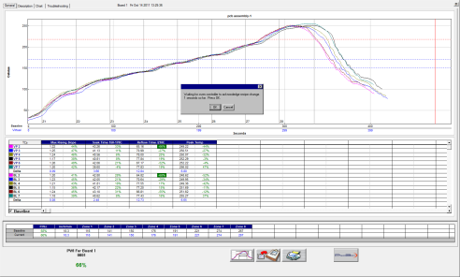 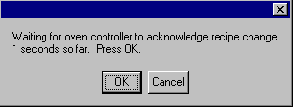

Figure 52: Oven controller acknowledge recipe change request

When the oven has received the new recipe information, a confirmation dialog box will appear. See Figure 53.

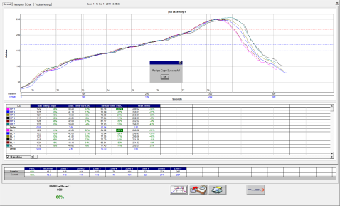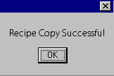

Figure 53: Oven controller recipe change confirmation

**Tip**: Oven controller: If nothing happens within several seconds, check the oven controller software to make sure there are no error messages or errors that will cause the system to hang.

# bt-NAV_Log-bookProfile Explorer

The Profile Explorer is a powerful and simple data file management tool. For each unique product name you use when profiling, the software will create a folder with the same name. See Figure 54. The software saves all the profiles run using that product name in that folder.

This field is only active when running in ***History*** mode.

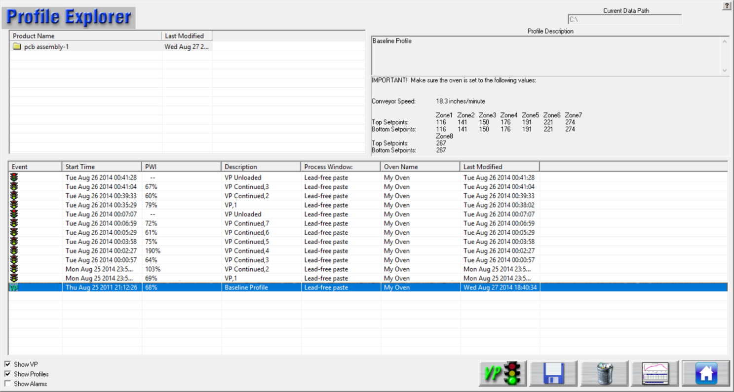

This button will only display when running in ***Production*** mode.

Figure 54: Profile Explorer

The list of product folders is in the upper left of the Profile Explorer.

* **View a profile** - Click on a product folder to display the profiles that have previously been run for any product. Highlight the profile you wish to view and then select the Graph button at the bottom of the screen or double-click the profile to display it.

**Note**: Once the profile appears on screen, you can use the Control + Up Arrow to view the next profile, and Control + Down Arrow to display the previous profile.

* The profile section can be sorted by clicking on any of the column headers. Single clicking on a profile will display the Profile description in the upper right corner.
* Double-clicking the profile will display the graph and statistics for that profile. Clicking the “Display Graph…” button can also do this.

**Note**: If the profile is labeled as “Bad” or if, for any reason, the automatic system software cannot display it, the profile is automatically copied to the Clipboard so that you can use a third party such as MS-Excel to view the data.

## Browse for Historical Data

The current Data Path for the data viewed in the Profile Explorer appears in the upper-right corner. The data path appears grayed out if running in production mode. It will be active, if you clicked on the “I am not going to run profiles or live Virtual Profiling” button (enabling History mode), when first launching the software.

The data path can be changed, but must be done so through the\software root directory\Log\KIC2000DataPath.kiccfg file.

To view historical Virtual Profile data from the same PC while Virtual Profiling is live, you launch a separate Host.exe file located: C:\software root directory\APPforViewer\KICHost.exe. This will open a separate Profile Explorer that will allow you to browse through the history of any product including the one currently running VP. Historical data will be available for any virtual profiles that have already been calculated.

**Note**: This feature was designed to allow you to view historical data stored in a different directory on the same computer or on remote PC over a network.

## View Historical Data Over a Network (History Mode)

While in History mode, you can view all collected data over a network from any PC running the software.

|  |  |
| --- | --- |
| 1. From your remote PC, start the software and click on the “I am not going to run profiles or live Virtual Profile” button. See Figure 55.   The software will open up normally.   1. When the main screen appears, click the Profile Explorer button. | Figure 55: Product Tracking Initialization |

1. A **Browse** button will be enabled in the upper right hand corner of the Profile Explorer screen. See Figure 56.

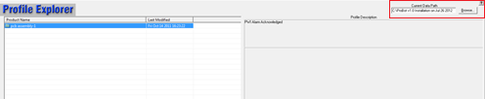

Figure 56: Profile Explorer – Browse Data Path

1. Click the **Browse** button and point to the root directory where your profiles are stored.

Keep in mind that you want to direct it to the root directory of the main “Profiles” folder.

For example: if the profiles are stored in a directory named F:\software root directory\Profiles\Board A, you would direct it only to the F:\software root directory\ folder.

### Profile Explorer Buttons



|  |  |
| --- | --- |
| bt_Inspection_Start | **Start Virtual Profiling –**Click this button to start Virtual Profiling. The software will always use the latest qualifying profile as the Virtual Profile - Baseline profile. |
| b | **Save Selected Profile –** Click this button to save an event or profile to the location of your choice, either hard disk, network drive, or floppy disk. |
| b | **Delete File -** Click this button to delete an event or profile. |
| bt_Inspection_Historyb | **Display the Graph and Statistics for this profile -** Click this button to display the graph and statistics for the selected profile. If you have an event other than a profile, the Display Graph and Statistics button will change to a Charts button. |
|  | **Return to Main Menu –**Click this button to return to the main menu screen. |

### Profile Explorer Checkboxes

At the bottom-left of the Profile Explorer are checkboxes to select what information to display:

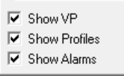

**Show VP –** Display all VP Start and Stop events for the selected product.

**Show Profiles –** Display the Profiles for the selected product.

**Show Alarms –** Display the Alarm state changes for the selected product.

**Note**: Double click any event to view the details including alarm event history.

**Note**: If two alarm/alert acknowledgements appear at the same time, only one will appear in Profile Explorer.

## Profile Explorer – Virtual Profiling

The profile that meets Virtual Profiling criteria will be displayed with a green VP  overlaying the standard profile icon.

The software will always use the most recent qualifying profile as the Virtual Profile -Baseline profile.

### View Virtual Profile Data

1. Select your product folder from the upper left- corner of the Profile Explorer.

This will display the profiles and events for that product.

1. Choose a Virtual Profile event.

### Profile Explorer Event Icons

#### Profile Icons

 **Profile –** This icon appears for any valid profile that does not fit Virtual Profile criteria.

 **Virtual Profile capable –** This icon appears for the most recent Virtual Profile capable profile.

### Virtual Profile Event Icons

The Profile Explorer displays an event icon for any event that occurs while Virtual Profiling is running and only when Virtual Profiling is running. These events include:

 **VP Start –** This icon appears when Virtual profiling is enabled.

 **VP Stop –** This icon appears when Virtual Profiliing is disabled.

#### Alarm Icons

 **In Spec. – Alarm state change –** This icon appears when the Virtual Profiling alarm state changes back to Ready. There are three ocassions when this icon may appear:

* Back into Spec
* Back into Control
* Process Temperatures Back to Normal

 **Warning – Alarm state change –** This icon appears when the Virtual Profile alarm state changes to Warning. There are three ocassions when this icon may appear:

* Cpk Warning
* Significant Process Temperature Variation
* Process Is Likely to Go Out of Spec Soon.

 **Out of Spec. – Alarm state change –** This icon appears when the Virtual Profile alarm state changes to Out of Spec. There are nine ocassions when this icon may appear:

* Process temperatures are Out of Spec
* Product length is different from the Virtual Profile – Baseline profile
* Encoder stopped, or changed signifigantly.
* Oven recipe no longer In-Spec
* eTPU lost communication

 **Warning Acknowledged –** This icon appears once the operator acknowledges the Warning alarm state change.

 **Alarm Acknowledged –** This icon appears once the operator acknowledges the Out of Spec alarm state change. Not all alarms require acknowledgement.

#### Communications Icons

 e**TPU Communication Error –** This icon appears if the software loses communication with the eTPU.

 e**TPU Communication Restored –** This icon appears when the software re-gains communication with the eTPU.

## Access History Data Backup Files

As the software processes Virtual Profiles, it logs data files to a *Profiles* folder that later can be analyzed. It automatically stores these *Event* and *VPdata* files associated with each specific product to a *History* folder.

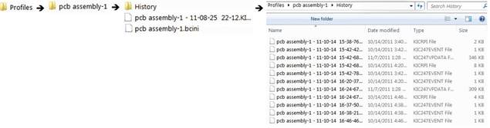

|  |  |
| --- | --- |
| As a great number of these files can eventually accumulate (more than might be of immediate interest), the software provides an automatic process for archiving the excess files. When the number of files in the History folder exceeds 500, the software moves the oldest files to a subfolder it creates named *Backup1*. The software leaves 250 files behind in the History folder. As new files are written to the folder, each time the total exceeds the 500 file threshold, the software again moves all but 250 to newly created subfolders named *Backup2, Backup3,* and so on.  **Note**: The backup file archival process is fully automatic. Users cannot specify the triggering threshold value or the size of the backup file batch. | C:\Users\dklueck\Desktop\PCB assembly-1 with Backup folders.jpg |

While files are archived in a backup folder they cannot be accessed. To enable the software to access the files, you need to restore them to the History folder as described in the procedure below:

1. Navigate through the following folders to a Backup folder:

Main software / Profiles / Product Name / History / Backup

1. Open a **Backup** folder.
2. Select and copy the files of interest.
3. Open the **History** folder.
4. Paste the files into the History folder.

|  |  |
| --- | --- |
| 1. Launch the automatic system software. 2. Open the **Profile Explorer**. 3. Select the **Product Name** folder of interest.   The event and data files associated with the product appear listed in the lower panel.   1. Double-click the event files to display their data or analyze their alarm messages. | C:\Users\dklueck\Desktop\KIC Vision2\Screen Shot History Profile Explorer to replace screen current UM page 61.bmp |

**Note**: Be aware of both the number of files currently in the History folder and the number of files you are transferring from the Backup folder. If the number of transferred files makes the total in the History folder exceed the 500 file limit, it will again trigger automatic archiving to a backup folder. The software does not treat the transferred files as newer files in the History folder queue, ordering them instead by their original date. If hitting a limit trigger reduces the History folder population back down to 250, the transferred files you were interested in could be among those removed to a Backup folder.

## Insert Data Files from an Outside Source

If you receive data files via disc or email, you can copy them to the software root directory\Profiles folder in Windows Explorer. The next time you enter the Profile Explorer screen the software will automatically create folders for those profiles based on the profile name and put the profiles in the folders.

## Rename Profiles

In situations that require it, you have the ability to edit the profile name. This can be especially useful when products are very similar, but have different names. Once the profile has been optimized, it can be renamed and used as a baseline profile for similar products if the need arises. This eliminates the need to re-profile similar products unnecessarily.

**Note**: Renaming a profile includes the name that is embedded in the profile that shows up on the printout

1. Manually create a new folder in the C:\software root directory \Profiles folder using the new product name.
2. Copy the desired profile into this new folder.
3. A folder with that new Product Name will appear in Profile Explorer.
4. When you open that profile, it will display in the software with the new Product Name

* The new profile name will appear on all the screens (Profile Explorer, General Tab, Charts Tab, and Troubleshooting Tab). The new name will also appear in the data that is copied to the Clipboard.
* None of the files on the PC are actually renamed, when viewing the profiles in Profile Explorer, they all look the same. However, profiles run after the name has been changed will use the new product name as part of their file names

**Note**: Virtual Profiling will be most accurate for products that have their own baseline profile.

# Virtual Profiling

*Virtual Profiling* (VP) is a means of reliably predicting the thermal profile based on a comparison of real-time temperature and conveyor speed data against a *baseline* profile established by an earlier profiler run through the oven. The software generates a Virtual Profile at *a user-selected interval from once per hour to once every 24 hours.*

For a given product, this baseline needs to represent an optimum oven recipe with a good PWI value and a quality soldering result. During the initial profile run, the software simultaneously collects temperature data from the board and from the probes installed in the oven at product level. The software calculates a mathematical correlation between these temperature readings and stores this data as part of the baseline profile.

Once the baseline is established, the software goes into monitoring mode, recording real-time belt speed and probe temperature data at the specified interval as the production run passes through the oven. Comparing real-time data to the baseline profile, the automatic system algorithms accurately extrapolate a simulated thermal profile. When oven data varies significantly from the baseline profile, the software displays appropriate warnings to system operators. The software saves the data from each profile/virtual profile, creating a valuable quality assurance record.

If you’ve purchased the option, the software can display a chart and table of profile data based on the process window and also Statistical Process Control (SPC) charts.

**Note**: Before you start Virtual Profiling, make sure all hardware is properly installed and configured.

## Get a Valid Baseline Profile

Virtual Profiling makes use of a special profile, called the *baseline* profile, as the data model for its predictions. The software requires that you first establish this baseline before it enables Virtual Profiling. The baseline profile should represent your optimum oven recipe for your product and needs to meet the Virtual Profile criteria shown below:

* The PWI must be below the Maximum PWI to allow the VP value as set in Global Preferences.
* The conveyor speed measured by the encoder must be within 20% of the specified conveyor speed.
* Probe temperatures must be valid; if any probe thermocouple reports a range of greater than 30°C between adjacent readings (every 2.5 seconds), the software will consider them invalid.

If your profile meets the above criteria, it can work as a baseline profile. The baseline profile will display differently in the Profile Explorer screen—the profile’s icon will have an overlying green VP icon . If you suspect the current baseline profile needs replacement by a newer version that more closely matches current production conditions, the software lets you create a new baseline during ongoing production. As long as this *verification profile* meets VP criteria, it can become the new baseline profile. See [Verify the Virtual Profile](#_Verify_the_Virtual)

### Integrate Empty Oven Data

For a baseline to work as a good predictive model, it needs to use temperature data that reflect both *board present* and *board absent* states along the length of the probes. To obtain this data most efficiently, it may be necessary to run the profiler board with similar *boards moving ahead of it and an empty conveyor behind it.* The downstream flow of boards stabilizes the oven temperature and gives a good approximation of normal production conditions. As the profiler board exits each oven zone, the probes can measure the temperature when a board is not present. The software can integrate this comparative data for a more accurate predictive capability. The oven should remain empty until the profiler board completely exits the process chamber.

**Note**: Be aware of the potential to put the system into a state where the software lacks sufficient empty oven data to make reliable VP predictions. The condition can occur during a verification profile run where you insert the profiler board into an ongoing production flow. With other boards both ahead of and behind the profiler board, no interval for gathering empty oven data occurs, and Virtual Profiling will not be able to be used.

## Create/Load a Virtual Profile

There are two ways to begin Virtual Profiling:

1. Open the Profile Explorer and select your product folder in the upper-left corner. This will display the profiles and events for the selected product. If you have a profile that meets Virtual Profiling criteria, the profile icon will be overlaid with a green VP. This qualifying profile (Baseline) will always be the most recent profile that meets Virtual Profiling criteria (only one profile can qualify as the baseline).

No need to highlight the Baseline profile, simply click the Start Virtual Profiling button. This will start Virtual profiling for the selected product.

|  |  |
| --- | --- |
| 1. If you have run a profile that meets the Virtual profile criteria, then the **Start** Virtual profiling button will appear once the profile has completed. Click the **Start** Virtual Profiling button to begin Virtual Profiling for this product. A message will display asking you to confirm if you want to proceed. See Figure 57. | bt_Inspection_Start |
|  |  |

**Caution**: Your software security key must be connected prior to enabling Virtual Profile mode. If the key is removed from the computer while Virtual Profiling mode is enabled an alarm message will be displayed.

**Tip**: If your oven is capable of communicating with the software, a dialog box will appear notifying you that Virtual Profile is starting and the oven recipe will be changed automatically.

If your software is not communicating directly with the oven controller, the software will display the Baseline profile recipe. Make sure the oven is set to the exact recipe settings.

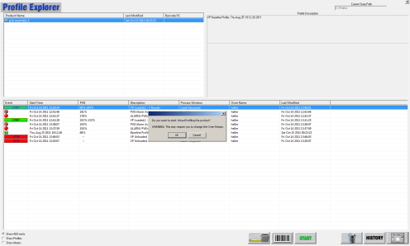 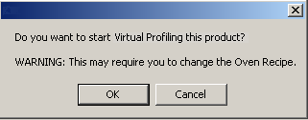

Figure 57: Profile Explorer – Start Virtual Profiling

If your oven is capable of communicating with the software and the current oven recipe matches the Baseline profile recipe, a dialog box will appear telling you that the recipe is already set correctly. See Figure 58.

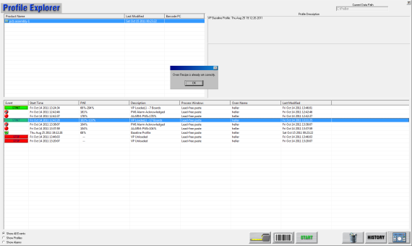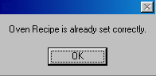

Figure 58: Virtual Profiling – Oven Recipe set correctly

**Tip**: Oven Controller: If nothing happens within several seconds, check the oven controll software to make sure there are no error messages or errors that will cause the system to hang.











## Live Mode - General Tab

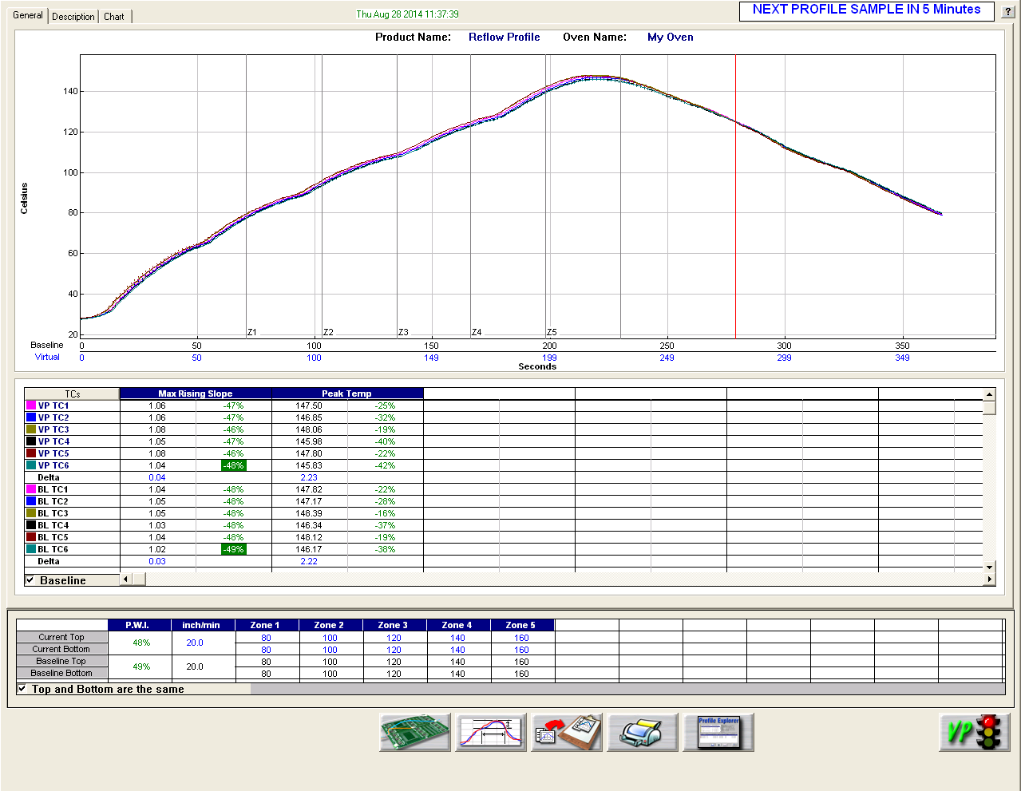

Figure 60: General Tab Screen

On the *Live-Mode General tab* screen, the software displays both the baseline and virtual profile. To distinguish between the two, the baseline profile appears in a solid line format, while the virtual profile appears in dashed-lines.

**Note**: To enlarge the graph portion of the screen, double click on the graph. To enlarge the statistics portion of this screen, double click on the statistics.



### Profile Statistics

On the General tab screen, the VP and baseline statistics appear in a table below the profile graph. Uncheck the baseline check box to remove the baseline statistics form view. Below the statistics, the Virtual Profile and baseline profile recipes appear. These recipes should match identically. The current PWI appears in the bottom-left corner. The PWI for the last virtual profile will not be displayed, go to the Charts tab to view this information.

### Graph Controller

|  |  |
| --- | --- |
| The Graph Controller allows you to modify the view of the profile graph. See Figure 61. To open the Graph Controller, left-click on the TC column header in the Statistics table or double left-click, anywhere just outside the profile graph.  **Auto Scale –** The Auto Scale feature will automatically adjust the X and Y-axis scales to fit all of the data in the profile graph. When the Auto Scale feature is disabled, you must manually input the minimum and maximum scale settings for the X and Y-axis scale of the profile graph.  **TCs –** You cannot disable or rename a TC in a Virtual Profile. You can only perform this function on the Baseline Profile. Those changes would then be reflected in the Virtual Profile display. | Figure 61: Graph Controller |

**Grid –** Enables/disables the view of the X and Y-Axis scales.

**Reference lines –** Enables the view of Reference Lines displayed on the profile graph. These lines represent any temperatures referenced in the selected Process Window.

**Zone lines –** Enables the view for the oven zone lines on the profile graph.

**Predicted TCs only** - Removes the Original profile plot from view, displaying only the prediction profile plot on the graph.

**Zero decimal** – When viewing the Pointer tool, this setting enables or disables the decimal display. When unchecked, the software will display one decimal point.

**Internal temp** – Enables the view of the profiler’s internal temperature profile plot on the graph.

**Display Detailed PWI** – With this unchecked, you will only see the “overall” PWI for the profile. It will not display the individual TC PWI values.

**Extra Cooling Slope** – Enabling this feature displays multiple Cooling Slope measurements which are customizable by the user.

**TCs Line Thickness** – The pull down menu lets you select five different thicknesses for the TC lines drawn on the graph.

### Automatic Calculation Of Delta T + Delta (Or Range) For All Statistics

The software will automatically calculate, and display in the statistical chart, the Delta for both the original and predicted profile data for all TCs for all Statistics. See Figure 62. This is the range of the highest to the lowest value for any given specification. This information is strictly being displayed and is not factored in to the PWI value and is not used in the *optional* Navigator or Auto-Focus calculations.

### Examine Tool

|  |  |
| --- | --- |
| You can also view the Delta T (∆T), or Delta Temperature, at specific points across the profile by right mouse clicking on the graph. This will bring up a pointer and a chart will appear in the upper left corner of the graph. See Figure 62. | b  Figure 62: Examine Tool Display |

Wherever the pointer is moved across the profile, the following data will be displayed:

* The first column is the actual temperature for each TC, Original.
* The second column is the temperature of the predicted profile data – based on set point or belt speed changes.
* The Delta T for both actual and predicted TC data.
* The time during the profile at which the pointer is placed.

## Live Mode - Description Tab

|  |  |
| --- | --- |
| The Description tab displays the profile Description notes for the Baseline profile. See Figure 63.  You can edit these notes by clicking in the description area.  Below the description area, the Virtual Profile and Baseline Statistics, and recipes appear. The current PWI appears in the bottom-left corner. Enlarging the description area and statistics are not possible while viewing this tab. | Figure 63: Virtual Profiling – Description Tab |

## Verify the Virtual Profile

The V*irtual Profile* is a prediction of the process profile (inside the oven) generated from a model created when the Baseline profile was run. A *Verification* *Profile* is a comparison run against the virtual profile model. If you think the process has changed significantly or you have purposely changed the recipe, running a verification profile lets you verify the prediction model. This comparison can either verify that the process profile is still within specification or create a new baseline profile based on the recent changes.

The verification profile updates the Baseline profile for the current Virtual Profile, insuring that its prediction model yields the most accurate possible results, using the most recent profile. The software always recognizes the latest in‑spec profile as the Baseline for any Virtual Profile.

The software recognizes when the process temperatures change significantly as compared to the current Baseline profile, and then prompts you to run a verification profile. You can intentionally run a verification profile at any time during Virtual Profiling Live Mode.

**Note**: The software will only accept a verification profile as a new baseline if meets the standard VP criteria. See [Get a Valid Baseline Profile](#_Get_a_Valid).

### Start A Verification Profile

|  |  |
| --- | --- |
| A Verification Profile can run only when Virtual Profiling is running in live mode.   1. With Virtual Profiling running in live mode, select the Run Profile button at the bottom of the Virtual Profiling-live screen. See Figure 64. | bt-NAV_Run-profile  Figure 64: Run Profile Button, Main screen |
| 1. The software will display a message asking if you want to run a Verification profile: See Figure 65.  * If you choose “**No**”, the software will return to the previous screen. * If you choose “**Yes**”, the software will begin stepping through the run profile routine. | Figure 65 |

Before profiling, make sure:

* The Profiler is on and ready to profile.
  + **Transmit model** – Receiver or Base Station is plugged into computer.
  + **Datalog model** – The profiler is plugged into the download cable and download cable is plugged into the computer.
* Profiler batteries and internal temperature are at the proper levels to profile.
* All thermocouples attached to the profiler are below the defined product start temperature.

**Note**: Depending on the settings on your profiler and in the software, you may have to initialize the profiler. The software will let you know when this is necessary. To initialize the profiler, connect it with the supplied cable to the computer, and turn on the power. Click **OK** when the software displays the message that the initialization was successful.

1. Click the Profile Start button (green traffic light).

Once the Verification Profile is complete, the profiler has downloaded the profile data that meets Virtual Profile criteria, the software will display the dialog box shown below: (See Figure 66.)

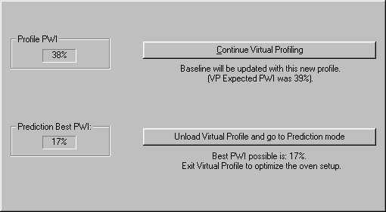

Figure 66: This dialog box will display the PWI and the  
predicted PWI for the Verification Profile.

Alternatively, if the Profile is out of spec, the dialog box shown below will appear stating that the PWI is too high. See Figure 67.

If you choose to continue running Virtual Profiling, you will receive WARNING #2, “The last profile was out of spec”. In this situation, you need to run profiles until an in spec profile is achieved before the software will allow you to continue Virtual Profiling.

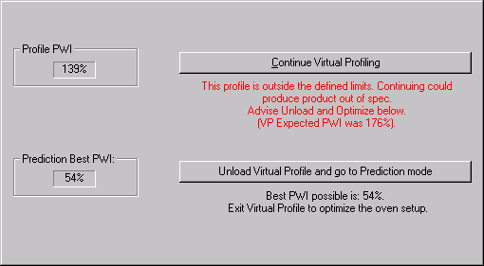

Figure 67: Out of Spec Verification profile

The dialog box will present two choices:

1. **Continue Virtual Profiling –** If the Verification Profile meets Virtual Profiling criteria, it will automatically be used as the new Baseline profile. If you choose this option, the software will update the Baseline and continue Virtual Profiling, using the Verification Profile as a new Baseline profile.
2. **Unload Virtual Profile and go to Prediction mode** – If the Verification Profile does not meet Virtual Profiling criteria or is out of spec, it can’t be used for Virtual Profiling. If you choose this option, you can predict changes to the profile in order to bring the profile back within its process specification. You will have to run at least one more profile in order to produce a profile that meets Virtual Profiling criteria.

**Tip**: For an explanation of Virtual Profile criteria, see the [Virtual Profiling](#_Understanding_Virtual_Profiling) Section of this manual

## Historical Mode

The software has an *historical mode* feature. This feature allows you to view the data for any Virtual Profile processed when the system has been running. Open the Profile Explorer and select any event other than a profile. The **Display the Graph and Statistics for this profile** buttonwill change from a single graph button display to a HISTORY button display, indicating there is Historical data associated with the selected event. See Figure 68 and Figure 69.

|  |  |
| --- | --- |
| Figure 68: Profile Explorer–Display Graph and Statistics for this profile | Description: \\RND\RND_Service\For DaveK\ProBot\Graphics\bt_Inspection_History.bmp  Figure 69: Profile Explorer–Display Historical Graph and Statistics |

## Historical Mode - General Tab

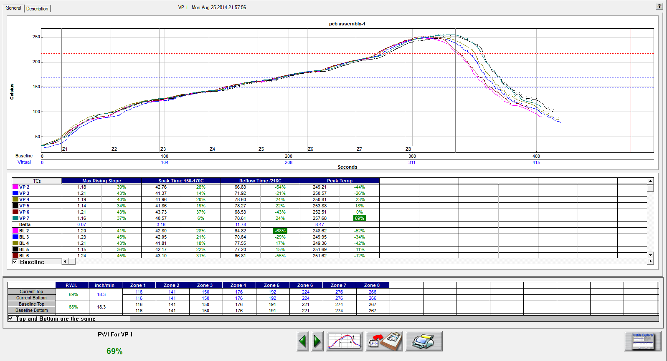

Figure 70: Virtual Profiling History – General Tab

The software will display the Baseline profile on the profile graph in a solid line format. Also on the profile graph is the Virtual Profile for the selected date/time. The Virtual Profile will be displayed on the profile graph in a dashed-line format. This display method allows you to easily distinguish between the Baseline and Virtual profiles.

Below the profile graph, the Virtual Profile and Baseline profile statistics appear. Uncheck the Baseline check box to remove the Baseline statistics from view. Below the statistics, the Virtual Profile and Baseline profile recipes appear.

**Viewing Historical Profiles**

To view the *Virtual Profiles* for this product use the Green arrow buttons to either go forward in history or go Backwards in history. Each time the arrow button is selected the software will display the next record in chronological order.

### Graph Controller

|  |  |
| --- | --- |
| The Graph Controller allows you to modify the view of the profile graph. See Figure 71. To open the Graph Controller, left-click on the TC column header in the Statistics table or Double left-click, anywhere just outside the profile graph.  **Auto Scale –** The Auto Scale feature will automatically adjust the X and Y-axis scales to fit all of the data in the profile graph. When the Auto Scale feature is disabled, you must manually input the minimum and maximum scale settings for the X and Y-axis scale of the profile graph.  **TCs**  The TCs section is a list of the thermocouples used for the profile. In the event that you wish to view the profile without a particular or multiple thermocouples, you can deselect individual thermocouples, or deselect the “All” check box, and choose only the thermocouples you wish to view. The software recalculates the PWI, and updates the profile statistics based on the remaining thermocouples selected. You must select at least one product thermocouple. | Figure 71: Graph Controller |

**Grid –** Enables/disables the view of the X and Y-Axis scales.

**Reference lines –** Enables the view of Reference Lines displayed on the profile graph. These lines represent any temperatures referenced in the selected Process Window.

**Zone lines –** Enables the view for the oven zone lines on the profile graph.

**Predicted TCs only** - Removes the Original profile plot from view, displaying only the prediction profile plot on the graph.

**Zero decimal** – When viewing the Pointer tool, this setting enables or disables the decimal display. When unchecked, the software will display one decimal point.

**Internal temp** – Enables the view of the profiler’s internal temperature profile plot on the graph.

**Display Detailed PWI** – With this unchecked, you will only see the “overall” PWI for the profile. It will not display the individual TC PWI values.

**Extra Cooling Slope** – Enabling this feature displays multiple Cooling Slope measurements which are customizable by the user.

**TCs Line Thickness** – The pull down menu lets you select five different thicknesses for the TC lines drawn on the graph.

### Automatic Calculation Of Delta T + Delta (Or Range) For All Statistics

The software will automatically calculate, and display in the statistical chart, the Delta for both the original and predicted profile data for all TCs for all Statistics. See Figure 72. This is the range of the highest to the lowest value for any given specification. This information is strictly being displayed and is not factored in to the PWI value and is not used in the Navigator or Auto-Focus calculations.

### Examine Tool

|  |  |
| --- | --- |
| You can also view the Delta T (∆T), or Delta Temperature, at specific points across the profile by right mouse clicking on the graph. This will bring up a Pointer and a chart will appear in the upper left corner of the graph. See Figure 72. | b  Figure 72: Examine Tool Display |

Wherever the pointer is moved across the profile, the following data will be displayed:

* The first column is the actual temperature for each TC, Original.
* The second column is the temperature of the predicted profile data – based on set point or belt speed changes.
* The Delta T for both actual and predicted TC data.
* The time during the profile at which the pointer is placed.

## Historical Mode - Description Tab

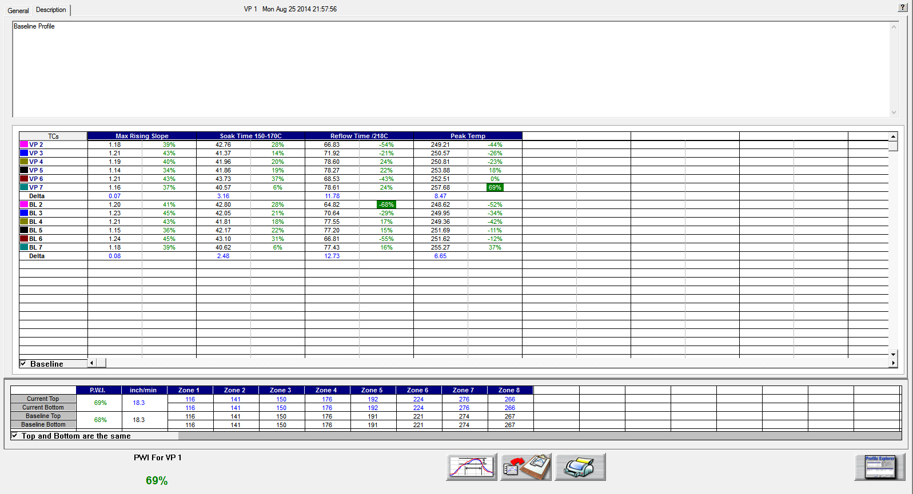

Figure 73: Virtual Profiling History – Description Tab

In Historical mode the Description tab displays the Baseline profile description notes. See Figure 73. You can edit these notes by clicking in the description area. Below the description area, the Virtual Profile and Baseline statistics, and recipes are displayed.

# Password Protection

To enable the Password protection feature, go to the *Global Preferences* screen and select the *Password Protection* check box. See Figure 74.

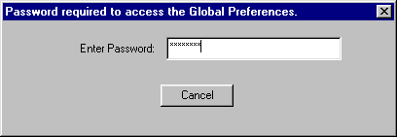

Figure 74: Password Protection

Items that are password protected:

* Global Preferences button on the main screen
* In the Process Window Screen – Saving or deleting Process Windows or changes to Process Windows
* In the Run a Profile first screen – Remove Oven
* In the Profile Explorer – Delete a profile
* In the Profile Graph and Statistics screen – Access to the Optimization tab

# Printing

The software will print profiles only from within the profile display screens. Click on the printer icon button at the bottom of the profile display to open the Profile printout setup menu. There are two print formats available – Portrait or Landscape.

## Portrait Mode

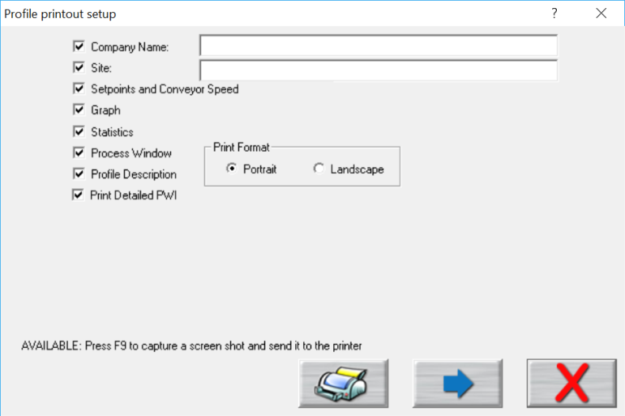

Print

Preview

Print

Cancel

Figure 75: Portrait Format

1. Check the items you wish to include on your profile printout.
2. Press the **Print** button to print the report.
3. Press the **Print Preview Button** to display a preview of the report. See Figure 76.

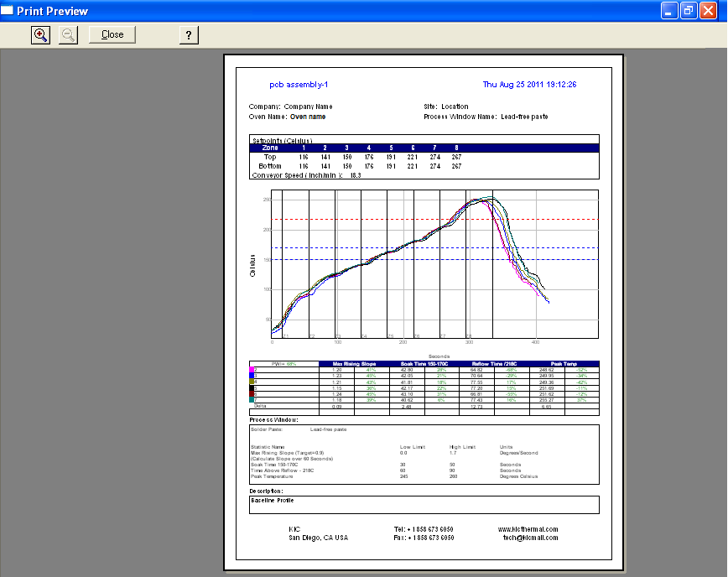

Figure 76: Sample Portrait Print Preview

## Landscape Mode

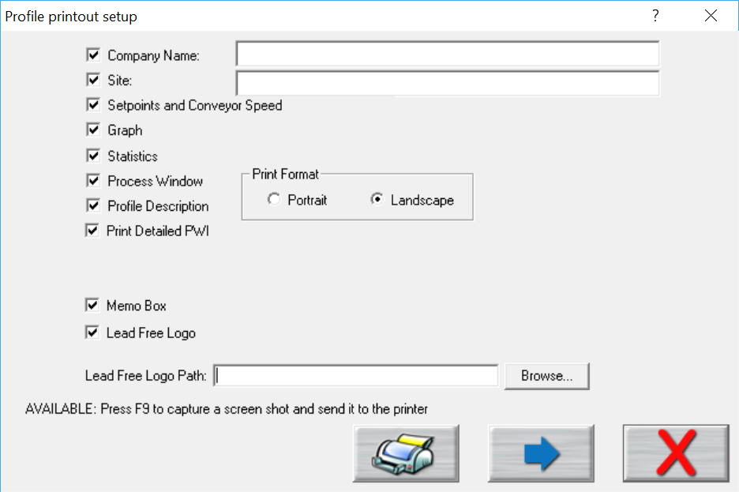

Cancel

Print

Print

Preview

Figure 77: Profile Print Portrait Options

Below are the additional options available with Landscape mode:

* **Memo Box** –Enables/Disables a Memo Box area for Draft, Review and Approval Signatures and Dates.
* **Lead Free Logo** – Enables/Disables the image display area.
* **Lead Free Logo Path** – When “Lead Free Logo” is enabled, specify the path to any BMP image file that you want to appear in the image display area on the report.

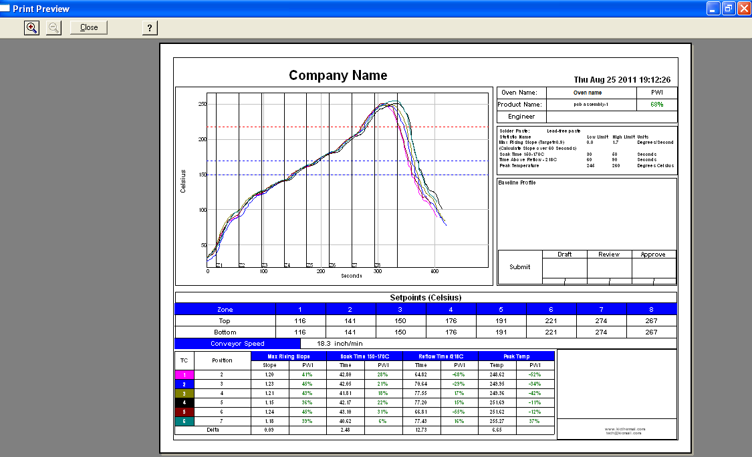

Figure 78: Sample Landscape Print Preview

Optionally, you can print the contents of any screen in the automatic system software by pressing **F9** on your keyboard. The **F9** function will not work while viewing the Profile Printout Setup dialog box.

**Note**: Before printing, make sure you have defined a printer for use with Windows.

# Write Data to and View Data Over a Network

## Write Data to a Network Drive

The software can be configured to write the collected data (profiles and historical VP data) to a network drive location. This would allow data from one or even multiple systems to be stored in one centralized location (Server/Shared Hard Drive).

The first step necessary is to map a network drive from the PC running the software to the desired network location. Due to the multiple varieties of OS and network configurations, this step cannot be described in great detail. We recommend you contact your IT/Network administrator for setting this up. Below is a typical example of this setup. See Figure 79.

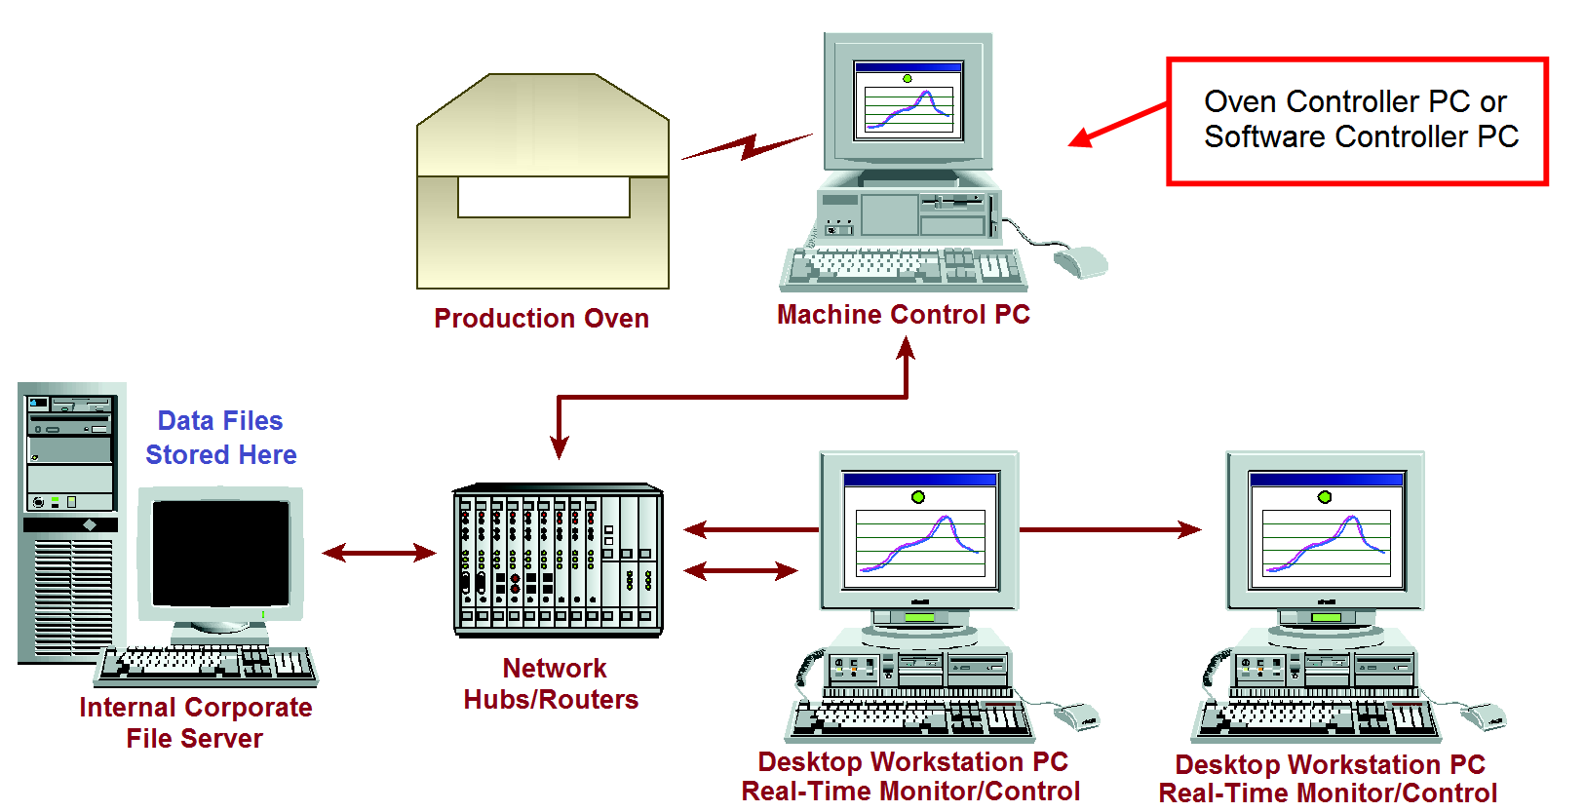

Figure 79: Example Network

Once you have mapped the drive, create a folder on the network drive and copy in the following folders from the C:\software root folder directory – Log, Ovens, Process Specs, and Profiles. Once completed, follow the steps below on the PC where the automatic system software is installed:

1. Ensure the automatic system software is closed, open Windows Explorer, and locate the file:

C:\software root folder\Log\KIC2000DataPath.kiccfg

1. The KIC2000DataPath.kiccfg file will open up in Notepad: See Figure 80.

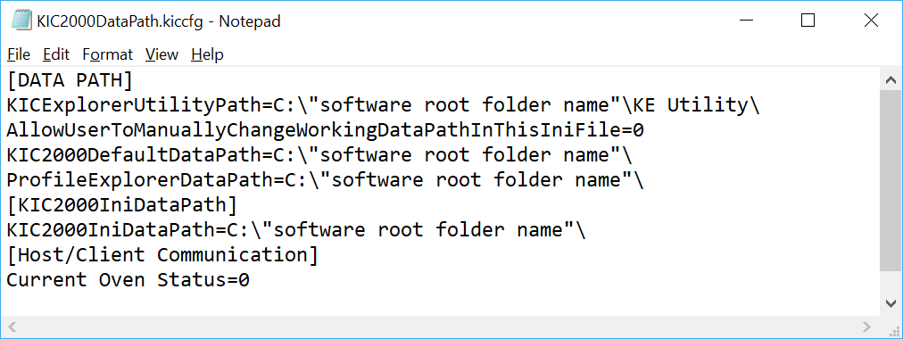

Figure 80

1. Change the line AllowUserToManuallyChangeWorkingDataPathInThisIniFile=0 to the value =1: See Figure 81.

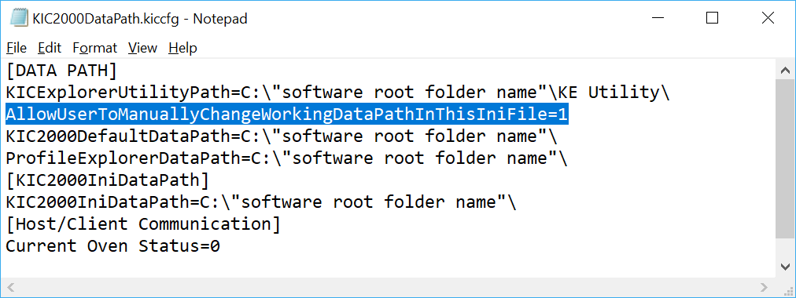

Figure 81

1. Change all of the lines shown below to = the desired network location. **Note:** This will be the main network folder you created and copied the Log, Ovens, Process Spec, and Profiles folders into. See Figure 82.

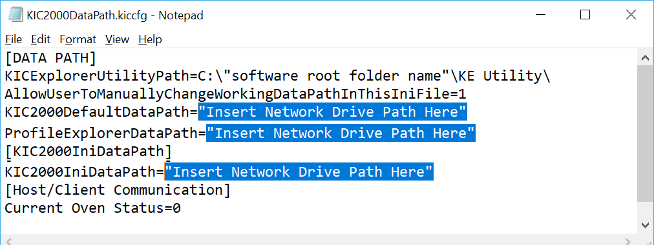

Figure 82

1. Once the DataPath.kiccfg file has been modified with the new locations, choose File/Save from the drop down menu to save the changes.
2. Close Notepad and start the software.

**Caution**: If you changed the default data path and run the software in history mode (select the “I am not going to profile or Virtual Profile” button), or if your network is not connected or is not functional, the working directory (location data is written to) will revert back to the default location of **C:\software root folder**. To write to the network again, shut down the software and repeat steps 1-6.

1. With the software open, go to the Profile Explorer:

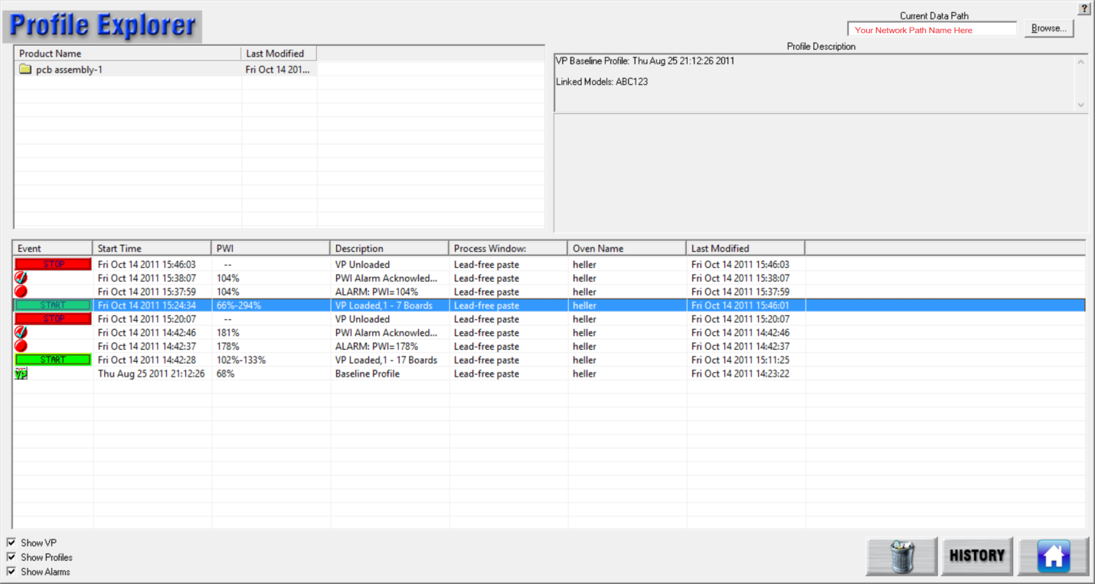

Figure 83

Your new network drive should be displayed in the upper right hand corner of the screen as the Current Data Path. See Figure 83.

**Note**: The Network path will be grayed out, and cannot be changed from inside of Profile Explorer.

All data collected in this software application will now be written to the network folder chosen.

**Note**: If you have multiple automatic systems, you will need to create a separate folder on the Network drive for each system – e.g. Line 1, Line 2, etc.

## Viewing Historical Data

You can also view all collected data over the network from any computer that has the software installed.

To view historical data over the network:

1. From your remote computer, start the software and click on the “I am not going to run profiles or live Virtual Profiling” button. See Figure 84.

**Caution**: Do not choose this button when working at the PC where the system hardware is installed.

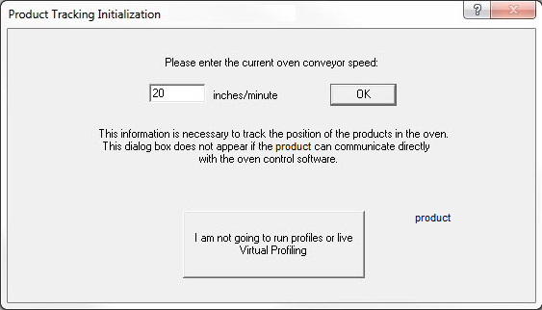

Figure 84

1. The software will open up normally. When the main screen appears, click on the Profile Explorer button.

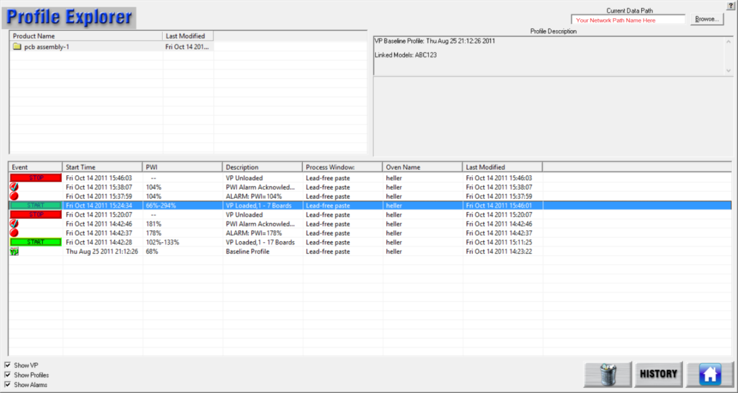

Figure 85

1. A **Browse** button will be enabled in the upper right hand corner of the screen: See Figure 85.

You can now click the **Browse** button and point to the directory where your profiles are. Keep in mind that you want to direct it to the root directory of the main “Profiles” folder.

For example: If the profiles are in the folder F:\software root directory\Profiles\Board A

you would direct it only to the folder F:\software root directory\







# Messages During Profiling and Baseline Profiling

During the profiling portion of getting your software ready to monitor and record production real-time and prior to starting a Virtual Profile, you may experience some conditions that cause the system to alert you to. Below is a table of the messages that you might see during this process: See Table 2.

|  |  |
| --- | --- |
| **Message Alarms** | **Message Description** |
| **Message, High PWI** | Recent profile of xxx%, PWI must be 90% |
| **Message Alarm H2** | eTPU Communication Failure - wait 5 seconds and try again |
| **Message Alarm H7** | Conveyor has stopped or encoder has been disconnected Virtual Profiling cannot be started. |

Table 2: Profiling System Alarms System message alarms

## System Messages and Alarms

### Message, High PWI

|  |  |
| --- | --- |
| If the verification profile PWI is >= 100%, you will receive this message when starting the VP.  If there was a problem with the most recent profile, it can be deleted and the system will try to use the next most recent profile as the baseline profile. Otherwise, you are advised to run another profile. See Figure 86. | Figure 86: Message High PWI |

### Alarm Message H2

|  |  |
| --- | --- |
| No communication. (After software launched and did not have time for eTPU to communicate with computer.) This message will usually appear if the eTPU was connected after the software was launched. This is because a connection to the eTPU has not been established yet. Waiting 5 seconds allows a connection to the eTPU to be established. See Figure 87. | Figure 87: Alarm H2 |

### Alarm H7

|  |  |
| --- | --- |
| This alarm will appear when trying to start a Virtual Profile from the Profile Explorer. The oven conveyor must be running and set to the correct speed settings in order to start Virtual profiling. See Figure 88. | Figure 88: Alarm H7 |

## Alarms and Messages During Virtual Profiling

The software incorporates the use of Warning and Alarm dialog screens to let you know if there is a problem and the cause for that problem. Below is a partial list of the Warning and Alarm dialog screens with explanations. These Alarms are active only when Virtual profiling is running.

| **Process Alarms** | **Description** | **Activates Alarm Relay** |
| --- | --- | --- |
| **Alarm # 1** | PWI=x% - Process is out of spec | **Yes** |
| **Alarm # 10** | This alarm only occurs when the software and the oven control software are communicating and indicates that the oven is not set to the baseline profile recipe. | **Yes** |
| **Alarm # 11** | The speed sensor has detected that the conveyor speed has changed significantly since the baseline. | **Yes** |

Table 3: Virtual Profiling – Process Alarms

|  |  |  |
| --- | --- | --- |
| **Hardware Alarms** | **Description** | **Activates Alarm Relay** |
| **Alarm H1** | eTPU Communication Failure (happened after Alarm H2) | **Yes** |
| **Alarm H2** | eTPU Lost Communication with PC.  Note: This Alarm condition can activate the Alarm Relay that is controlled by eTPU. | **Yes or No** |
| **Alarm H7** | Conveyor Stopped or Speed Encoder broken or not connected properly. | **Yes** |

Table 4: Virtual Profiling – Hardware Alarms

|  |  |  |
| --- | --- | --- |
| **Warnings** | **Description** | **Activates Alarm Relay** |
| **Warning # 2** | This process is likely to go out of spec soon. | **No** |
| **Warning # 3** | The last profile was out of spec. | **No** |
| **Warning # 4** | Oven temps have changed significantly since baseline. | **No** |

Table 5: Virtual Profiling – Warnings

## eTPU Communication

### Communication Troubleshooting for the eTPU

* **If the Yellow LED (AC Power) is not on, then there is no power present.**

To correct this, make sure the eTPU power supply is properly connected to the eTPU and connected to an AC power source. Use only a factory-supplied power supply.

* **If the green LED (Network communication) is not on, then there is no Ethernet communication.**

To correct this, ensure the dedicated Ethernet adapter is configured properly. Also make sure the correct IP address class is used, and that the subnet mask is entered correctly.

* **If you open the software and the red LED does not begin blinking (slow blink), then the SitePlayer IP address may not be configured properly.**

To correct this, exit the software and then open the file:

C:\software root directory\Log\KIC2000Hardware.kiccfg

Edit the line:

SitePlayerIPAddress=

Enter the IP address of your eTPU-SitePlayer.

If still not working, then use Internet Explorer to access the eTPU SitePlayer and use the manual switch.

* **If you cannot connect to the SitePlayer using Internet Explorer, then the SitePlayer IP address is typed incorrectly or the address is unknown.**

To correct this, enter the correct IP address for the SitePlayer. As long as the SitePlayer is not damaged, you can connect. If you are unsure of the correct IP address of the SitePlayer, remove the cover and read the IP address from the eTPU configuration label. If the IP address is unrecoverable, then the eTPU must be returned to your system supplier for reprogramming.

* **If communication with the eTPU is lost, (i.e. eTPU Ethernet cable unplugged, or the power disconnected) the system may not recover on its own.**

To correct this, close the software and then open it again. This should reset the eTPU SitePlayer. In some situations, it may require a PC reboot to regain communication with the eTPU. (green and red LEDs)

# Communicate with Oven Controllers

Because the software can interface directly with the oven controllers on many reflow oven models, several leading manufactures act as Value Added Resellers (VARs) for the automatic software. The software can automatically send setpoints and other recipe data to these systems, eliminating the need for separate data entry. The table below lists the oven manufacturers that support communication:

|  |  |  |  |  |
| --- | --- | --- | --- | --- |
| **Oven Manufacturer** | **Communication Capable** | **Baseline Oven recipe Capable** | **Specific Bracket** | **Min. software version for comm.** |
| **BTU** | Yes | Yes | Yes | 2.2 |
| **Vitronics** | Yes | Yes | Yes | 7.03 |
| **Heller** | Yes | Yes | Yes | 1.0.6.3.2 |
| **Rehm** | Yes, on V6 and VXP models | No | Yes | N/A |
| **Seho** | Yes | Yes\* | Yes | N/A |
| **Senju** | Yes | No | Yes | V1.0.0.3 |
| **Mailbox** | Yes | No | Yes | — |
| **\***Requires additional manual function inside oven software to accept recipe | | | | |

Supported Oven Controller Communications

## Confirm Oven Communications

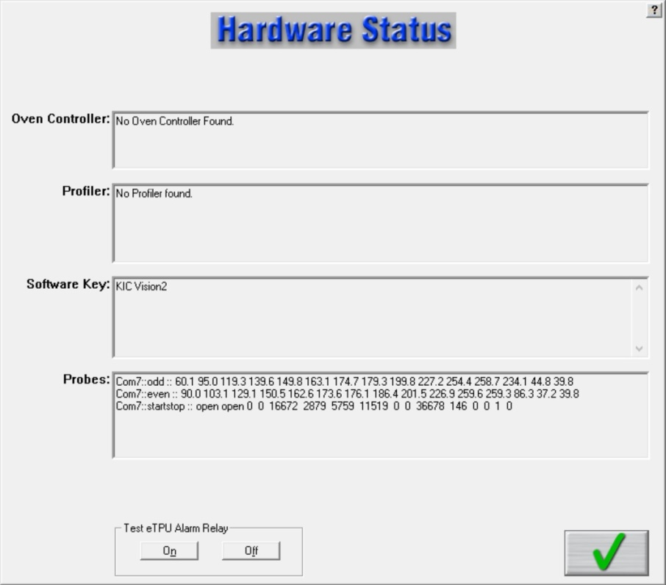

Figure 89: Hardware Status – Oven Controller Communication

Once you’ve installed the system on a communication-capable oven, your first task is to check the Hardware Status screen to see if the software recognizes the oven controller.

If the appropriate system isn’t identified in the *Oven Controller* field check the following:

* Verify that the software is installed on the same PC and hard drive as the manufacturer’s oven controller software.
* Exit the software and run the *ConfigurationProgram.exe* found in the software root directory folder. The Hardware tab lists a selection of ovens and oven models.
* Contact supplier or the oven manufacturer to make sure the version of oven controller software and firmware is compatible for oven communications.
* Make sure that the latest versions of the correct drivers are properly installed. (Contact tech support or the oven manufacturer for details.)

## Configure Software for Oven Communication

|  |  |
| --- | --- |
| There are *two* items you have to set in the GlobalPreferences screen when configuring the software for use with oven communications.   1. Enter an oven name, zone lengths, and zone limit data. 2. Click on the **Use Oven Base Recipe** check box. (Optional.) |  |

## Use a Base Oven Recipe With Oven Communication

The operating parameters of a reflow oven are specified by the manufacturer in the oven controller. These parameters may include zone setpoint temperatures, conveyor speed, fan speed, Nitrogen On/Off, conveyor width, etc. Taken together, these parameters form a *Base Oven Recipe*, which the software uses as a set of default values.

The software can set/load the zone setpoint temperatures and the conveyor speed parameters, adjusting them from the default values in the Base Oven Recipe.

In order for the engineer to specify the other parameters, a *Base Oven Recipe* must be created. This oven recipe has all the oven parameters except the zone set point temperatures and conveyor speed set correctly. When you load a Virtual Profile for a given product, this software will modify the set points and conveyor speed in the Base Oven Recipe, and then load the Base Oven Recipe into the oven controller. In this way, the oven will be setup exactly as it was during the Baseline Profile.

|  |  |
| --- | --- |
| When the *Use Oven Base Recipe* option is selected, nothing will happen until a Virtual Profile is loaded from the Profile Explorer. Then the software will present the Browse dialog in order to select the Base Oven recipe | Baseline Recipe |

## Run a Profile Using Oven Communication

When running profiles with oven communications, be aware of the following differences when compared to regular operations:

1. When running a profile and going through the sequence of screens leading up to the *Select Thermocouple* screen, you will not see a pull-down menu for the oven since there can be only one. You will also not see the screen for the oven settings since this was taken care of in Global Preferences.
2. When you are running the software with oven communication, the software sends data to the oven’s PC control software. This communication seems transparent at first, but once you gain more experience you will see certain signs that the automatic system software and the oven controller are communicating. One of the first things you might notice is that the recipe name loaded on the oven controller software will be *KICPROFILE*. Loading the *KICPROFILE* recipe provides the benefit of giving the automatic system software a vehicle to update oven settings without having to call a specific recipe file name and location of an oven controller recipe.
3. When running a profile, the software uses a Base Oven Recipe as a starting point for the oven recipe then changes the name to *KICPROFILE* and will/can only change the zone setpoints and conveyor speed settings thereafter. This gives the software the flexibility to change setpoints and conveyor speed on the fly without having you manually rename or save the recipe file.
4. For your first profile, load appropriate temperature and conveyor speed settings in the oven controller software. Once you have run your first profile or have loaded an existing profile from the Profile Explorer; zone setpoints, you can make conveyor speed adjustments manually while viewing the profile or let it happen automatically if you have the Navigator software option installed.

Once you choose to run a profile *using the predicted setpoints and conveyor speed,* the software automatically sends these new settings to the oven controller software to be loaded. When the new settings are loaded, watch for the following:

* With some oven controllers there may be an audio warning, indicating that the oven is going to change settings. Some of the audio indicators are also accompanied by a timer that will not allow the oven to load the new setpoints until the programmed time has elapsed. These timers can be reduced or turned off at the customer’s discretion.

|  |  |  |
| --- | --- | --- |
| * The software will display the message “Waiting for the oven controller to acknowledge recipe change”. There will be a time delay displayed for an estimated period for the oven to acknowledge the changes and that all conditions are right to set the oven to these new set points. See Figure 90. | PL 229  Figure 90 | |
| * You may notice with some ovens that it takes longer than others, you’ll have to get a feel for this as you go but if you feel the change is taking too long then switch over to the oven software and try to ascertain if there is some kind of disturbance that would cause the oven controller not to load the new set points. | | PL 230  Figure 91 | |

1. If you are starting a profile and the software tells you that the oven’s actual zone temperatures are not within 2 degrees of the of the set point value, and you know that you have waited long enough (possibly even answered that they are still changing), but now you know they are not, then you will have to answer “No” and follow the instructions. This information is outlined in the user manual, but what happens next may be a little confusing to a first time user. Here is a list of what takes place and why:

* You answer *No* the temperatures are not getting closer and the system then asks you to change the Setpoint values to that of the Actual. What the system is doing by this is finding out what the oven will actually control to in certain zones. It then takes the differences and uses them to update the oven.ini file so the next time the system optimizes for a profile it will take the zone delta limitations that it learned and apply it to the next profile. The software will use the new zone delta limits until the values change again by a set of oven setpoints that can’t be maintained by the oven are chosen. Remember that it is very important that you are sure that the oven can’t achieve the original setpoints before you answer *No.*  Once the new delta limits are established this will affect the capability of the Navigator to optimize your profiles.

|  |  |
| --- | --- |
| * Next the system will take you to the Verify Minimum and Maximum Set point Temperature screen. This is to verify that we have not allowed the software to choose set point values that the oven is not capable of controlling to. (See Figure 92.) * Next the software will prompt you that it will calculate new set points. When you click on OK, the screen will change to a profile graph that has calculated new oven set points for the oven to load in order to produce the optimized profile results. This works the same even if you don’t have the *Navigator* option. | Figure 92: Verify Setpoints |

If you entered the new set points manually the software will automatically find new set points like the Navigator would when you get to this point. Be patient you may have to go through this cycle of the oven not controlling to set point values a few times before the proper combination of acceptable set points and profile optimization can be found. In worst case scenarios you may have to change the 2.0 degrees delta between set point and actual because the oven is just simply not capable of getting within 2 degrees C of the set point no matter what the temperature.

**Tip**: If you get into a situation where you are having to adjust too many times and are still not getting set points that the oven will control to, but you are or you will be in spec by manually changing predicted set points, then go into the Optimization Tab and turn off “Allow Zone Set points To Change”. The next time around, the software will not change any of the zone values but you can go in and change them manually to exactly what the actual values are and run the profile.

## Start a Virtual Profile With Oven Communication

Before running a Virtual Profile with oven communications, review the following:

1. You have *Use Base Oven Recipe* checked in Global Preferences but the software did not ask you to select it when you started the VP. If you have just run your baseline profile and start a VP immediately, without exiting that product, then the VP will start without asking you to choose a Base Oven Recipe. The system assumes since you just ran a successful baseline profile that all of the oven settings are correct, and in turn, the Base Oven Recipe settings are correct.
2. You setup your product and have a baseline profile now but you do not have an oven recipe to match it. What recipe will you load when you want to run production on this product? Remember that even though you originally loaded a specific oven recipe file, the software took over and loaded the KICPROFILE recipe on your oven and did not save any subsequent zone setpoints and conveyor speed changes to that original oven recipe.

You can save any changes made to the original recipe while profiling if you want to create a recipe that can be run on the oven controller without the software running. If you choose not to save the changes, when you load this product under the software it will load the proper recipe parameters for that product.

|  |  |
| --- | --- |
| 1. When starting a Virtual Profile from the Profile Explorer, you will be asked to select your Base oven Recipe. A browse dialog box will appear, providing you with the means to browse your PC and point to the location and file name of the Base Oven Recipe you’ve chosen to use for this product. See Figure 93.   Remember it should be the same one you chose when you originally ran your baseline profiles. If you choose the wrong Base Oven Recipe, you could have boards fall off the conveyor or never even make it in because the Base Oven Recipe you chose does not match the width of the original file you loaded. | Baseline Recipe  Figure 93 |

1. When you have selected and opened the Base Oven Recipe, the software will load that recipe on the oven. All of the parameters in this recipe are correct for this product except the zone set points and conveyor speed. With some ovens, you may hear and audio warning, you may see the light tower change to an amber state, you may even see the conveyor stop momentarily and then start again indicating that the oven is loading the Base Oven Recipe. Seconds later you may hear or see one or all of these signs again as the software sends just the zone set points and conveyor speed settings to the oven controller.

|  |  |
| --- | --- |
| 1. If you have already loaded a VP and selected a Base Oven Recipe then you will not see the *Select the Base Oven Recipe to be Loaded* screen. Instead you will see the screen shown at the right, verifying that you are loading the correct Base Oven Recipe. If you choose *No* then the *Select Base Oven Recipe to Be Loaded*: screen will appear. (See Figure 94.) | PL 233  Figure 94 |

**Note**: If you feel that the system is taking too long to load the Base Oven Recipe or the setpoints, switch over to the oven controller software and see if you can detect a reason why the oven is not accepting the changes.

## Base Oven Recipe Automatic Verification

For Base Oven Recipe compatible ovens, users can automatically verify the correct Base Oven Recipe before beginning a Virtual Profile. This feature is especially useful for users that have multiple production products using multiple Base Oven Recipes. The system will allow you to select the Base Oven Recipe and if the selected recipe does not match, the Virtual Profile cannot begin.

1. Close the software if open.
2. Find and open the file: C:\software root directory\Log\KIC2000UserSettings.kiccfg
3. In the [PROPHET] section find and edit the line:

AllowNotChangeRecipeAuto=1

1. Save and then exit the file.
2. Open the software.
3. On the Global Preferences screen Global tab, select the **Use Oven Baseline Recipe** check box.

|  |  |
| --- | --- |
| The next time a Virtual Profile starts, a dialog box appears, prompting you to verify the correct Base Oven Recipe, or select a different one. | PL 234 |
| Click the **No** button to choose a different Base Oven Recipe. Select the **Yes** button to display the *Select the Base Oven Recipe to be loaded* screen and continue. |  |
| If the selected Base Oven Recipe does not match, a yellow dialog box appears. To select a different recipe select the **Cancel** button. When the correct recipe is selected, the software goes directly to the Virtual Profile display. |  |

# Dual Lane Systems And Functionality

The automatic system can monitor production through dual lane reflow ovens. This section will define the unique capabilities of the dual lane configuration.

A *Dual Lane-Dual System* configuration uses two instances of the software application to track different recipes through the oven.

A radio button display during the installation routine lets you choose between the standard configuration or the dual lane setup.

**Note**: For more information about the hardware components of the system, see the *Automatic System Hardware Installation Manual* (TFS-330210-000).

## Dual Lane Dual Systems

A dual system installation features two distinct instances of the automatic system software and a complete duplication of the thermal management hardware. Dual systems include *two*:

* Pairs of probes
* Encoders
* eTPUs
* Board sensors

|  |  |
| --- | --- |
| Each automatic system instance receives data from its own associated eTPU. Each stores its logged data and executable subroutines in separate folders identified as either *front rail* or *back rail*. (The front rail designates the lane closest to the lifting cover of the oven—the back rail designates the lane closest to the hinge of the oven cover.) | C:\Users\dklueck\Desktop\DSC09143b.jpg |

The two instances of the software permit using different recipes in each lane. In the desktop toolbar, each automatic system instance is represented by its own icon. F for Front Rail and B for Back Rail



## Configure Dual Lane Systems

During the software installation, you will have the option to select what type of system will be in use:

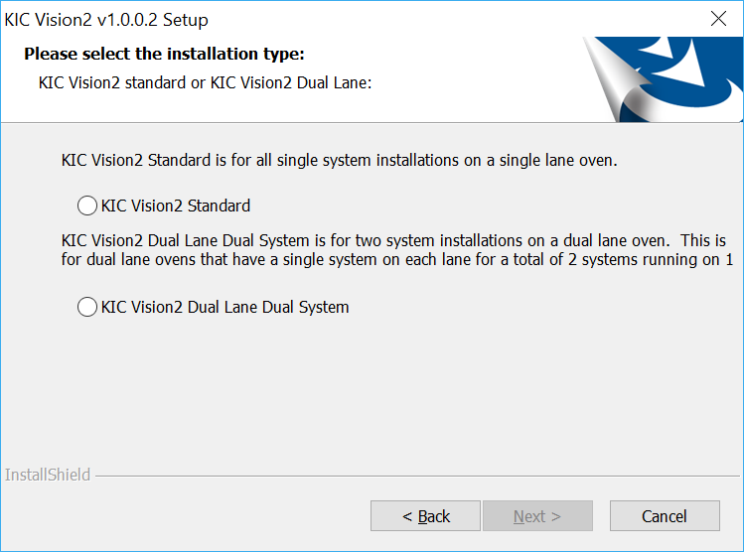

Select “*Dual Lane Dual System*” if there is a complete system installed on each lane of the oven.

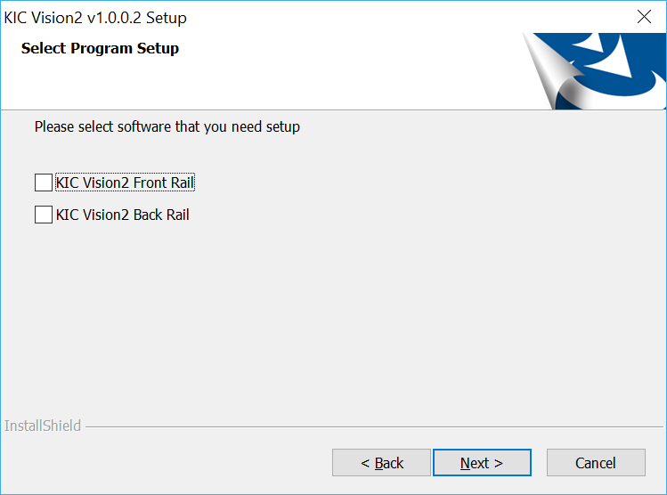

When “*Dual Lane Dual System*” is selected, as noted previously, there will be two separate software directories used – one for the “Front” and one for the “Back”. You will be able to choose whether you want to install the software for either one, or both directories.

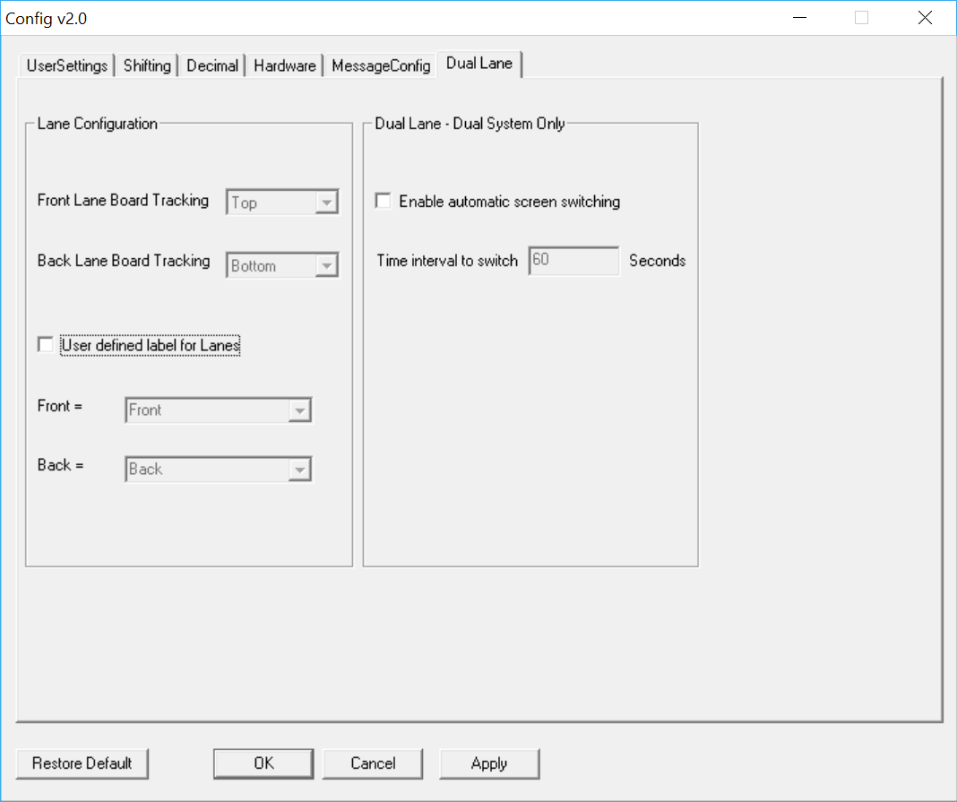Additional settings for a Dual Lane system configuration can be found in the *ConfigurationProgram.exe* located in the C:\Software Root directory.

***Lane Configuration*** – Front and Back Lane Board Tracking drop-down boxes are not used.

***User defined label for Lanes*** – By default, the software will label the lanes “Front” and “Back”. When the checkbox is checked, the drop-down menu allows you to select alternate designations for the lane names.

**NOTE:** The Front Lane is always the lane closest to the front side of the machine.

***Dual Lane – Dual System Only*** – When a Dual System is in use, there are two instances of the automatic system software running – one for each lane. By default, a user must select the lane they want to see on the screen at any given time.

When selecting this checkbox, the user can define an interval for the software “automatically” to switch over to the other lanes display after no input from the mouse cursor. **Note**: *Automatic switching will only occur when both lanes are running a live VP.*

**Note: For Dual Lane Dual System installations, the settings in this configuration utility must be entered into both install directories – C:\Software Root Directory Front Rail and C:\Software Root Directory Back Rail.**

On Dual Lane Dual Systems, when you select *User defined label for Lanes*, the selection chosen will display as a watermark on the Index, General, Description, Charts, and Troubleshooting screens. See example below:

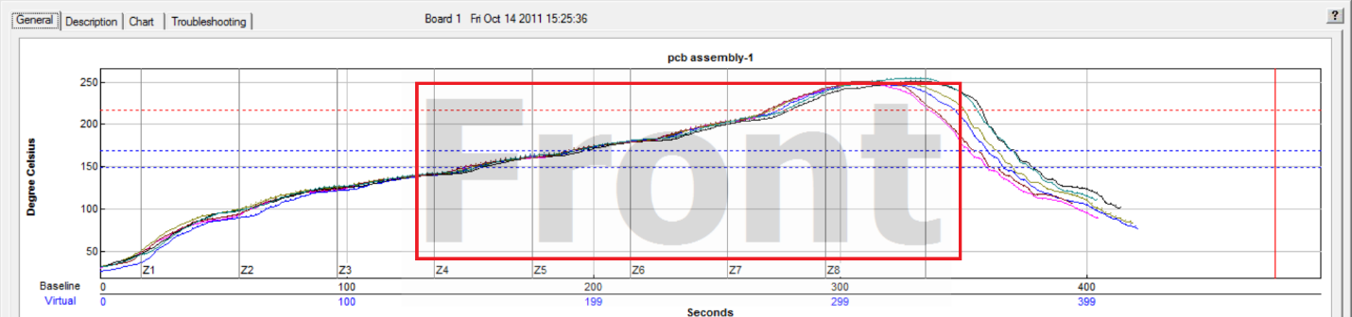

# Configuration Program

The system has many individual software settings that can be changed to suit the user’s process and or hardware set up. The configuration program tool facilitates quick and easy system setting changes, saving the user from the complications of manually editing the configuration files.

**Note:**  Only persons with advanced training in the automatic system software should modify these settings. Changes using this tool will directly affect the data collected by the system. Configuration software tool location:

C:\software root directory\ConfigurationProgram.exe

## User Settings Tab

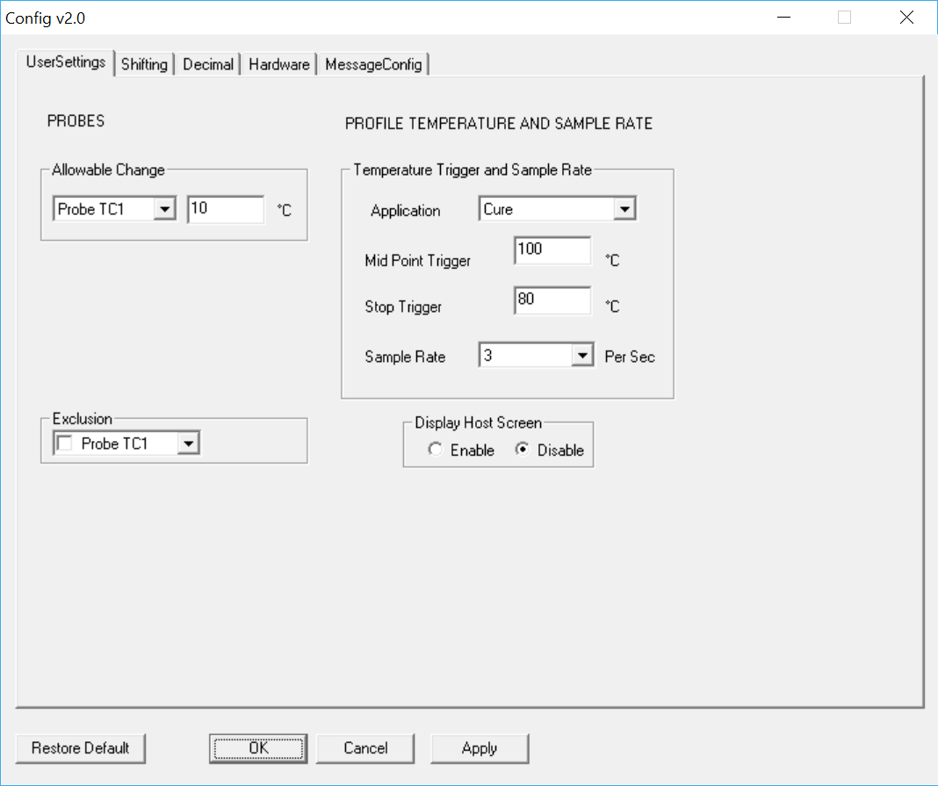**Allowable Change** – Defines how much deviation is allowed in any one of the 30 probe TC’s before a Warning condition is generated.

**Exclusion** – Allows user to disable any of the 30 probe TC’s from the VP calculations.

**Display Host Screen** – Enables/disables the display of the Host diagnostic screen.

**Temperature Triggers and Sample Rates**

The temperature triggers dictate when the profile begins and ends allowing for more consistent data collection. This area of the tool allows you to change the temperature trigger values as well as sample rate for each application type.

There are three temperature triggers:

**Start -**The profile Start temperature trigger is always 2C above the “Maximum Product Temperature at start of profile” setting in the Global tab of the Global Preferences screen. This value can be changed as needed from as low as 15C to as high as 40C.

**Mid Point –** The Midpoint temperature trigger must be higher than the Start trigger, and the Stop trigger. Be sure the temperature in your heated process will achieve this setting or the profile will fail.

**Stop –** The profile will end when all of the thermocouples attached to the profiler have cooled to below the Stop Temperature trigger setting.

**Sample rate –** Set the sample rate for each application type.

## Shifting Tab

In the event that the software does not properly shift (align) the profile it may be necessary to manually enter measurements to correct any profile display/shifting issues.

Select the check box and then enter the required measurements. Contact supplier of system for assistance.

## Decimal Tab

This area controls the number of decimal places for the Conveyor Speed and Zone Setpoints displays in the software.

## Hardware Tab

This area controls the configuration of the eTPU network addresses and allows for enabling or disabling of the oven communication when applicable.

## Message Config Tab

When certain messages are displayed in the software, the user can select a checkbox for “Do not show this again”. If checked, that message box becomes “disabled”. This area allows the user to enable or disable those messages.

# 

### 

**Part 2: Software and Hardware Options**

[Software Options 93](#_Toc494304209)

[Use Navigator to Optimize Profiles 94](#_Toc494304210)

[Use Auto-Focus 95](#_Toc494304211)

[Save Energy With Navigator and Auto-Focus 96](#_Toc494304212)

[Use Sweet Spot Target 97](#_Toc494304213)

[Use Statistical Process Control Charts 98](#_Toc494304214)

[Using Live Data Output 102](#_Toc494304215)

[Alarm Relay 106](#_Toc494304216)

[Light Tower 106](#_Toc494304217)

[Appendix A: The Process Window Index 107](#_Toc494304218)

[Appendix B: Recalculating Zone Delta Limits From Navigator/Auto-Focus Predictions 110](#_Toc494304219)

[Contact KIC 114](#_Toc494304220)

# Software Options

The *optional profile* optimization tools include *Navigato*r *Power,* *Auto-Focus* *Power, and Sweet Spot*. *Optional process monitoring tools include SPC Charting.* *Optional* data management tools include *Live Data Output*.

## Navigator

Navigator is a prediction tool that automatically finds the optimal oven setup for each product you profile. Navigator lets you understand how changes to belt speed and oven set points will affect a product profile. Navigatorcan create and evaluate billions of potential product profiles, automatically selecting the profile and oven setup that best fits the Process Window. This automated prediction tool is exponentially more powerful and accurate than any tool currently on the market and allows you to find the optimal profile in about a minute. The automated prediction tool is designed to center the profile in your process window, and you may set the limits to fit your process. An example of this is running sensitive components with lead-free solders: if your assembly cannot see temperatures above 235°C, but must see a fairly high peak temperature to reflow the lead-free solder, Navigator will find a profile that will be centered between the high and low limits.

Perhaps the most significant feature of the software and the Navigator tool is that they rank your profiles using the *Process Window Index*. This allows you to compare performance between processes and, more importantly, to be assured that you have found the most robust and reliable profile for a given product that your oven can achieve.

## Auto-Focus

*Auto‑Focus* is a simulation software that eliminates the need to guess at an initial oven recipe. Auto-Focus automatically calculates the ideal oven recipe, allowing you to avoid conventional oven setup pitfalls. Auto‑Focus gets smarter with every profile you run, providing you with increasingly accurate oven recipes.

## Navigator/Auto‑Focus Power

Used with Navigator and Auto-Focussoftware, the Power feature optimizes your profiles and/or initial oven settings based on reduced energy use. Studies have shown that many reflow ovens consume more energy than required in order to process the products in spec. The Navigator Power and Auto-Focus Power functions identify the oven recipes that consume the least amount of energy while processing the products in spec. The result is improved quality at reduced energy costs.

## Sweet Spot

The Sweet Spot feature allows you to define a “non-centered” target value for your statistics when creating a Process Window.

## Statistical Process Control Charts

Statistical Process Control (SPC) charts provide graphical data of the key process parameters that need to be monitored for product quality assurance. SPC charts aid the ability to understand the predictability of the process and to know in real-time when a process may be changing and affect product quality.

## Live Data Output

Live Data Output (LDO) processes data for every virtual profile as real-time output for use with third-party applications. Third-party software can provide line balancing, production host monitoring or statistical process control.

# Use Navigator to Optimize Profiles

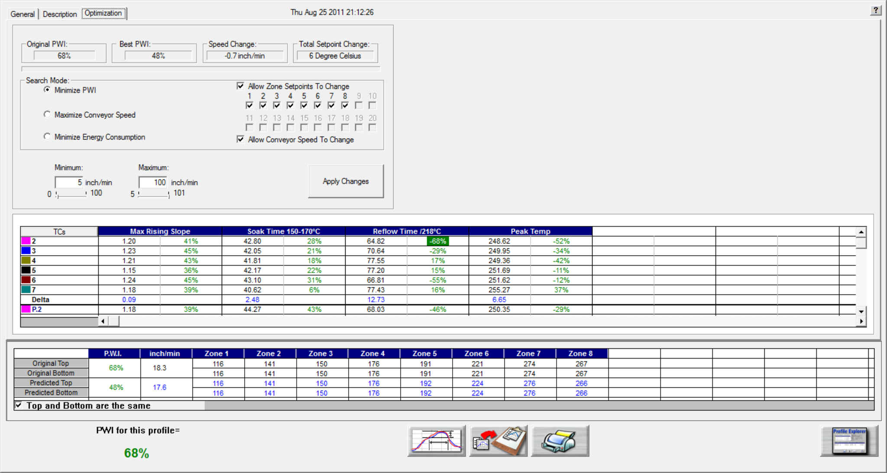

Figure 95: Profile Optimization Tab

The *Optimization* Tab allows you to set the search parameters for Navigator. Thesoftware will search through millions of set point and conveyor speed combinations to find the optimal oven settings for each product. These optimization calculations are based on the selections you make on this tab. See Figure 95.

**Original PWI** – The Process Window Index for the original profile

**Best PWI** – The best Process Window Index that can be found based on the oven recipe optimization constraints selected.

**Speed change** – The total change to the conveyor speed for the best oven recipe found.

**Total set point change** – The sum of all set point changes for the best oven recipe found.

### Search Mode For Optimization

* **Minimize PWI** – Search for the combination of set point temperatures and conveyor speed that will minimize the Process Window Index.
* **Allow zone set points to change** – This option will determine if Navigator will include zone set point changes when predicting new solutions.
* **Allow conveyor speed to change** – Choose whether to allow Navigator to vary the conveyor speed. If you choose this feature, you can set the minimum and maximum speeds.
* **Maximize conveyor speed** – Search for the set point temperatures that will maximize conveyor speed.
* **Minimize energy consumption** – Used by the Power software feature. The software searches for the oven settings that will minimize the power consumption of the oven by finding oven set point solutions with slower conveyor speeds and lower temperature settings.

### Conveyor Speed Constraints

As long as the Allow Conveyor Speed to Change feature is selected, these options will be available.

**Low** – Select the minimum conveyor speed you would like Navigator to recommend for new products.

**High** - Select the maximum conveyor speed you would like Navigator to recommend for new products.

# Use Auto-Focus

## Auto-Focus Tab

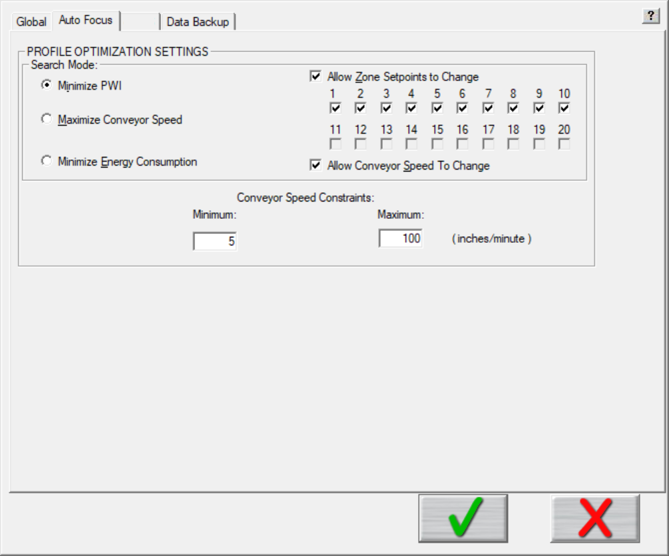

Figure 96: Preferences – Auto Focus Tab

**Note**: *Auto-Focus* is an optional utility that is only available if programed on your software key. The Auto-Focus tab and its control settings will only appear on the Global Preferences screen if the software is enabled on the key.

### Profile Optimization Settings—Search Mode

**Minimize PWI** – Search for the combination of set point temperatures and conveyor speed that will minimize the Process Window Index (PWI).

**Allow Zone Set points to Change –** This option determines if Auto*-*Focus will include zone set point changes when predicting new solutions.

**Allow Conveyor Speed to Change -** Choose whether to allow Auto-Focus to vary the conveyor speed. If you choose Allow to Vary you can set the minimum and maximum.

**Maximize Conveyor Speed** – Search for the set point temperatures that will maximize conveyor speed.

**Minimize Energy Consumption** – Using the Power feature, the software will search for the oven settings that will minimize the power consumption of the oven by finding set point solutions with slower conveyor speeds and lower temperature settings.

## Conveyor Speed Constraints

**Minimum** – Select the minimum conveyor speed you would like Auto-Focus to recommend for profiling new products.

**Maximum** – Select the maximum conveyor speed you would like Auto-Focus to recommend for profiling new products.

# Save Energy With Navigator and Auto-Focus

Studies have shown that many reflow ovens consume more energy than required in order to process products within their specifications. The *Power* feature, included with both the Navigator Power and Auto-Focus Power, lets you optimize your oven settings for reduced energy use. The Power feature identifies the oven recipes that consume the least amount of energy while keeping products within spec.

## Enable the Power Feature in Auto-Focus

|  |  |
| --- | --- |
| 1. On the Global Preferences screen, select the **Auto-Focus** tab. 2. In the **Search Mode** area of the **Profile Optimization Settings** panel, click on the **Minimize Energy Consumption** radio button. | Description: C:\Users\dklueck\Desktop\Power auto focus Prof Opt Settings.png |

## Enable the Power Feature in Navigator

|  |  |
| --- | --- |
| 1. On the Virtual Profile Live Mode screen, select the Optimization tab. 2. In the **Search Mode** panel, click on the **Minimize Energy Consumption** radio button. | Description: C:\Users\dklueck\Desktop\Power Nav Optimization tab Searrch Mode.png |

# Use Sweet Spot Target

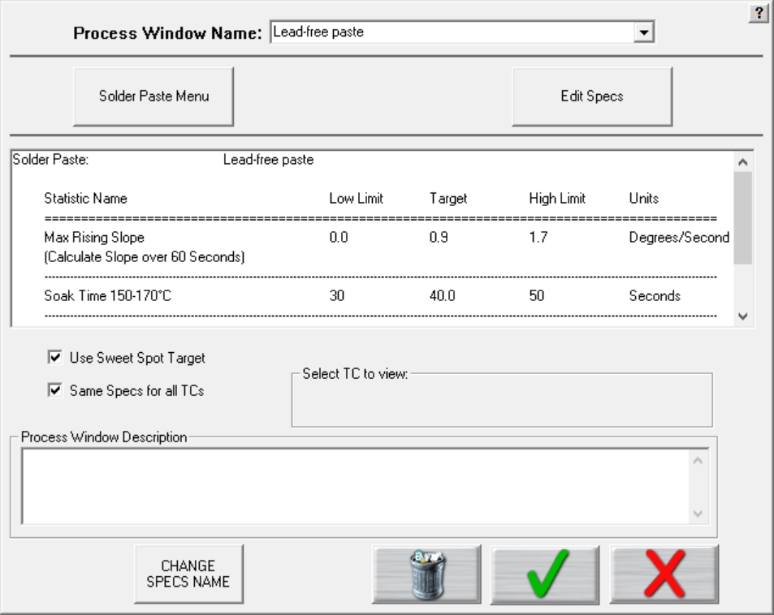

Figure 97: Sweet Spot Target

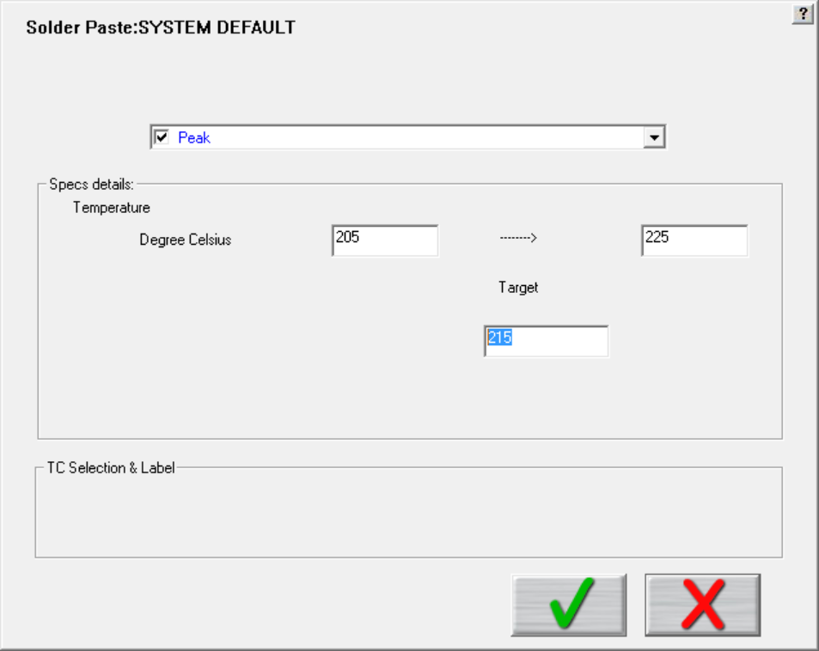Normally, when selecting a specification, only an upper and lower limit is defined, and the “target” value is automatically the center of the upper/lower limits.

If you have purchased the *Sweet Spot Target* option, enabling this feature allows you to manually define your own Target value for each statistic. This function may be desired when there is a defined specification window, but the desired optimal value may not be the exact center of the process limits.



























# Use Statistical Process Control Charts

Statistical Process Control (SPC) charts provide graphical data of the key process parameters that need to be monitored for product quality assurance. SPC charts aid the ability to understand the predictability of the process and to know in real-time when a process may be changing and affect product quality.

This option lets you display charts showing SPC data in both Live (VP) and in Historical modes.

## Live Mode - Charts Tab

|  |  |
| --- | --- |
| The Chart tab will display a control chart for the overall profile PWI, and each individual process specification, as defined in the Process Window setup.  The alarm limits for each specification appears on each chart using red horizontal lines.  At the top of each hour, the software will plot a data point for each product thermocouple on each chart. The chart data will coincide with the live Virtual Profile data.  The software will update the overall PWI for each chart and calculate the Cpk and display the results above each chart. | Figure 108: Virtual Profiling– Chart Tab, all charts |

**Note**: You can enable or change the Cpk alarm values in the “Global Preferences” screen before you start Virtual Profiling.

### View Chart Data

To view individual chart data, click inside the chart area of your choice. This will display that particular chart in a full screen view.

Move the mouse pointer over the chart data, a display box will appear. This display box data includes the PWI, Cpk, date, and time for that virtual profile. The date and time for the last virtual profile appears at the bottom of the full screen chart in blue text.

Click in the chart area to return to the regular Chart tab view:

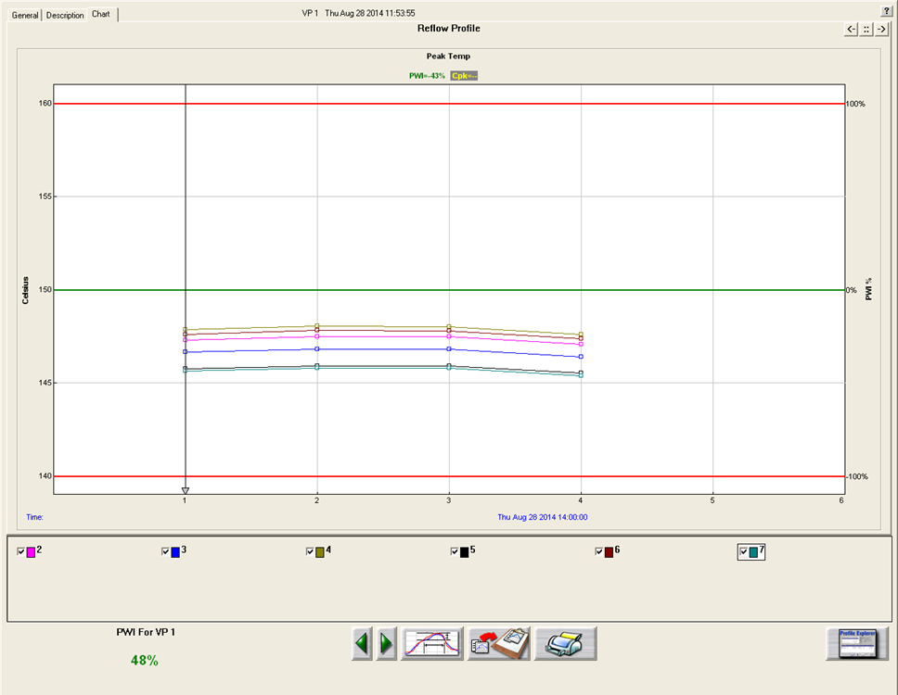

Virtual Profiling – Chart Tab, zoom chart

## Historical Mode - Chart Tab

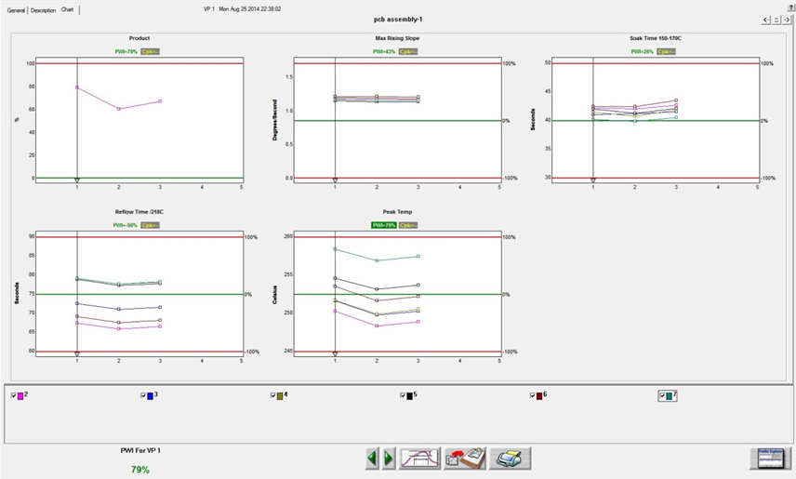

Virtual Profiling History – Chart Tab, all charts

The Chart tab will display a control chart for the overall profile PWI and for each individual process specification with alarm limits as defined in the Process Window setup. The chart data will coincide with the Virtual Profile data, date and time.

### View Control Charts

Depending on the screen resolution, setting of the computer not all charts may fit within the screen area. Use the buttons in the upper-right corner of the Chart tab to select the number of charts to display and toggle between then.

The control charts hold all of the historical Virtual Profile data for your product as selected in the Profile Explorer. Each data point on each chart represents a virtual profile.

**Virtual Profile selector line -** Each chart has a Virtual Profile Selector Line at specific virtual profile #. The virtual profile # appears at the top of the screen, along with the date and time that virtual profile # was entered into the system. You can move the Virtual Profile Selector line position by clicking and dragging the small triangle at the bottom of the Virtual Profile Selector line.

The Maximum PWI and Cpk for the selected virtual profile, date and time are highlighted above the corresponding chart(s).

Each chart contains data for every product thermocouple used during the profile. Below the charts you can de-select the TCs that you wish to remove from the control chart display. De-selecting a TC will remove the data for that TC from the each control chart. Click the check box again to display the data for that TC. The PWI for the selected virtual profile appears, in the bottom-left corner.

### Viewing Chart Data

To view individual chart data, click inside the chart area of your choice. This will display that particular chart in a full screen format. Move the mouse pointer over the chart data, and a display box will appear. This display box data includes the PWI, Cpk, date, and time for that virtual profile. The date and time for the last virtual profile appears at the bottom of the full screen chart.

### History Mode Chart Options Menu

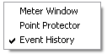

Figure 109: History mode-Chart Options Menu

**Meter window –** Right click anywhere in the full screen chart area. The Chart Options menu will appear, select Meter Window. This will display a small data box in the upper-left corner of the profile graph. This data box will display the historical – statistic data for any selected virtual profile. To select a virtual profile move your mouse pointer along the chart data, at each data point the historical – statistic data for that virtual profile appears. Right-click in the chart area again and de-select Meter Window to disable this feature.

**Point protector –** When this feature is enabled, the software will display individual data points for each virtual profile. To activate this feature right click anywhere in the full screen chart area. A menu will appear, select Point Protector. This will display the individual data points on each control chart. De-selecting this feature will remove the data points from the control chart, showing only a plot of the same data. By default, the Point Protector is enabled for charts containing 20 virtual profiles or less. Click in the full screen chart area again to return to the regular Chart tab view.

#### Buttons

The Charts tab will have two extra buttons found only on this screen.

* **Scroll backwards in time** – Clicking on the green left arrowhead will result in displaying the **previous** set of virtual profiles.
* **Scroll forward in time** – Clicking on the green right arrowhead will result in displaying the **next** set of virtual profiles.







**Note**: Each chart can display a maximum of 200 data points at any given time. Every 200 data points are considered a set of data. A set of data can contain up to 200 data points, or if the production run was stopped before 200 virtual profiles were processed, a data set may contain less than 200 data points.











































# Using Live Data Output

The Live Data Output (LDO) feature outputs Virtual Profile (VP) data in real time for use by third-party applications such as Line Balancing/Production Monitoring Host or SPC software. This data includes all relevant process information, profile data, Virtual Profile data, statistics, and limits. There are several different LDO formats that can be chosen from. Examples of these formats will be shown later in this section.

**Output of the LDO file data** –When the VP is running, the statistical data from each newly completed Virtual Profile is written to the LDO file.

**Viewing LDO data** – LDO is designed to output data only and is not meant as a historical database. It is intended to be used with third party software that collects the LDO data while the Virtual Profile is running-live. If you are not running third party software to collect the LDO data, and wish you to view historical data, this can be accomplished from within the actual automatic system software in use.

**LDO destination** – The location where the LDO output file is written to can be specified by the user in the ConfigurationProgram.exe utility.

**Note**: For the Live Data output to function, the appropriately programmed USB dongle key must remain connected to the PC at all times during use. You can verify whether or not you have the LDO feature by viewing the Software Key panel in the Hardware Status screen.

**An LDO output file example**

Below is an example of the type of data included in the LDO output file:

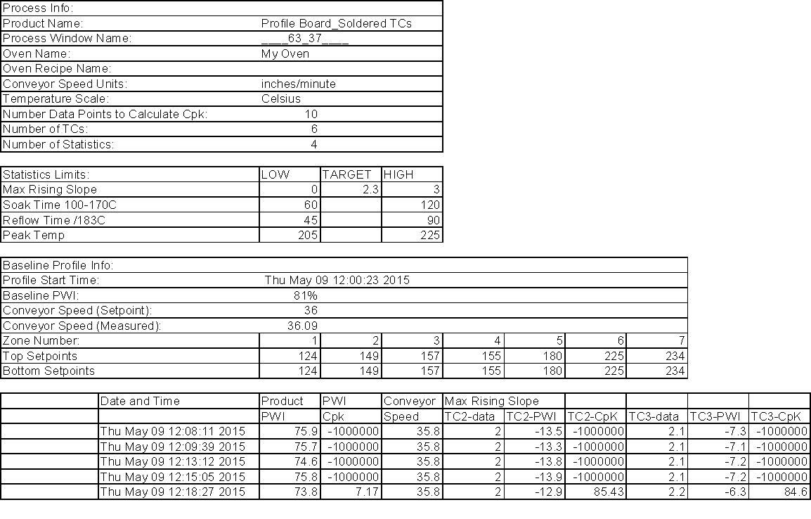

Figure 147: Live Data Output text file

## LDO Formats

There are several standard LDO formats to choose from:

* LDO Standard TSV or CSV format for WordPad
* LDO Standard TSV or CSV format for Excel
* LDO 1 Board 1 File (txt output)
* LDO XML format (1 Board 1 File)

The following are specialized output formats and not typically selected by most users:

* LDO KP Data Only (CSV)
* LDO XML Format A
* LDO XML Format A2
* CUSTOME LDO

## Details Of Output Files

### LDO Standard TSV And CSV For WordPad

* The output file type is a .TXT
* TSV format is Tab delimited
* CSV format is Comma delimited.
* The output file is first generated when the VP is started
* File is appended as each VP is calculated
* The default output file name is KIC\_VISION\_LiveDataOutput.txt
* The user can choose to define their own specific output file name
* When default or user defined naming is selected, output file is overwritten at virtual profile changeover
* File name format can also be set to: PRODUCT\_YYMMDD\_HH-MM-SS.txt
* When this naming is selected, a new file is generated when product changeover occurs

### LDO Standard TSV And CSV For Excel

* The output file type is a .TXT
* TSV format is Tab delimited
* CSV format is Comma delimited.
* The output file is first generated when the VP is started
* File is appended as each VP is calculated
* The default output file name is KIC\_VISION\_LiveDataOutput.txt
* The user can choose to define their own specific output file name
* When default or user defined naming is selected, output file is overwritten at virtual profile changeover
* File name format can also be set to: PRODUCT\_YYMMDD\_HH-MM-SS.txt
* When this naming is selected, a new file is generated when product changeover occurs

### LDO 1 Board 1 File (Txt Output)

* The output file type is a .TXT
* Separate individual file is generated as each VP is calculated
* File name is ProductName\_OvenName\_YYMMDD\_HH-MM-SS.txt
* User cannot change file name

### LDO XML (1 Board 1 File)

* The output file type is a .XML file
* Separate individual file is generated as each VP is calculated
* File name is ProductName\_OvenName\_YYMMDD\_HH-MM-SS
* User cannot change file name

**Note:** Examples of each of the available output file types can be found in the C:\Software Root Directory\Sample LDO files folder.

## Configure LDO

1. With the automatic system software shut down, browse to the C:\Software Root Directory folder and run the ConfigurationProgram.exe application, and select the LDO tab:

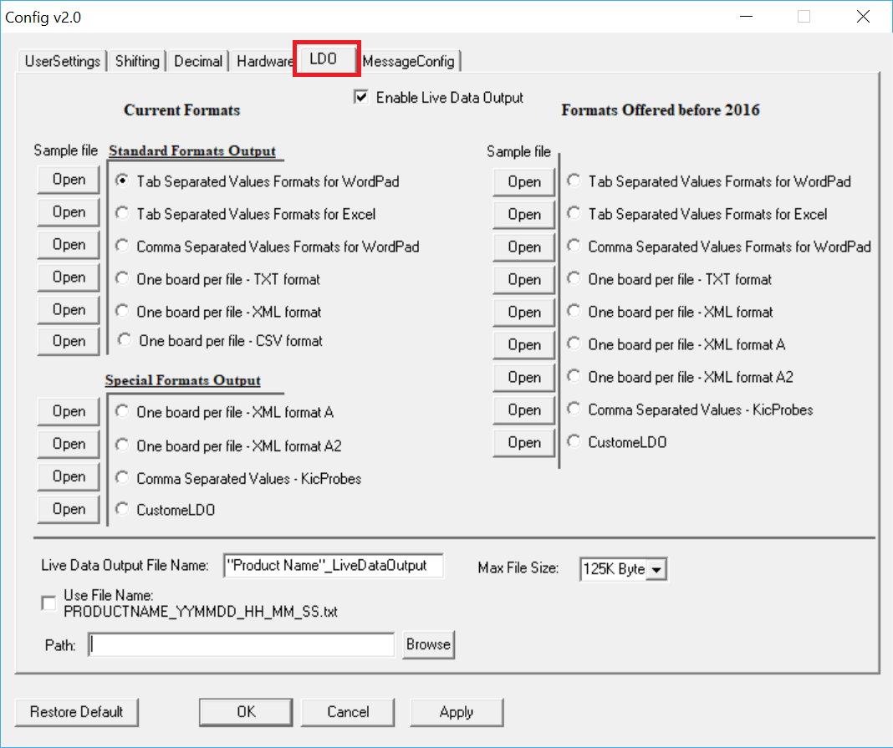

1. Check the “Enable Live Data Output” checkbox
2. Select the desired Format
3. The type of Format chosen will affect what naming structure for file will be used (See Details of Output Files above).
4. Select the destination path for the output file by clicking on the Browse button. This needs to be a location on the local drive.
5. “Max File Size” lets you specify how large the LDO output file can get before a new one is started.

If a VP is running for an extended amount of time, once the maximum file size is reached, a new file will be generated and the new file name will be appended with a \_# as shown in the example below:

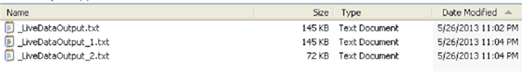

### Delete Accumulated LDO Files

In time, accumulating LDO files can take up too much hard disk space and need to be deleted. The software provides an *Auto Delete* function that lets you specify time intervals for automated file purging. You can specify a maximum number of days–up to 1827 (five years)–that the system retains the files before automatic purging. You can also select a time in the 24-hour cycle for the system to automatically check for files that exceed the maximum day limit.

1. In the automatic system folder, double-click on the **AutoDelete** icon. \\RND\RND_Service\For DaveK\RPI\RPI Graphics\V 1.4\AutoDelete App icon.png

The Auto Delete LDO files screen appears:

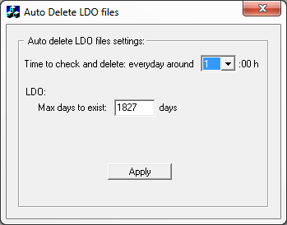

1. Click in the *Max days to exist* field, and type in a new value.

C:\Users\dklueck\Desktop\Auto Delete LDO max time limit.png

|  |  |
| --- | --- |
| 1. Use the drop down list to select an hour during the day to check for old files.   C:\Users\dklueck\Desktop\Auto Delete LDO time to check2.png   1. Click the Apply button. | C:\Users\dklueck\Desktop\Auto Delete hour list exposed.png |















































































































# Alarm Relay

The Alarm Relay connects to the Alarm/Barcode port of the eTPU, and provides an external notification to the user when an alarm condition occurs. It allows for an optional audible light tower to be powered and triggered; can include SMEMA interface connections; and it allows a user to hardwire in an external device of their choosing. The Alarm Relay is required to have an external AC power source.

**Note**: For more information about the hardware components of the system, see the *Automatic System Hardware Installation Manual* (TFS-330210-000).

# Light Tower

The Light Tower is a means of providing an audio and/or visual cue when the automatic system software has determined that the oven process has reached an out-of-control condition.

The light tower can only be used with the *optional Alarm Relay*, as it plugs directly into the *Alarm Relay* box. It uses a single Red light with an audible buzzer, which are both activated anytime an alarm condition occurs. Because it is controlled directly by the *Alarm Relay*, the light and audible buzzer will stay on for as long as the *Alarm Relay* is energized.

# Appendix A: The Process Window Index

**A Method for Quantify Thermal Profile Performance**

## The Problem

While there are currently statistically valid methods for quantifying pick and place and screen printer performance, there is no widely accepted method for comparing performance of thermal profiles, and thus, no quantifiable system of ranking thermal process performance. Once a thermal profile has been run, it is judged as being either in or out of spec, and perhaps subjectively judged as being OK, good, or really good. Efforts to track process performance for SPC or QC generally focus on a single, or a small group, of profile statistics; for example, peak temperature of one or two thermocouples on a golden board. The Process Window Index is a statistical method for ranking thermal profile and thermal process performance.

## Defining the Process Window Index

|  |  |
| --- | --- |
| The Process Window Index (PWI) is a measure of how well a profile fits within user defined process limits. See .  This is done by ranking process profiles on the basis of how well a given profile “fits” the critical process statistics. A profile that will process product without exceeding any of the critical process statistics is said to be inside the Process Window. The center of the Process window is defined as zero, and the extreme edge of the process window as 99%. | Process-Window-Index  Figure 148: Process Window and PWI |
| A PWI of 100% or more indicates that the profile will not process product in spec. A “Process Window Index” of 99% indicates that the profile will process product within spec, but it is running at the very edge of the Process Window. A “Process Window Index” of less than 99% indicates that the profile is in spec and tells users what percentage of the process window they are using: for example, a PWI of 70% indicates a profile that is using 70 percent of the process spec. | PWI-Theory  Figure 149: The Process Window Index (Single Statistic—Peak Temperature of one Thermocouple) |

The PWI tells users exactly how much of their process window a given profile uses, and thus how robust that profile is. The lower the PWI, the better the profile. A PWI of 99% is risky because it indicates that the process could easily drift out of control. Most users seek a PWI of below 80%, and profiles with a Process Window Index between 50% and 60% are commonly achieved (if the oven is sufficiently flexible and efficient).

shows the Process Window Index for the Peak Temperature of a single thermocouple. The Process Window Index for a complete set of profile statistics is calculated as the worst case (highest number) in the set of statistics.

For example: if a profile is run with six thermocouples, and four profile statistics are logged for each thermocouple, then there will be a set of twenty-four statistics for that profile, and the PWI will be the worst case (highest number expressed as a percentage) in that set of profile statistics. Note that shows the user-designated critical statistics for a single thermocouple.

PWI How Determined - Leaded R0511A -- NoTitle NoBorder

Figure 150: The Process Window Index  
(Multiple Statistics for a Single Thermocouple and Final PWI Calculation)

## Calculating the PWI

To calculate the Process Window Index: i=1 to N (number of thermocouples); j=1 to M (number of statistics per thermocouple); **measured\_value[i,j]** is the [i,j]th statistic’s value; **average\_limits[i,j]** is the average of the [i,j]th statistic’s high and low limits; and **range[i,j]** is the [i,j]th statistic’s high limit minus the low limit.

PWI Calculation Formula R0811A No Border

Figure 151: Formula for calculating the PWI

Thus, the PWI calculation includes all thermocouple statistics for all thermocouples. The profile PWI is the worst case profile statistic (maximum, or highest percentage of the process window used), and all other values are less.

**Note:** When using non-centered Target values, a modified formula is used.

## Benefits of Ranking Thermal Profile Performance

The analysis of thermal profiles with the Process Window Index offers four significant benefits. The first is that profiles can be easily compared, and users can be confident that they are using the best profile their process can achieve. Before the PWI was available for profile analysis, comparing profiles was subjective, and users could never be certain they had the best profile for their product. The PWI provides an excellent opportunity for process improvement and its use is a significant step towards Zero-defect Production.

The second benefit is that the PWI greatly simplifies the profiling process. When used in advanced profiling tools, all profile statistics are reduced to a single number (the PWI) that even the most inexperienced operator can understand. This means significant savings in terms of training costs and a reduction in defects caused by operator error. It further means that in a few minutes, an inexperienced operator can setup an oven with the optimal profile, a job that formerly could take an experienced engineer hours.

The third benefit is that because the PWI reflects the performance of the whole profile, it provides much better indicator of process capability than tracking a single statistic. The PWI thus provides excellent data for SPC and other QC monitoring programs while simplifying data gathering and reducing process monitoring costs.

Finally, the PWI gives users a simple method for comparing thermal process performance. Comparisons may be made between individual lines on the shop floor, between processes at multiple plants, and between processes using dissimilar equipment. The ability to quantify thermal process performance will give electronics assemblers a means for comparing the performance of their soldering equipment. This is of value in selecting equipment, for buy off, and for process troubleshooting.

is the result of a series of tests comparing oven performance using several sizes of PCBs. Each board was profiled in the given oven, and then an automated profile prediction tool was used to find the optimal profile for that board in the given oven. After the oven setpoints were changed and the oven stabilized, a second profile was run to confirm that the predicted PWI had been achieved. shows that there is significant variation in oven performance between various makes and models. In this test, Oven C had more zones than Ovens A and B, and performed better, as would be expected.

|  |  |  |  |  |  |
| --- | --- | --- | --- | --- | --- |
| **Oven** | | **Board Type** | | | |
| **Manufacturer** | **Model** | **Motherboard** | **Cell Phone** | **Display Adapter** | **Mainframe** |
| A | X | PWI = 87% | PWI = 62% | PWI = 79% | PWI = 126% |
| B | Y | PWI = 71% | PWI = 58% | PWI = 61% | PWI = 93% |
| C | Z | PWI = 33% | PWI = 29% | PWI = 34% | PWI = 58% |

Table 10: Comparison of Oven Performance – Best Achievable PWI

## Conclusion

The simplicity of the Process Window Index makes its validity as a statistical tool readily apparent and its adoption as an industry standard clearly offers a significant opportunity for the improvement of the soldering process. The advantages detailed above point to its value in demystifying the soldering process and open the door to precision control of a process that has been ignored for too long. Issues like Lead-free electronic assembly means that electronics assemblers can no longer be complacent about their soldering process. Sophisticated tools utilizing the PWI as a standard for accurately measuring the thermal process will mean more efficient production, improved and simplified process control, and higher quality final product.

# Appendix B: Recalculating Zone Delta Limits From Navigator/Auto-Focus Predictions

Occasionally, when using the *Navigator Power* or *Auto-Focus Power* options to generate new recipes, it may give suggested setpoints that your specific oven may not be able to achieve. For example, it may suggest setting Zone 1 to 100 and Zone 2 to 150, but after loading the settings, you find that your oven is only able to hold Zone 1 to 109. When this situation occurs, there is procedure in the software you can follow that will force it to “learn” the capabilities of your oven, which means it will be able to provide suggested setpoints that your oven is more likely to be able to maintain. The steps below will show how to perform this recalculation both on a stand-alone PC, and also when the software is communication with the oven control software.

## For Stand-Alone Software Installations

|  |  |
| --- | --- |
| 1. When you go to start the predicted profile, click on the traffic light and the software will first ask if the oven is stabilized. Choose No. |  |
| 1. Next, it will ask you if the oven is still in the process of stabilizing. Choose No. |  |
| 1. The software will then display this message, letting you know that it will now start the “recalculation” process. (Note: on a stand-alone oven, you do not need to change the actual oven setpoints at this point). Click OK. |  |
| 1. On this screen, change the zone setpoints to the actual temperature that the oven is able to maintain. After entering new setpoints, click the arrow forward button. |  |
| 1. Next, it will bring you to the Zone Setpoint and Zone Min/Max Temperatures screen. This is just to allow you to confirm that the Min/Max values that are entered are correct. Click the arrow forward button. |  |
| 1. Click OK on this screen to start the “recalculation” of the zone delta limits. |  |
| The software will now automatically change some of the default settings of the software, to settings that are more applicable to your specific oven, in regards to how it calculates the suggested recipe setpoints. When the calculation is completed, it will return you to your original profile plot, and it will display a new “Predicted” recipe suggestion that your oven should be able to maintain. | |

## For Oven Controller Software Installations

|  |  |
| --- | --- |
| The following section outlines the steps used when your profiling software is installed on the oven PC, and is communicating with the oven control software. | |
| 1. When you go to start the predicted profile, click on the traffic light and the software will prompt you if the oven temperatures are not within 2 degrees of the zone setpoint. If the temperatures are not getting closer, click “No”. |  |
| 1. *IMPORTANT:* you will now need to switch over to your oven control software, and change the setpoints to the temperature that the zones are actually controlling to. Only click “OK” after you have modified the oven recipe. |  |
| 1. Next, it will bring you to the Zone Setpoint and Zone Min/Max Temperatures screen. This is just to allow you to confirm that the Min/Max values that are entered are correct. Click the arrow forward button. |  |
| 1. Click OK on this screen to start the “recalculation” of the zone delta limits. |  |

The software will now automatically change some of the default settings of the software, to settings that are more applicable to your specific oven, in regards to how it calculates the suggested recipe setpoints. When the calculation is completed, it will return you to your original profile plot, and it will display a new “Predicted” recipe suggestion that your oven should be able to maintain.

# mapContact KIC

## On the Web

You can find the latest KIC product news along with a library of useful information at our website:

[www.kicthermal.com](http://www.kicthermal.com) or [www.kic.cn](http://www.kic.cn)

## KIC Technical Support

KIC Tech Support is available by email:

USA: [tech@kicmail.com](mailto:tech@kicmail.com)

Europe: [europe.tech@kicmail.com](mailto:europe.tech@kicmail.com)

Asia: [asia.tech@kicmail.com](mailto:asia.tech@kicmail.com)

## KIC Product Training

Contact KIC Customer Support by email, [training@kicmail.com](mailto:training@kicmail.com)

## KIC Sales

Contact KIC sales:

USA: [sales@kicmail.com](mailto:sales@kicmail.com)

Europe: [europe.sales@kicmail.com](mailto:europe.sales@kicmail.com)

Asia: [asia.sales@kicmail.com](mailto:asia.sales@kicmail.com)

China: [asia.sales@kicmail.com](mailto:asia.sales@kicmail.com)

## Find the KIC Representative in Your Area

Send an email, or visit our web page to find a local representative.